EASTER GREETINGS CAMPAIGN
For this campaign we suggest that you write a simple card or greeting to the individual saying, for instance, that you are thinking of him/her and/or urging them not to lose hope ― or words to that effect. A picture postcard is always welcome and cheapest to send. You can include your name and address if you wish but do not mention ACAT or include a religious greeting or motif if so advised, since communication from a foreign organisation can endanger the prisoner. Several individuals featured in previous campaigns have been released. Sadly others are still in prison and it is important not to forget them. Changes in their circumstances are described, where known. As usual we include human rights groups. For individual prisoners or their families it is heartening to receive fairly regular cards of encouragement. Members should not feel obliged to respond to every appeal case or to write to all the addresses listed for a particular case.
Overseas postage (airmail) for items weighing up to and including 20 grams to all of the countries featured in our current appeals costs £1.85.
See also: https://www.royalmail.com/current-postage-prices.

GROUPS
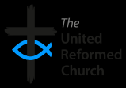
CHORLEY UNITED REFORMED CHURCH provides a drop-in support, advice and signposting service for refugees and asylum seekers in Chorley (Lancashire). There is no need for an appointment and the church promises a warm welcome, refreshments and help with a range of issues including accommodation, benefits, learning English, connecting with other asylum seekers and refugees and a chance to join in with activities including gardening, arts and crafts, woodwork and more. The service began in June 2021 and is popular and helpful for clients.

Please send a greeting to:
Chorley URC
Hollinshead Street
Chorley
Lancashire
PR7 1EP
Tel: 01257 760066
Email: refugee.support@chorleyurc.org

MAP has been offering practical support and social opportunities to asylum-seekers and refugees in Middlesbrough since at least 2009. The project aims to create welcoming spaces, where there is an instant sense of community. Its members offer a varied programme of services including second-hand clothing and household goods distribution, a regular weekly activities programme, and one-off classes, collaborations, outings and activities, which are often delivered in partnership with others.

Please send a greeting to:
MAP
54 Borough Road
Middlesbrough
TS1 2JH
Email: MAPMbro@gmail.com

Scottish Faiths Action for Refugees is a multi-faith partnership project hosted by the Church of Scotland. It seeks to co-ordinate and promote action by faith communities in Scotland to support asylum seekers and refugees. Its vision is for Scotland to be a safe place where refugees and asylum seekers feel welcomed, included and can flourish. Faith groups play an integral part in enabling this. Its members work with Christian, Jewish, Muslim and Interfaith groups.

Please send a greeting to:
Scottish Faiths Action for Refugees
4th Floor, 121 George Street
Edinburgh
EH2 4YN
Tel: 07388 376784
Email: schalmers@churchofscotland.org.uk
Website: www.twitter.com/WithRefugees

The Islamic Human Rights Commission (IHRC) is an independent campaign, research and advocacy NGO that fights for justice for all peoples, regardless of their racial, confessional or political background. Set up in 1997, it is a non-profit organisation with Special Consultative Status with the Economic and Social Council of the United Nations. IHRC is the first Muslim civil rights group in the UK to have a standalone in-house legal department that provides affordable legal services. Its volunteers and campaigners come from many different parts of the world and many different backgrounds. The IHRC’s aims and inspiration derive from the concept of human rights in Islam and from the Islamic call to:

rise up in defence of the oppressed: And what reason have you that you should not fight in the way of Allah and of the weak among the men and the women and the children, (of) those who say: Our Lord! cause us to go forth from this town, whose people are oppressors, and give us from Thee a guardian and give us from Thee a helper. [Qur’an 4:75]

Please send a greeting to:
The Islamic Human Rights Commission
202 Preston Road
Wembley
HA9 8PA
Tel: 0208 904 4222
Email: info@ihrc.org
Website: www.ihrc.org.uk/contact-us/how-to-contact-ihrc/

INDIVIDUALS
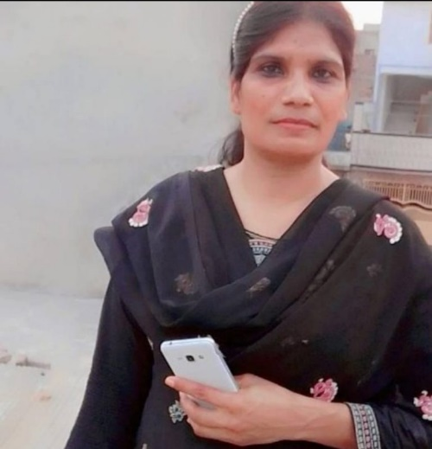
Shagufta Kiran has been waiting for trial in Central Jail Rawalpindi in Pakistan since she was arrested in July 2021 under the notorious sections 295/6 of the country’s penal code. Her offence was allegedly forwarding a WhatsApp message containing blasphemous content, which she did not author and claims not to have read. A Christian and former nurse, Shagufta is married with four children. The fear of reprisals has forced the family into hiding. At least part of the time held in solitary confinement, she is likely to face the death sentence until this can be challenged in the Supreme Court.

Background
A number of Christians have spent years on death row in Pakistan for alleged blasphemy. A well-known case was the Punjabi farm labourer Asia Bibi. Since 1986, more than 1,000 people have been accused under the blasphemy laws. Over 50% of those cases involve religious minorities, including Ahmadis, Sikhs and Hindus as well as Christians. Although no- one has been executed under the laws, many of those accused, their lawyers and any persons speaking out against blasphemy laws and proceedings have become victims of lynching or street vigilantism.
Since 1990 extremists have murdered at least 65 people over blasphemy allegations, including lawyers, two judges and over fifty defendants on release (at least 15 of whom were Christians). Once an accusation has been made, some extremists see it as their duty to kill the person concerned, whether or not their guilt has been proved. Defence lawyers face threats of violence and judges are often afraid to hear prominent cases, knowing their lives are in danger. Extremist organisations often bring busloads of demonstrators to intimidate those involved in legal proceedings. A Human Rights Commission of Pakistan lawyer was shot dead in May 2014 for defending a university lecturer accused of blasphemy. [Source: Church in Chains]

Please send a (non-religious) message (do not mention ACAT) to:
Shagufta Kiran
Central Prison Rawalpindi (Adiala Jail)
Adiala Road
Dahgal
Rawalpindi 46606
Pakistan

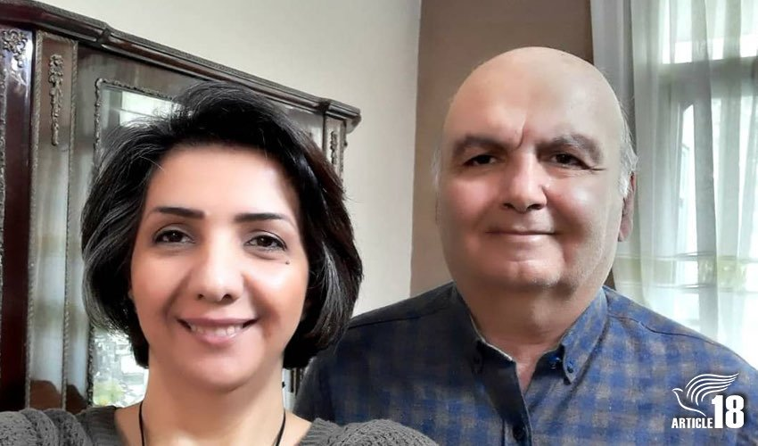
Sara Ahmadi and her husband Homayoun Zhaveh (who has advanced Parkinson’s disease) are Christian converts from Islam who were sentenced in 2020 to eight and two years respectively for their house-church activities in Iran – Sara for leadership and Homayoun for membership. Charges against the couple included ‘action against national security’ through membership of ‘Zionist missionary Christianity’ groups, and Sara was charged with ‘running illegal groups’. They are serving their sentences in separate sections of Tehran’s Evin prison. They have also been banned from foreign travel or membership of any social or political group for two years after their release and given six months’ community service at a centre for people with learning disabilities. In September 2022 Homayoun was reportedly denied medication in prison.

Please send two separate messages (non-religious, do not mention ACAT) to:
Sara Ahmadi
Evin Detention Centre
Tehran Province
Tehran
District 2
Islamic Republic of Iran

and to:
Homayoun Zhaveh (as above)

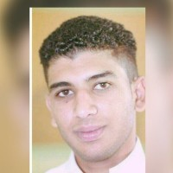
In August 2014 Tarut Island police (Saudi Arabia) arrested 18-year-old Abdullah Al-Derazi on the street and beat him severely. During detention he was beaten and tortured to extract a confession, which he was also tricked into signing. During three years of pretrial detention he was held incommunicado for three months, denied access to a lawyer and was kept in solitary confinement for a period. Following a farcical trial he was sentenced to death in 2018 and the verdict upheld in August 2022. The forced confession provided the only evidence of guilt of the several charges placed against him. These included taking part in protests, damaging property, and participating in the formation of a terrorist cell aimed at destabilizing the country’s internal security. In such circumstances Saudi prosecutors are known for fabricating and exaggerating criminal charges and for including earlier offences when the defendant was a minor.

Please send a non-religious greeting (do not mention ACAT) to:
Abdullah Al-Derazi
Al-Mabaheth Prison
(General Investigations Directorate)
Dammam
Saudi Arabia

Background
In an interview with the American magazine The Atlantic on 3 March 2022, Saudi Crown Prince Mohammed bin Salman claimed that Saudi Arabia has ‘eliminated’ the death penalty, except for one category mentioned in the Qur'an, which is related to murder. Between January and June 2022 the state executed 120 people. These included 81 individuals on 12 March 2022 in what is regarded as the largest mass execution since the country’s foundation. More than half of the victims had not been charged with murder. [Sources ESOHR, ALQST]

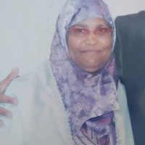
Mahdia Marzougui is a Tunisian nurse who began working in Medina, Saudi Arabia, in 2008. In July 2020 she was arrested and held in investigative detention for almost ten months before appearing before a court in April 2021. Her country's consulate did not intervene and did not appoint a lawyer for her. She was charged with praising a ‘terrorist organisation’ and ‘destabilising the social fabric’ on Twitter and Facebook. The postings were in fact general news and her followers on social media numbered 86. In January 2022 she was sentenced to three and half years in prison, with a one-year suspended sentence, to be followed by deportation. Then in September/October 2022 the sentence was extended to 15 years. Other activists, including Salma al-Shehab and Noura al-Qahtani, have had similar experiences.
Please send a non-religious greeting (do not mention ACAT) to:
Mahdia Marzougui
Sha’ar Prison
Asir
Bariq
Saudi Arabia

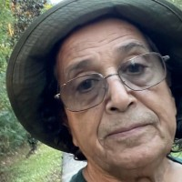
Saad Ibrahim Al-Madhi, a dual US-Saudi American citizen, was arrested in November 2021 when travelling from Florida to Riyadh to visit his family. In October 2022 he was sentenced to 16 years in prison for posting 14 tweets on Twitter, allegedly attempting to destabilize the kingdom and supporting terrorism. The tweets included criticism of the demolition of parts of the old neighbourhoods in Jeddah and Mecca, concern over poverty in the kingdom, and a reference to the murdered Saudi journalist Jamal Khashoggi. The prosecutors initially asked for a 42-year prison sentence, then a 16-year sentence and a travel ban for a further 16 years. His conditions of detention are unclear, but his family claim that they amount to torture. He has also been held in solitary confinement. His prison is a political, maximum-security prison, the largest in Saudi Arabia and one of five built in response to terrorism threats.

Please send a non-religious greeting (do not mention ACAT) to:
Saad Ibrahim Al-Madhi
Al-Ha’ir Prison
Riyadh 14761
Saudi Arabia

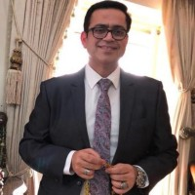
At the time of writing Palestinian national Dr Hani al-Khudari continues to be detained in Saudi Arabia despite the expiry of his sentence on 28 February 2022. On 8 March 2020 he and his father, Dr Mohammed al-Khudari, were charged in a mass trial of 68 persons before the Specialized Criminal Court with ‘joining a terrorist entity’, understood to be Hamas (the charges were described by Amnesty International as ‘trumped up’). The trial was marred by numerous and serious violations of due process rights, including enforced disappearance, arbitrary arrest and incommunicado detention, and solitary confinement. Dr Hani al-Khudari was also denied access to medical care for gallstones. Dr Mohammed al-Khudari was released in October 2022, seven months after the expiry of his sentence and following three years of arbitrary detention.
The arrests of the two Palestinian nationals are part of a wider crackdown by the Saudi Arabian authorities on Palestinian, Jordanian and Saudi Arabian nationals residing in Saudi Arabia with a perceived link to Hamas. Dr Hani al-Khudari is believed to be in Abha Prison.

Please send a non-religious greeting (do not mention ACAT) to:
Dr Hani al-Khudari
Abha Prison
Al Muruj
Abha 62527
Saudi Arabia

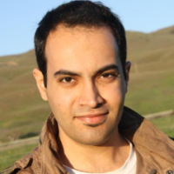
Abdulrahman al-Sadhan is a Saudi national who holds a university degree in business and worked as an assistant to the Head of the Saudi Arabian Red Crescent Society in Riyadh. Arrested in 2018, he was sentenced in March 2021 to 20 years in prison for, among other things, ‘supporting a terrorist entity (ISIS)’, ‘preparing, storing and sending what would prejudice public order and religious values, adopting an extremist approach calling for the exclusion of women and depriving them of the rights guaranteed to them by law’ and ‘offending state institutions and officials and spreading false rumours about them’. The evidence comprised tweets extracted from satirical twitter accounts and a confession, almost certainly made under torture/duress. During various hearings, he had little or no access to a court-appointed lawyer. Reports indicate that during his detention Al-Sadhan was subjected to severe torture and sexual harassment including but not limited to electric shocks, beatings that caused broken bones, flogging, suspension in stress positions, death threats, insults, verbal humiliation and solitary confinement. His health has deteriorated in detention, and he is now pre-diabetic, a condition he did not suffer from prior to his arrest.
Background
The so-called Specialized Criminal Court is notorious for using the Saudi Counter-Terrorism and Anti-Cybercrime Laws in order to subject peaceful activists, religious clerics and members of the Shi’a minority to grossly unfair trials, hand out lengthy prison sentences and sentence people to death based on confessions extracted under torture. Al-Ha’ir is the largest prison complex in Saudi Arabia and houses both men and women. Facilities include isolation cells, and physical torture rooms.

Please send a (non-religious) greeting (do not mention ACAT) to:
Abdulrahman al-Sadhan
Al-Ha’ir Prison
Riyadh 14761, Saudi Arabia

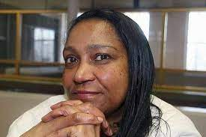
Linda Carty is a Kittian American with UK citizenship. A former school teacher, she has been on death row in Texas since 2002, when she was sentenced to death for the abduction and murder in 2001 of 25-year-old Joana Rodriguez in order to steal Rodriguez's new-born son, Ray. Carty claims she was framed by drug dealers because she had previously been an informant. Joana was kidnapped, suffocated to death and found in the boot of Linda’s car. Prosecutors claim Linda was so desperate for a baby that she sought to kidnap Joana and keep baby Ray for herself. Carty has claimed throughout that she was framed by three men for her work as an informant with the Drug Enforcement Administration. The other co-defendants in the kidnapping and murder case were given prison terms but none received the death penalty after testifying against Carty. She has featured in a number of appeals and campaigns since 2017.
If executed, Carty would become the first female British national to be put to death since Ruth Ellis in 1955 and the first British Black woman executed in over a century. Barrister Hugh Southey QC has campaigned for Linda’s release for over ten years and cites a lack of DNA evidence linking the convicted grandmother to the crime. [Picture: Evening Standard]

Please send a greeting to:
Linda Carty
Mountainview Unit
2305 Ramson Road
Gatesville
Texas 76528
USA

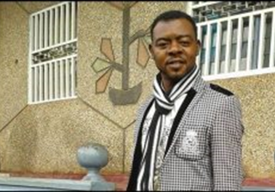
Mancho Bibixy was arrested in the dead of night on 17 January 2017 and is now six years into a 17-year sentence at Kondengui Central Prison in Yaoundé, Cameroon. Broadcasting from a popular radio station, he was convicted of crimes against the state and spreading false information. Tortured, ill-treated and in poor health, his original 15-year sentence was increased in 2021 after he complained about poor prison conditions. He was considered a leader of a peaceful demonstration against the marginalization of the English-speaking minority and has featured in ACAT appeals since Christmas 2019. In January 2021 he emailed us to say that the messages of encouragement he has received from us have helped him considerably.
Please send a greeting (religious or non-religious, and you can mention ACAT) to:
Mr Mancho Bibixy
Yaoundé Central Prison
1000 Yaoundé
Cameroon

REMEMBER IN YOUR PRAYERS
Chau Van Kham, an elderly prisoner in Vietnam, serving 12 years for peaceful protests against the regime.
Oumar Sylla and Ibrahima Diallo, two pro-democracy leaders arbitrarily detained and in poor health in Conakry prison, Guinea, known for its harsh conditions.
Shagufta Kiran, a Christian former nurse arrested for alleged blasphemy in Pakistan and likely to face the death sentence.
Sara Ahmadi and her husband Homayoun Zhaveh, who has advanced Parkinson’s disease, serving prison sentences in Iran for house-church activities.
Abdullah Al-Derazi, beaten and tortured at the age of 18, tricked into signing a forced confession and sentenced to death for protesting in Iran.
Mahdia Marzougui, a Tunisian nurse, held in detention for ten months and sentenced to three and half years in prison in Saudi Arabia for posting messages on social media.
Saad Ibrahim Al-Mahdi, a dual US-Saudi citizen, allegedly tortured and sentenced to 16 years in prison for social media posts held to be attempts to destabilize the kingdom.
Dr Hani al-Khudari, a Palestinian detained in Saudi Arabia beyond expiry of his prison sentence, given for alleged support of terrorism.
Abdulrahman al-Sadhan, following severe torture and a sham trial, sentenced to 20 years in prison in Saudi Arabia for supporting terrorism.
Linda Carty, a US-UK dual national, sentenced to death in Texas, USA, following a flawed trial in 2002 for the abduction and murder of a child.
Mancho Bibixy, tortured, ill-treated and in poor health, serving a 17-year sentence for protesting peacefully for the rights for English-speakers in Cameroon.
A Prayer for Prisoners of Conscience
Let us pray for the tortured,
for prisoners of conscience,
people imprisoned without a just trial,
for the innocent who have been swept away
from family and community in raids at dead of night.
Surely we, who take the gift of freedom for granted,
Should often hold them up before God the all-merciful.
[www.stpeterschurchfairwater.org.uk]
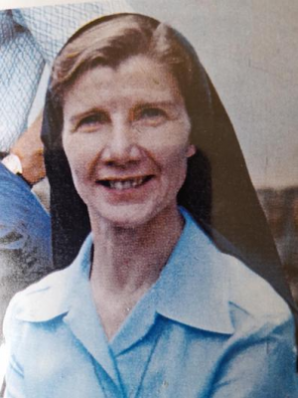
Sr Joan Sawyer was a Columban Sister from Belfast who was killed with seven prisoners at Lurigancho Prison, Lima, Peru on 14 December 1983 after being caught up in a hostage crisis. As prisoners and hostages tried to leave the prison in an ambulance, police fired a hail of bullets and stopped them. The Cross still stands there, bleak and bare near the main road to Lurigancho Prison in Lima. No Mataras, the inscription reads. You shall not kill. People come to stand or kneel there, to bring flowers, to pray. The prison remains, as drab, as unwelcoming, as overcrowded as when Joan walked the corridors. Lurigancho holds thousands of men, young and old, all hoping for a better life, for freedom. Men that Joan knew and loved, men who called forth the best in her, who knew that her gentleness would never fail, knew she would never give up on them.

Keep in mind those who are in prison
as though you were in prison with them
and those who are being badly treated
since you too are in the one body.
Hebrews 13:3
[Columban Sisters - www.columbansisters.org/]

