EASTER GREETINGS CAMPAIGN
Please write a simple message to the individual saying, for instance, that you are thinking of him/her and/or perhaps urging them not to lose hope (or words to that effect). A picture postcard ― in an envelope if you choose ― is always welcome and cheapest to send. You can include your name and address but do not mention ACAT or include a religious greeting or motif if so advised, since communication from a foreign organisation can endanger the prisoner. Some individuals featured in previous campaigns have been released; others are less fortunate, and we must not forget them. Changes in their circumstances are described, where known. As usual we include a couple of human rights groups. For individual prisoners and/or their families, it is heartening to receive fairly regular cards of encouragement, but please read the special guidelines below for posting greetings to certain countries. Do not feel obliged to respond to every appeal case. Postage overseas is expensive: As of October 2025 sending a letter or card weighing up to 100g overseas from the UK costs £3.40.

Guidelines for sending greetings to certain countries
Writing to a prisoner in China requires attention to detail to ensure the letter/card reaches the recipient. We recommend writing the address in both English and Chinese characters. The latter can be copied and pasted directly onto the greetings envelope/card and is repeated at the end of the newsletter. This also applies to some other languages. A prisoner may never be allowed even to hold the physical letter, but the fact that he/she is receiving mail from abroad is noted by prison staff, which may lead to better treatment, as it signals that the world has not forgotten him or her. In no circumstances, however, must the greeting refer to ACAT, any organisation or church, or make any political or religious reference. Censors will immediately discard the message.
Prisons in the UAE often do not allow prisoners to receive physical mail (this sometimes applies to Egypt too). We recommend writing to the embassy, asking them to forward a short greeting to the prisoner and enquiring about conditions and welfare. This creates a diplomatic record which may help the prisoner.

GROUPS

Justice Defenders is an international charity that trains incarcerated individuals and prison staff as paralegals and lawyers, aiming to provide access to justice (legal representation) for those denied it, especially in Kenya and Uganda. They offer accredited law programmes in partnership with universities and work for systemic change within the justice system, addressing issues such as unlawful detention and inadequate legal representation.

Please send a greeting to:
Justice Defenders
c/o Bryden Johnson
Kings Parade, Lower Coombe Street, Croydon CR0 1AA
Their email address is via subscription at:
https://www.justice-defenders.org/contact-us
(Use only if you are willing to receive messages from them.)


Asylum Welcome is a small local group that offers information, advice and practical support to asylum seekers, refugees and vulnerable migrants living in Oxfordshire. They help adults, young people and families to feel safe, respected and understood as members of a diverse community.

Please send a greeting to:
Asylum Welcome
Unit 7, Newtec Place, Magdalen Road, Oxford OX4 1RE
Tel: 01865 722082, Fax: 01865 792532
Email: welcome@asylum-welcome.org

INDIVIDUALS

Please send a message to Anas el-Beltagy, Egypt.
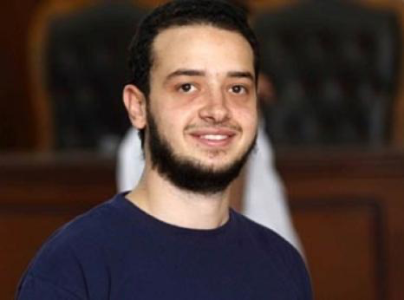
Anas el-Beltagy remains in arbitrary detention in Egypt, where he has been held since December 2013, primarily because his father was a leading member of the Muslim Brotherhood and sat in parliament. Although repeatedly acquitted and ordered for release, prosecutors have kept him in detention by adding new charges ― known as ‘rotation’, this practice is often used to maintain indefinite detention. During his detention Anas has been tortured and ill-treated, including being held in a small iron cage. He has also been held in prolonged solitary confinement and forced to sleep on a concrete floor. In the Tora Prison Complex south of Cairo he continued to be subjected to torture and other ill-treatment, including prolonged solitary confinement. For a time he was in Badr 3 Prison, which is notorious for suicide attempts, torture, and ill-treatment such as denial of healthcare, exposure to extreme cold, constant surveillance, and bombardment with bright lights 24 hours a day, not to mention lack of outdoor exercise and contact with other prisoners. Anas has also been in solitary confinement and on hunger strike in his current location.

Please send a non-religious message (do not mention ACAT) to:
Anas el-Beltagy
10th of Ramadan Reform and Rehabilitation Centre
Cairo–Ismailia Desert Road
Nr Belbeis
Sharqia Governorate,
EGYPT

Please send a message to Oqba Hashad, Egypt.
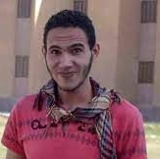
Oqba Hashad, an Egyptian student, remains in pretrial detention at the 10th of Ramadan Prison in Egypt, where he has been held for over six and a half years. This exceeds the two-year legal limit for pretrial detention under Egyptian law. Although a judge ordered his release in February 2024, it was circumvented by the practice of ‘rotation’ (repeatedly adding new charges). The charges levelled against him included "joining a group formed against the rule of law” and “participating in demonstrations to overthrow the regime", but his detention is also attributed to the human rights activism of his brother, Amr Hashad.
Held incommunicado for 77 days, Oqba Hashad was suspended naked by his arms from the ceiling, beaten, dragged on the ground by a rope around his neck, insulted, and subjected to electric shocks. Despite needing a prosthetic leg due to a childhood amputation, he has been denied a replacement (needed after his prosthesis broke in August 2022) and essential medicine and antiseptics required for the care of his stump have been withheld. He has suffered from severe back pain and spinal issues due to sleeping on prison floors and being forced to move without even a wheelchair. Authorities have reportedly denied him access to the necessary antiseptics and sterilization tools required to care for his amputation stump, raising fears of infection.

Please send a non-religious message (do not mention ACAT) to:
Oqba Hashad
10th of Ramadan Reform and Rehabilitation Center
Cairo–Ismailia Desert Road
Nr Belbeis
Sharqia Governorate,
EGYPT

Please send a message to Zeynab Jalalian, Iran.
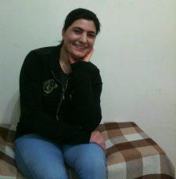
Zeynab Jalalian remains in Yazd Central Prison in Iran, where she is serving a life sentence for her work on behalf of Kurdish women and girls. She is currently the longest-serving female political prisoner in the country, having been in detention since February 2008. In late September 2025, following significant international pressure, Jalalian was transferred to a private hospital in Yazd to undergo fibroid embolization surgery for uterine myomas. She was returned to prison just 24 hours after the operation, despite requiring post-operative care and continued medical supervision. She continues to suffer from multiple chronic conditions.

You can send a short greeting or write a longer message to her at the following address:

Zeynab Jalalian
C/o KMMK-G/Taimoor Aliassi
Action NDV 2024
21, rue Antoine-Carteret
1202 Geneva
SWITZERLAND

Alternatively, while there is no official address for Yazd Central Prison, communication with prisoners may be attempted via the central administration of the prison at the following location:

Zeynab Jalalian
C/o The end of Imam Khomeini Avenue
Past Imam Reza Square,
Adjacent to the Central Prison, Yazd, Iran.
Post Code: 8914813191
ISLAMIC REPUBLIC OF IRAN

Please send a message to Ahmed Mansoor, UAE
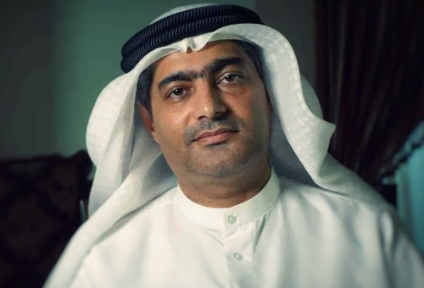
Ahmed Mansoor, the Emirati human rights defender and blogger, remains imprisoned in the UAE. His situation has worsened, with a new 15-year sentence upheld in March 2025 from a separate mass trial in July 2024. This comes on top of his earlier 10-year term (NL Dec 2019-Feb 2020), when he was sentenced in a closed trial to 10 years in prison in 2018 for “insulting the status and prestige of the UAE and its symbols" ― including its leaders ― after making peaceful calls for reform. He is held in Al Sadr prison in Abu Dhabi, in prolonged solitary confinement in an isolation ward, with reports of a tiny cell, no bed, no running water in the cell, and extremely limited access to showers or exercise. Under these conditions and after hunger strikes he is in very poor health.

UAE prisons do not often allow prisoners to receive printed or written mail. In this case please write a short greeting to Ahmed Mansoor via the following UK embassy address, asking also for an update regarding his welfare. This creates a diplomatic record and may help the prisoner.

His Excellency Mr Mansoor Abdullah Khalfan Juma Abulhoul
Embassy of the United Arab Emirates
1 - 2 Grosvenor Crescent London SW1X 7EE
Tel: 020 7581 1281
Fax 0207 808381
Webite: www.mofaic.gov.ae/en/missions/london
Salutation: Your Excellency / Dear Ambassador

Please send a message to Xu Zhiyong, China.
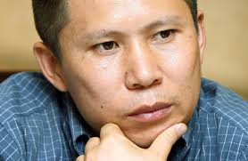
Xu Zhiyong, a prominent legal scholar and civil rights activist in China, remains imprisoned in Lunan Prison in Shandong Province. He is currently serving a 14-year sentence for "subversion of state power". He is in poor health following a hunger strike (for 25 days in October 2024). He was protesting against "inhumane treatment", which included being stripped of his name (referred to only as "Prisoner No. 003"), being denied the right to correspondence with family, and constant surveillance by other inmates (even in the restroom). Recent updates highlight a significant decline in his health and ongoing struggles with prison authorities regarding his treatment and communication rights. (NL Dec 2023-Feb 2024, picture HRW)

A suggested greeting is:
"We are thinking of you. Do not lose hope."
Chinese: 我们一直惦记着你。不要失去希望。

Xu Zhiyong  Lunan Prison  Linshu County  Linyi City  Shandong Province  276700  PEOPLE’S REPUBLIC OF CHINA | 山东省临沂市临沭县  鲁南监狱  许志永 (收)  邮编：276700  PEOPLE’S REPUBLIC OF CHINA

Please send a message to Saïda El Alami, Morocco.
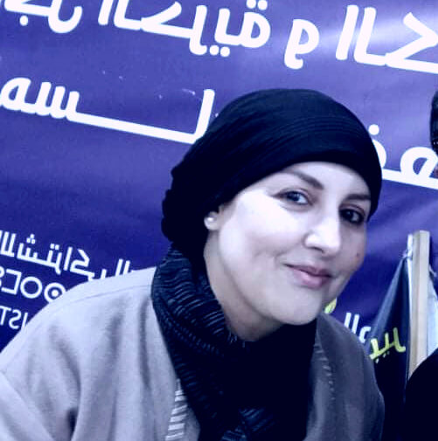
Saïda El Alami is serving a three-year prison sentence at Oukacha Prison, Casablanca (sentence upheld in December 2025). Following a brief release by royal pardon in 2024, she was re-arrested in July 2025 and re-convicted for "insulting a legally constituted body [and] the judiciary" and "publishing and broadcasting false allegations" after criticising online the handling of a death in police custody (2022). The prison (Ain Sebaâ 1 prison) has refuted allegations of physical assault and threats by prison guards, attributing marks on her hand to a blood test. She also went on hunger strike during her trial in July 2025. (See also our Christmas 2025 campaign).
Here are suggestions for a simple greeting (French in brackets). Using French increases the chances of the greeting passing the censors.
I am writing to you to send you a message of friendship and solidarity. Please know that you are not forgotten and that many people are thinking of you. (Je vous écris pour vous envoyer un message d'amitié et de solidarité. Sachez que vous n'êtes pas oubliée et que de nombreuses personnes pensent à vous.)
I wish you much courage and strength in these difficult times. (Je vous souhaite beaucoup de courage et de force dans ces moments difficiles.)
With my warmest wishes for your well-being. (Mes vœux les plus chaleureux pour votre bien-être). [Signed:…..]

Send a message to her in the prison or c/o her lawyer:
Saïda El Alami  Prison Oukacha Aïn Sebaâ 1 (Oukacha)  Route Ouled Ziane  Casablanca  20000 MOROCCO | Saïda El Alami  c/o Maître Souad Brahma  4, Boulevard Mohamed V  Résidence Al Mahatta  Appartement 42, 26100 Berrechid  MOROCCO
Write "Lettre de Soutien" (Support Letter) on the card/envelope. This helps categorise it as non-legal personal correspondence.

Please send a message to Shagufta Kiran, Pakistan
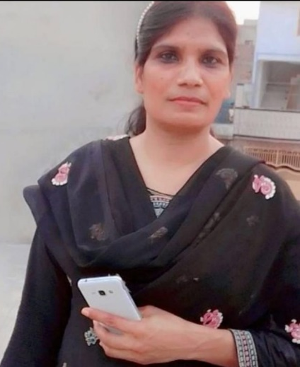
Former nurse, mother and Christian Shagufta Kiran remains in solitary confinement (for her own protection) after she was arrested (2021) and sentenced to death (2024) for blasphemy. The charge is that she allegedly forwarded a WhatsApp message containing blasphemous content. She is currently in a solitary "protection cell" until the sentence can be challenged in the Supreme Court, and her family remain in hiding. Judicial hearings in blasphemy cases face extreme pressure from hardline religious groups in Pakistan. Her case is seen as a major test of the country's Prevention of Electronic Crimes Act (PECA). Her defence argues that the fact she was not the author of the WhatsApp content and claims not to have read it should legally protect her from a death sentence. Other, minor charges have also been filed. (Last featured Easter 2023)

Writing to Shagufta Kiran requires extreme caution. Due to the sensitive nature of blasphemy charges, her mail is subjected to intense scrutiny.
Please send a non-religious greeting (do not mention ACAT) to:
Shagufta Kiran  Central Jail Rawalpindi (Adiala Jail)  Adiala Road  Dahgal Rawalpindi  Punjab  PAKISTAN | Address in Urdu  (also see back page)  شگفتہ کرن سینٹرل جیل اڈیالہ  اڈیالہ روڈ راولپنڈی  پنجاب پاکستان  PAKISTAN
Write the address in both English and Urdu to ensure it is handled correctly by local postal and prison staff.

Please send a message to Barrister Tureen Afroz, Bangladesh

In February 2026 Barrister Tureen Afroz was arrested for “criminal complicity”, primarily in the shooting of protesters during the ‘Monsoon Revolution’ of 2024, when around 1,400 were killed following a deadly crackdown on student-led protests against the ousted Sheikh Hasina’s administration. Her lawyers argue that the charges ―which also include fraud ― are politically motivated by political factions that have gained power since the 2024 uprising and are targeting her for her previous role as a leading prosecutor of Islamist and opposition leaders. There are credible reports that she was subjected to severe physical and psychological abuse while in police custody, when she was viciously beaten with lathis (batons) on her thighs and legs, kicked, slapped, punched, and subjected to repeated physical assaults on the back parts of her body. [Picture: jagonnews.com]

Directly contacting a prisoner normally requires a prisoner ID number, which is not publicly available for Tureen Afroz. The following details are, however, recommended.

Please send a non-religious greeting (do not mention ACAT) to:

Prisoner: Barrister Tureen Afroz
Father's Name: Late Taslim Uddin Ahmed
Dhaka Central Jail
Rajendrapur
Teghoria Union
Keraniganj Upazila
Dhaka District.
BANGLADESH

Please send a message to Ulviyya Guliyeva, Azerbaijan.


Ulviyya Guliyeva, an Azerbaijani independent journalist, photographer and human rights defender, is currently arbitrarily detained in connection with the so-called Meydan TV Case – a sweeping crackdown on independent media. She was arrested on 6 May 2025 after a police raid on her home and placed in the Baku Pre-trial Detention Centre under highly restrictive conditions. The International Federation for Human Rights and OMCT have raised serious concerns that her detention is part of politically motivated prosecutions targeting journalists in Azerbaijan.
While in police custody, Ulviyya reported being beaten by several officers and subjected to explicit rape threats intended to coerce her into revealing passwords to her electronic devices – a form of torture and sexual violence prohibited under international law. She also endured a violent apartment search conducted without legal counsel present, and allegations of fabricated evidence later used against her. After her arrest, she experienced severe headaches, vomiting, dizziness and fainting, symptoms linked to assault and the denial of medical care, which authorities have repeatedly failed to provide.
These abuses reflect a broader pattern affecting civil society actors in Azerbaijan’s crackdown on free expression and independent media. The authorities have also refused to conduct an independent investigation into these allegations, violating domestic and international obligations under the European Convention on Human Rights and the Convention Against Torture.

Please send a non-religious message (do not mention ACAT) to:

Ulviyya Guliyeva
Kurdakhani Pre-Trial Detention Centre No.1
Sabunchu District, Zabraat-2 settlement
Bakı İstintaq Təcridxanası
REPUBLIC OF AZERBAIJAN

Please send a message to Golrokh Ebrahimi Iraee, Iran.

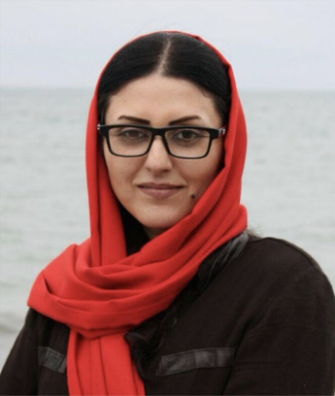
Golrokh Ebrahimi Iraee has been repeatedly detained and imprisoned by Iranian authorities for her peaceful human rights work, including protests against executions and advocacy on behalf of prisoners’ rights. She was first arrested in November 2019 and taken to Qarchak Prison in Varamin near Tehran, before being transferred after interrogation by the Islamic Revolutionary Guard Corps (IRGC) to other facilities including Ward 2A of Evin Prison, and Amol Prison in northern Iran. Her detention has been marked by denial of access to family visits and lawyers, physical assaults during transfers, and ill-treatment in custody.
Although she was released from Amol Prison in May 2022 after serving part of earlier sentences, she has since faced more charges, including “gathering and colluding against national security” and “propaganda against the state”, indicating ongoing legal peril. Throughout her imprisonment and interrogations, she was denied visits, subjected to harsh conditions and transfers, and separated from her husband, fellow human rights defender Arash Sadeghi, who is himself imprisoned and suffering from serious illness. Various rights groups recognise Iraee as a prisoner of conscience whose repeated detention and mistreatment reflect systematic reprisals by the Iranian state against peaceful activism.

Please send a non-religious message (do not mention ACAT) to:
Golrokh Ebrahimi Iraee
Zendān-e Evin (Evin Prison)
Shahid Kachoui Street
Tehran Province
Q9WP+99
ISLAMIC REPUBLIC OF IRAN

Please send a message to Abir Moussi, Tunisia.

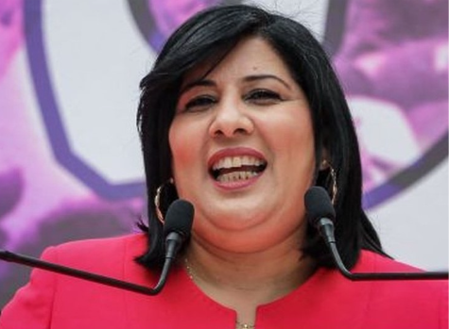
Abir Moussi, a lawyer and president of the Free Destourian Party, has been in prison since 3 October 2023 solely for peacefully exercising her rights to freedom of expression and assembly as an opposition figure critical of President Kais Saied’s rule. Abir’s arrest followed an attempt to submit an appeal against presidential decrees ahead of local elections — a lawful act, however security forces arbitrarily detained her, holding her in undisclosed locations before placing her into pre-trial detention. Her detention is part of a broader crackdown on dissent and the arbitrary use of politically motivated prosecutions to silence critics.
Abir Moussi has been charged under Article 72 of the Penal Code with offences including “attempting to change the form of government,” carrying the death penalty, despite video evidence and witness testimony showing she was peacefully protesting. She was first sentenced in August 2024 under Decree-Law 54 for criticising the electoral process, a highly vague law used to punish dissent. A later court upheld additional politically driven sentences. Abir reportedly faced harassment and punitive transfers between prisons, including from Manouba Prison in Tunis to Prison Civile de Bulla Regia in Jendouba — both far from her family and legal counsel, undermining her right to adequate defence and access to healthcare. There are concerns about lack of adequate medical care, exposure to substandard conditions, and the disregard of her health needs.

Please send a non-religious message (do not mention ACAT) to:
Abir Moussi
Prison Civile de Bulla Regia
Province de Jendouba
Bulla Regia
HQ57+RXX
TUNISIA

Please send a message to Linn Htut, Myanmar (Burma).
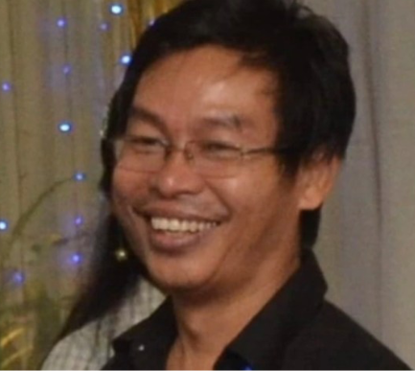
Linn Htut, the former Shan State Chief Minister and a member of the National League for Democracy (NLD), was arrested on 1 February 2021 during the Myanmar military’s nationwide coup. He was reportedly taken without a warrant, held incommunicado, and subjected to torture which included sleep deprivation, prolonged interrogation, and other ill-treatment in an attempt to extract a false confession. Military officers allegedly told him that he would be released if he agreed to support the junta, a demand Htut refused.
After being moved between secret detention and solitary confinement, Htut stood trial in proceedings inaccessible to his family and media. He was sentenced between January and November 2022 to 20 years imprisonment with hard labour on trumped-up charges of corruption and electoral fraud – charges widely seen as politically motivated. Now 65, Htut suffers from diabetes, hypertension, arrhythmia, and severe pain, conditions that have worsened due to lack of adequate medical care in Tharyarwaddy Prison, where detainees routinely endure poor hygiene, neglect and abuse.
In June 2025, the UN Working Group on Arbitrary Detention found his detention arbitrary and called for his immediate release. With reports that at least 1,800 people have died in custody since the coup, including many political prisoners, his life remains at grave risk.

Please send a non-religious message (do not mention ACAT) to:

Linn Htut
Tharyarwaddy Prison
Bago Region
MQ6X+F2P
MYANMAR (BURMA)

Please send a message to Cãn Thi Thêu, Vietnam.


Cãn Thi Thêu, a respected Vietnamese land rights activist and human rights defender, has been imprisoned for five years in Prison No. 5 in Thanh Hoa Province for peacefully documenting and protesting forced land seizures and human rights violations. She and her family were arrested in June 2020 after reporting on a violent government raid in Dong Tam Village; Thêu and her son Trinh Bá Tu were later sentenced to eight years’ imprisonment, and another son, Trinh Bá Phuong, to ten years, under Article 117 of Vietnam’s Criminal Code for “opposing the state”. Their convictions follow a decade of activism against land grabs that have impacted many rural communities.
Reports indicate Thêu has been subjected to torture and inhumane treatment, including poor detention conditions, and continues to suffer lingering health problems from earlier mistreatment, such as chronic eye infection caused by crowded, poorly ventilated cells and lack of water. She has recently fallen ill with symptoms consistent with a stroke and has been denied adequate medical care and regular family contact, heightening fears for her wellbeing. Human rights organisations stress that she is a prisoner of conscience, detained solely for exercising her rights to freedom of expression and peaceful assembly, and should be immediately and unconditionally released.

Please send a non-religious message (do not mention ACAT) to:
Cãn Thi Thêu
Thanh Hoa Prison No. 5
Yên Tâm, Yên Định district
Thanh Hoa Province
2GJ4+2X
VIETNAM

Please send a message to Narges Mohammadi, Iran.

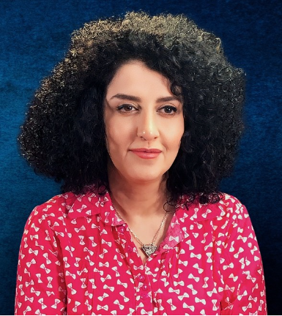
Narges Mohammadi, a 2023 Nobel Peace Prize laureate and Iranian human rights defender, is facing grave risk to her health due to deliberate denial and delay of adequate medical care by Iranian authorities – a common tactic used as punishment and linked to her peaceful activism. She has serious heart and lung conditions and requires ongoing specialised treatment and monitoring which prison and prosecution officials have deliberately obstructed. Many human rights organisations note that access to urgent care has been conditioned on her compliance with Iran’s discriminatory compulsory veiling laws, which she refused on principle.
Mohammadi has been repeatedly arbitrarily detained, convicted and sentenced in multiple cases arising solely from her human rights work, including documenting sexual violence against detained women, and supporting nationwide protests for Woman, Life, Freedom. She has spent many years in custody under harsh conditions, such as prolonged solitary confinement and access restrictions affecting lawyers and family, which have aggravated her health issues. Her imprisonment has continued through overlapping sentences, and she has recently been handed an additional multi-year prison term amid broader repression of dissent in Iran. Multiple human rights bodies and the Norwegian Nobel Committee have condemned her treatment as cruel and life-threatening, emphasising that she is a prisoner of conscience detained for exercising fundamental rights.

Please send a non-religious message (do not mention ACAT) to:
Narges Mohammadi
Zendān-e Evin (Evin Prison)
Shahid Kachoui Street
Tehran Province
Q9WP+99
ISLAMIC REPUBLIC OF IRAN

ADDRESSES AND GREETINGS TO COPY AND PASTE

For Xu Zhiyong, China
我们一直惦记着你。不要失去希望
(We are thinking of you. Do not lose hope.)

Xu Zhiyong  Lunan Prison  Linshu County  Linyi City  Shandong Province  276700  PEOPLE’S REPUBLIC OF CHINA | 山东省临沂市临沭县  鲁南监狱  许志永 (收)  邮编：276700  PEOPLE’S REPUBLIC OF CHINA

For Shagufta Kiran, Pakistan (URDU)
ہم آپ کے بارے میں سوچ رہے ہیں۔ امید مت ہارو۔
(We are thinking of you. Do not lose hope)

Shagufta Kiran  Central Jail Rawalpindi (Adiala Jail)  Adiala Road  Dahgal Rawalpindi  Punjab  PAKISTAN | شگفتہ کرن سینٹرل جیل اڈیالہ  اڈیالہ روڈ راولپنڈی  پنجاب پاکستان  PAKISTAN

REMEMBER IN YOUR PRAYERS
Mohammed Adel, imprisoned in Egypt on bogus charges; on hunger strike, beaten, assaulted, threatened with death, and denied health care.
Dr Kizza Besigye, Ugandan opposition politician, abducted, and held in arbitrary detention under harsh conditions while denied urgent medical treatment.
Zhang Yadi, young Chinese student held incommunicado and at high risk of torture for advocating human rights for Tibetans and other ethnic groups.
Chow Hang-tung, Jimmy Lai and Owen Chow, Chinese pro-democracy activists imprisoned in solitary confinement and at risk of torture.
We pray also for the many prisoners of conscience throughout the world to whom we are sending messages of hope and encouragement.

A REFLECTION FOR EASTER
Xenia Dennen

In 2010, I flew to the Solovetsky Islands (or Solovki), within the Arctic Circle in the White Sea, ice bound for eight months of the year, but in summer often bathed in sunlight, even at midnight. To me, Solovki had a luminous natural beauty that was enchanting, but, at the same time, I had a sense of darkness as I thought of what had gone on there during the Communist period. A monastery was founded on the largest of the Solovetsky Islands in the 15th century, and developed dramatically in the next century. By the 17th century, the monastery had a library of 1500 books and 1000 icons. In the 20th century, Solovki became a place of appalling human suffering: from 1923 to 1939, it was a labour camp, and by 1930 it held more than 53,000 prisoners. About 40,000 of them are buried on the islands. A torture chamber (the Sekirka) was housed in the Church of the Beheading of St John the Baptist, on Sekirka Hill, from which 365 steps led down a steep incline to a lake below. Here, prisoners had to sit all day on poles (their feet were not allowed to touch the ground), which were fixed between the walls. If they fell off, they were beaten or were attached to a log and thrown down the steps to the lake below. Boris Shiryaev, the son of a Russian landowner, was imprisoned in Solovki from 1922 to 1929. He wrote a memoir in which he describes a Russian Orthodox priest called Fr Nikodim — known as the ‘consoling priest’ — who was a gifted storyteller and kept his fellow prisoners spellbound every evening with his stories. One Christmas, he was caught celebrating the liturgy and was imprisoned in the Sekirka where, to keep warm at night, the prisoners would form what was called a ‘stack’: four lay on their side, with another four on top crosswise and another four on top of them, like a stack of logs; their breath kept them warm.
To help the prisoners get to sleep, Fr Nikodim would tell stories “and a weight would be lifted from our hearts”, as a fellow prisoner told Boris Shiryaev. When would Fr Nikodim’s sentence come to an end, Boris asked, to which came the reply: “He’s already come to the end — on Easter Day. He led Easter matins in a corner, after which we greeted each other with ‘Christ is risen!’ We then all lay down in stack formation, and as we drifted off to sleep he told us a ‘story’ about Christ’s resurrection. In the morning, we emerged from the stack, but our ‘consoling priest’ did not get up. We tried to wake him, but he was already cold.”
During my visit in 2010, I explored the monastery buildings, the Transfiguration Cathedral, where Fr Nikodim had told his stories, and the great refectory, which had been whitewashed to obliterate the prisoners’ messages carved into the walls. I began to feel very cold. Two monks crossed this great space, disappeared into a small side chapel, and started to sing vespers: the sound lightened the weight of the place.
When I talked to the Abbot, I asked him whether he saw the monastery’s prayer as a way to help to redeem the past. He replied simply: “This is a special place; we feel that here Christ is close.” For me, Fr Nikodim and other martyrs like him are part of that presence: they help to turn the past terrible darkness into light.
This article first appeared in The Church Times of 10 October 2025 and is reproduced here by kind permission of the author and the Editor.
[Photograph: Алексей Задонский - Own work, CC BY-SA 4.0, https://commons.wikimedia.org/w/index.php?curid=42852904]

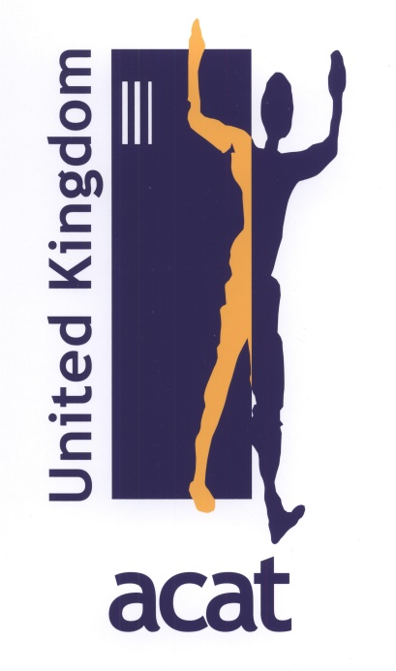 | Contacts  Dr Derek Lewis (Secretary)  25 Higher Woolbrook Park  Sidmouth, Devon, EX10 9ED  Tel: 01395 577669  Email: ukacat@gmail.com  Maurice Dyson (Treasurer)  Tel: 01624 824255  Email: mauricedyson@outlook.com

HOW YOU CAN HELP
Read our newsletters, case appeals, ideas for action, background information and prayer materials.
Join in our Christmas and Easter Campaigns and write to prisoners, victims and human rights workers.
Urge authorities to expose torture, release prisoners, improve prison conditions and bring torturers to justice.

What finer sound
Is there than a human being
Singing
Against
Cruelty, against Hate?
(Nidar Dinshaw)

Website: http://www.acatuk.org.uk
Registered Charity No.1072628
President: Revd Dr Paul Oestreicher
Patrons: Professor Lord David Alton, Revd Dr David Cornick,
Baroness Caroline Cox, Revd Dr David Deeks, Rt Revd Guli Francis-Dehqani,
Rt Revd Declan Lang, Cardinal Vincent Nichols,
Revd Canon Professor David Thompson, Rt Revd Peter Wheatley
Printed by Sidmouth Print

