CHRISTMAS GREETINGS CAMPAIGN 2025
For this campaign please write a simple card or greeting to the individual saying, for instance, that you are thinking of him/her and/or perhaps urging them not to lose hope (or words to that effect). A picture postcard ― in an envelope if you choose ― is always welcome and cheapest to send. You can include your name and address if you wish but do not mention ACAT or include a religious greeting or motif (even a Christmas tree!) if so advised, since communication from a foreign organisation can endanger the prisoner. Several individuals featured in previous campaigns have been released. Sadly others are still in prison and it is important not to forget them. Changes in their circumstances are described, where known. As usual we include a couple of human rights groups. For individual prisoners and/or their families, it is heartening to receive fairly regular cards of encouragement. Do not feel obliged to respond to every appeal case. Postage overseas is expensive: As of October 2025 sending an overseas letter or card from the UK costs £3.40 for items up to 100g.

GROUPS
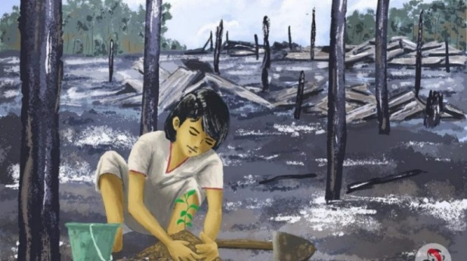
Advance Myanmar is founded and run by a team of people with decades of experience of human rights in Myanmar/Burma. Providing humanitarian assistance at times of crisis, it also assists local communities to promote positive change to tackle the root causes of those crises. It currently supports over 100 political prisoners in 36 prisons across the country. One of these was Thaik Tun Oo, who spent 20 months in prison, including one year in solitary confinement, and was tortured. Released in May 2023, he had to flee Burma, where one of his brothers was forcibly recruited to the army and later jailed for trying to escape. In Thaik’s own words: “In Burma people suffer so much. I have lots of health issues, my body is full of scars, but I am OK”.

Send a greeting to:

Advance Myanmar  110 The Bon Marche Centre  241-251 Ferndale Road  London SW9 8BJ | Email: info@advancemyanmar.org  Website: www.advancemyanmar.org

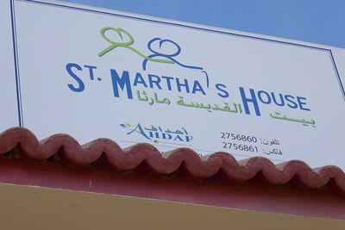
FHL is a non-political Christian Charity whose mission is to secure a resilient and enduring Christian community in the West Bank, Gaza, Israel and Jordan. In the early 20th century Christians made up roughly 29% of the population of the Holy Land. Today they account for less than 2%. Without support for the Holy places of the Bible, the birthplace of Christianity, these could become cultural museums with no Christian presence at all. FHL provide practical help directly to needy and vulnerable Christians through funding immediate relief in emergencies. They also support small projects for creating a sustainable future in the Holy Land, encourage pilgrimages to meet local Christians and maintain St Martha's House, the first day care centre for elderly women in Bethlehem. The women are mainly widows living alone and needing care, because their families have emigrated or simply can't afford to help.
Send a greeting to:
FHL (Registered Office)  Farmer Ward Road  Kenilworth  Warwickshire  CV8 2DH | Email: office@friendsoftheholyland.org.uk  Website: www.friendsoftheholyland.org.uk/

INDIVIDUALS
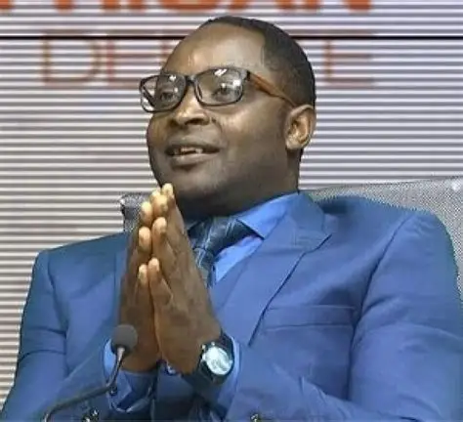
In April 2025 Abdul Karim Ali ― last featured in our Christmas Greetings Campaign 2024 ― was sentenced to life imprisonment in Cameroon. After being invited by the government to participate in mediation in a long-standing conflict with a regional English-speaking minority, he was first arrested in 2022 for reporting on the use of torture by the military. He has also denounced the practice of kidnappings, torture, and military trials in French," which he described as "unjust, inhumane, and a legacy of colonial oppression." After two years of ill-treatment, including detention in a notorious torture centre, and illegal military trials that repeatedly stalled for lack of evidence, he was convicted of "hostility against the homeland" and "secession." [Picture: www.mimimefoinfos.com]

Please send a short greeting (it can be religious and you can mention ACAT) to:

Abdul Karim Ali
Kadengui Central Prison
Yaoundé
Centre Region
Cameroon

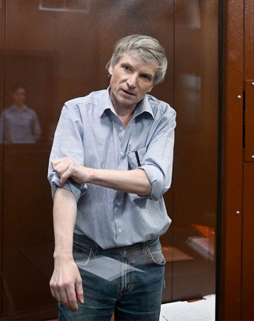
After calling in March 2022 at a municipal council session for an end to Russia’s war of aggression against Ukraine, Aleksei Gorinov was arrested and charged with ‘disseminating knowingly false information about Russian Armed Forces’ under a newly introduced criminal offence. He was the first person to receive a prison sentence (7 years) for calling the 'special military operation' in Ukraine 'a war' and stating that children were dying and made orphans as a result. By December 2023 he was seriously ill following respiratory problems after having had part of his lung removed several years ago. In 2024/25 he received three more years for allegedly “justifying terrorism” based on conversations with fellow inmates. A military court rejected his appeal in and extended his sentence to 10 years. Despite serious health problems he has been reportedly denied medication and still in solitary confinement. He featured in our last Christmas appeal.

You can send either a short greeting or letter (it can be religious and you can mention ACAT) to the following address. You may also include a return address although a reply is not guaranteed.

Alexei Gorinov
IK-10 UFSIN Rossii po Altayskomu krayu
Traktornaya Ulitsa, 26А
Rubtsovsk, Altai Krai
658207
The Russian Federation

The address in Cyrillic script is:
Исправительная колония № 10 УФСИН России по Алтайскому краю
ул. Тракторная, д. 26А г.
Рубцовск, Алтайский край 658207
Россия
[A letter in Russian would be welcome. You can use Google Translate for compiling a short text. ]

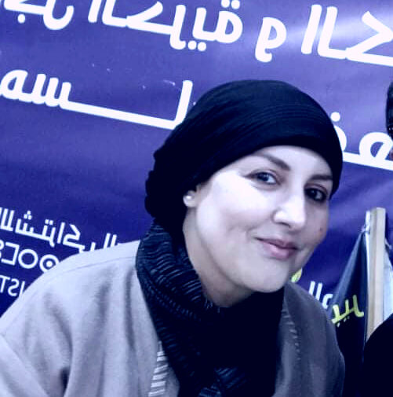
Saïda El Alami is a 49-year-old human rights defender who has used social media to denounce the actions and corruption of the security services and the judiciary, including the detention of journalists and the death in 2022 of Yassine Chabli in police custody. Her activism has led to a series of convictions: two years in prison for "insulting government officials, […] the king and judiciary" (April 2022); an additional year for "spreading false allegations" (September 2022) ― this later reduced to eight months on appeal (October 2023). Released by royal pardon (July 2024), she was re-convicted and sentenced to three years and a fine (c. $2.000) for "insulting a legally constituted organisation, spreading false allegations and contempt of justice" (September 2025). At one point she went on hunger strike and has also been held in solitary confinement.

Please send a greeting (it can be religious and you can mention ACAT) to the following. You can also write a letter to her, giving your address if you wish.

Saïda El Alami
Prison Oukacha Aïn Sebaâ
Casablanca
20000 Morocco

You can also write to her via her lawyer:
c/o Maître Souad Brahma
4, Boulevard Mohamed V
Résidence Al Mahatta
Appartement 42
26100 Berrechid
Morocco

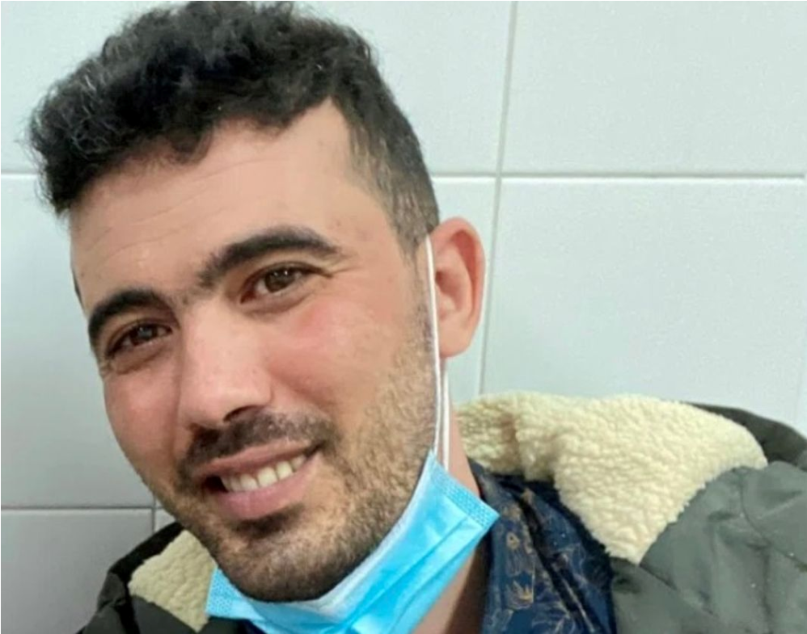
Mohamed Benhlima is currently serving a life sentence in Blida military prison, Algeria, where he has reported repeated torture and ill-treatment without any official investigation. A former Algerian military officer and whistleblower, Mohamed Benhlima was forcibly returned from Spain to Algeria in March 2022 despite warnings from human rights organizations. He had exposed alleged corruption within Algeria’s military leadership and participated in the peaceful Hirak protest movement. His activism led to a death sentence in absentia in 2021 on charges including espionage and desertion. Since his return, Benhlima has been held in Blida military prison under harsh conditions: solitary confinement since April 2022, with only 10-minute daily breaks and no contact with other inmates; limited family visits, sometimes restricted to just 10 minutes under guard supervision; allegations of torture and sexual violence, including beatings and prolonged isolation. He has filed complaints at least six times since May 2022, most recently on 8 December 2024 but Algerian authorities have not launched any investigations.

Please send a non-religious message (do not mention ACAT) to:
Mohamed Benhlima,
Prison De Blida
N1, Blida 09000
The People’s Democratic Republic of Algeria


Palestinian Christian Layan Nasir has been detained multiple times by Israeli military authorities since 2021, probably for her student activism. She has been mainly held under administrative detention without formal charges. First imprisoned in 2021, she was held for eight months in April-December in 2024, with no contact with her parents and only brief access to legal counsel. In October 2025 she was sentenced again to eight months in prison, marking her third detention in four years. Her detention has attracted widespread condemnation from church leaders.

Please send a short greeting (it can be religious and you can mention ACAT) to:
Layan Nasir
Ofer Military Prison
PO Box 3007, Giv'at Ze'ev, Israel
Fax: 011 972. 08 9193360

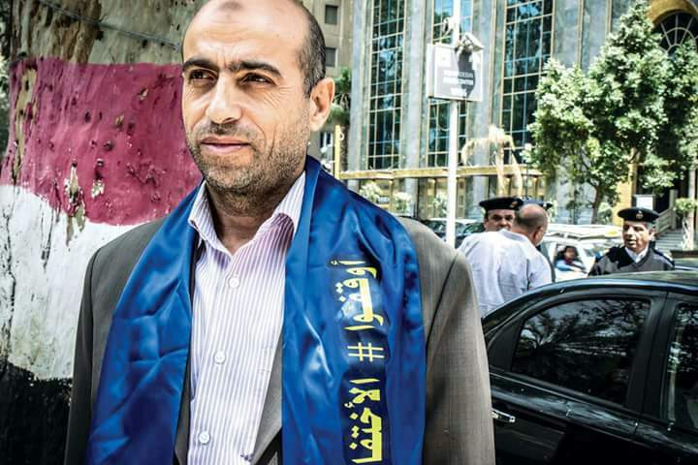
Ibrahim Metwaly remains imprisoned in Egypt’s Badr 3 prison, facing multiple trials on terrorism-related charges widely condemned as politically motivated. His health is deteriorating, and rights groups are urgently calling for his release. A human rights lawyer and co-founder of the Association of the Families of the Disappeared in Egypt, Ibrahim Metwaly has been arbitrarily detained since September 2017, when he was arrested at Cairo International Airport en route to Geneva to address the UN about enforced disappearances, including that of his own son. He suffers from multiple conditions, including an enlarged prostate requiring urgent surgery. Authorities have denied him adequate medical care. Since September 2024 Metwaly has been referred to three separate trials on similar terrorism-related charges which are widely viewed as retaliation for his peaceful human rights work, especially his efforts to seek justice for victims of enforced disappearance.

Please send a short greeting (non- religious, do not mention ACAT) to:
Ibrahim Metwaly
Badr Correction and Rehabilitation Complex
Badr 3
Nr Badr
Cairo-Suez Road
Cairo Governorate
Egypt

Note: The authorities do not publish a precise address for this high security and secretive prison. The above is based on the best available geographic location. It is fair to say that it cannot be certain that posted mail will be delivered.

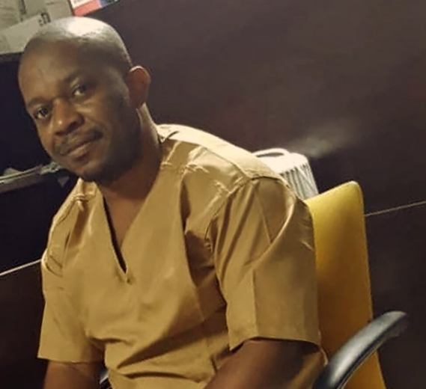
Joaquín Elo Ayeto, a long-standing human rights defender and member of the opposition party Convergence for Social Democracy (CPDS), as well as co-founder of the civil-society platform Somos+, has been arbitrarily detained since 1 August 2024 after agents of the gendarmerie forcibly entered his home in Malabo and arrested him in connection with his peaceful human-rights work.
On 9 August 2024 he was transferred to the infamous Black Beach Prison in Malabo and on 13 August to Oveng Azem Prison in the eastern city of Mongomo, where he remains in in-communicado detention. At the time of his arrest, his family says he was suffering from both malaria and typhoid fever. Since his transfer to Oveng Azem, no reliable information has been made available about his health, his legal status or his access to his family and lawyer.
Joaquín’s detention appears to be purely retaliatory, carried out in direct response to his work exposing human-rights violations in Equatorial Guinea through Somos+ and the CPDS. The platform’s efforts to reveal abuses linked to mining explosions on Annobón and the authorities’ decision to label the organisation as “illegal” underscore the political nature of his arrest. His transfer to a remote maximum-security prison, the denial of access by family or lawyer, and the absence of publicity disclosed charges, or transparent proceedings raise grave concerns that his detention amounts to enforced disappearance and arbitrary detention.
Background
Equatorial Guinea, under the leadership of President Teodoro Obiang Nguema Mbasogo, has a long-documented record of repressing dissent, restricting freedom of expression and association, and using the criminal justice system and prison regime to silence human-rights defenders and opposition figures. This case is emblematic of this broader pattern; civilian activists and civic-space actors being directly targeted for challenging official narratives, facing arbitrary arrest, ill-treatment, denial of legal safeguards and transfer into remote detention.

Please send a message (it can be religious and you can mention ACAT) to:
Joaquín Elo Ayeto
Oveng Azem Prison
Mengomeyén, Wele-Nzas
Equatorial Guinea

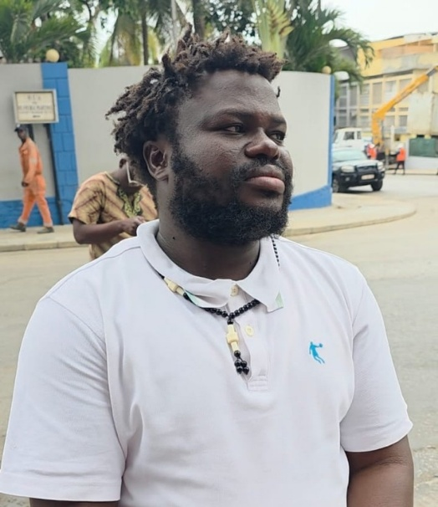
Serrote Jose de Oliveira is an activist who was livestreaming a protest against rising fuel prices in Luanda on 28 July 2025. During the livestream he was shot in the left leg by armed men believed to be linked to the Criminal Investigation Services (CIS). Serrote was then arrested and held incommunicado denied access to legal counsel or his family, and transferred between detention centres without any formal charges in place.
Following his arrest, his family learned he was detained in the prison cells of the CIS in Luanda, and on 6 August 2025 he was transferred to the Comarca Central Prison without his lawyers being notified. Since then, his health condition and legal status remain uncertain, and he has not been given adequate medical treatment for his gunshot wound. His detention appears to be arbitrary and to result from his peaceful exercise of the right to protest and freedom of expression. The denial of medical care, family access, and proper legal representation raises serious concerns that his treatment amounts to arbitrary detention and ill-treatment.

Background
Angolan civic space has sharply deteriorated in recent years, with authorities using excessive force and arbitrary arrests to silence dissent. Since the economic crisis and fuel subsidy cuts of 2023-2025, protests against corruption, unemployment, and rising living costs have been met with violent repression by the security forces, particularly the Criminal Investigation Service and Rapid Intervention Police. Human rights defenders, journalists and youth activists have faced intimidation, surveillance, and politically motivated prosecutions under broadly defined “national security” and “public order” laws. In this climate the shooting and subsequent incommunicado detention of a protestor illustrates how the authorities treat public criticism as a security threat rather than a legitimate exercise of rights.

Please send a greeting message (it can be religious and you can mention ACAT) to:

Serrote Jose de Oliveira
Calomboloca Prison
Quibala
RWWX+F2Q
Angola

Lord Jesus Christ, we humbly cry out in the depths of our despair, beseeching You on behalf of the innocent – Your children unjustly imprisoned. Heavenly Father, protector of the blameless, manifest Your divine justice within these cold walls of man-made law

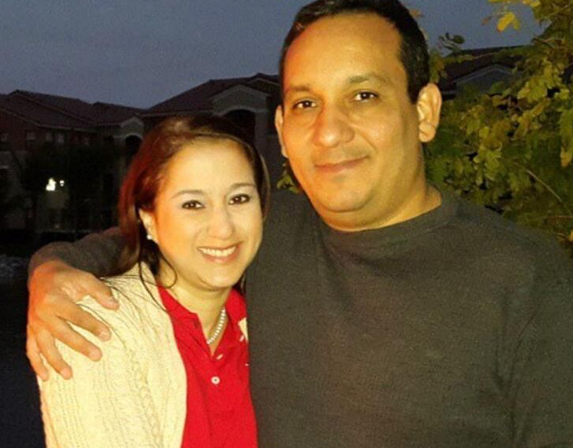
Maria Auxiliadora Delgado, an engineer and human rights defender, has been arbitrarily detained since March 2019 for her peaceful activities and association with civil society groups in Venezuela. She and her husband, Juan Carlos Marrufo, were arrested by officers of the Bolivarian Intelligence Service (SEBIN) on politically motivated charges, without a warrant or due process.
Since February 2024 Maria has been enduring inhumane prison conditions in Rodeo I prison, near Caracas, alongside other political prisoners. According to Amnesty International, she has been denied essential medical testing and treatment despite ongoing health concerns and repeated requests from her family and lawyer. Her husband remains in the same facility under equally harsh conditions, including prolonged isolation and lack of access to drinking water.
Maria’s detention is arbitrary, and her ill-treatment constitutes a clear violation of the absolute prohibition of torture and other cruel, inhuman or degrading treatment under international law. The authorities’ failure to provide adequate medical care endangers her life and reflects the wider collapse of Venezuela’s prison and judicial systems, marked by corruption, neglect, and deliberate cruelty towards political detainees.

Background
Venezuela’s human rights crisis has deepened under a repressive state apparatus that uses security and intelligence forces to silence dissent. Since 2014 agencies such as SEBIN and DGCIM have carried out widespread arbitrary detentions, enforced disappearances and torture of critics and perceived opponents. Courts routinely validate these abuses by admitting coerced confessions and denying due process. Prisons like Rodeo I in Guatire, where Maria is held, reflect the collapse of Venezuela’s justice and health systems. Overcrowding, contaminated water and denial of medical care are common, and authorities deliberately use neglect as a form of punishment against political detainees. Her case exemplifies how Venezuelan authorities weaponize imprisonment and medical deprivation to intimidate and silence those demanding accountability.

Please send a message (it can be religious and you can mention ACAT) to:
Maria Auxiliadora Delgado
Internado Judicial de El Rodeo (Rodeo I Prison)
Guatire 1221, Miranda State
Venezuela

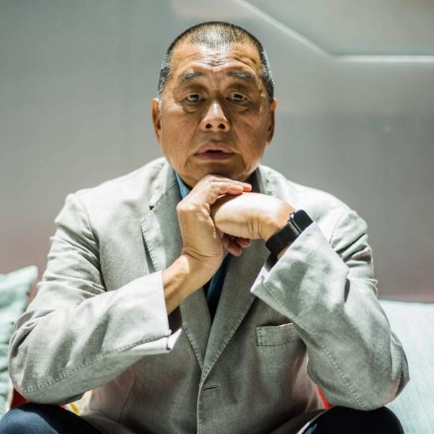
Jimmy Lai, a prominent Hong Kong media entrepreneur, founder of the now-defunct pro-democracy newspaper Apple Daily and British national, has been arbitrarily detained since December 2020. He faces multiple charges under Hong Kong’s National Security Law (NSL) and colonial-era sedition provisions, solely for peacefully exercising his right to freedom of expression and association with the press. His ongoing trial before the High Court – conducted without a jury and presided over by hand-picked national security judges – exemplifies the rapid erosion of judicial independence under the NSL.
Prosecutors accuse Jimmy Lai of “colluding with foreign forces” for his international advocacy and communications with overseas actors, and of “conspiring to publish seditious materials” for articles and commentaries published in Apple Daily. If convicted, he faces a possible life sentence. Amnesty International and multiple UN experts, including the Working Group on Arbitrary Detention, have declared his imprisonment arbitrary and politically motivated, calling for his immediate release. Since his arrest, Lai has been held at Stanley Prison, a maximum-security facility, and has endured prolonged solitary confinement, restrictions on correspondence, and denial of contact with his family and chosen lawyers.

Background
The crackdown on Jimmy Lai has taken place within the wider dismantling of rights and freedoms in Hong Kong since the imposition of the National Security Law in June 2020. Once a territory known for judicial independence and robust civil liberties, Hong Kong has seen a sweeping transformation of its legal order under pressure from Beijing. The NSL’s vague definitions of “collusion”, “subversion” and “secession” allow the authorities to criminalise peaceful criticism and journalism as threats to “national security”. In 2024, the introduction of Article 23 legislation further entrenched this repression, expanding the reach of security offences, increasing police powers, and limiting public oversight. Nearly all major pro-democracy figures have been prosecuted, while independent outlets have been closed. Courts are increasingly used as instruments of political control, with NSL-designated judges imposing lengthy pre-trial detentions and closed-door hearings.

Please send a message (non-religious and do not mention ACAT) to:
Jimmy Lai
Stanley Prison
Correctional Services Department
99 Tung Tau Wan Road
Stanley, Hong Kong Island
Hong Kong Special Administrative Region
People’s Republic of China

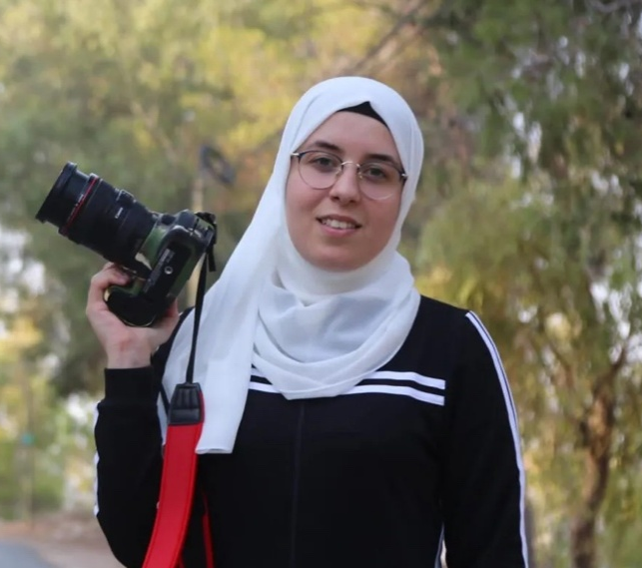
Bushra al-Taweel, a Palestinian journalist and human rights defender from Ramallah, has been arbitrarily detained without charge or trial since November 2023 under Israel’s administrative detention system. A prominent advocate for prisoners’ rights and spokesperson for the Aneen Al-Qaid Media Network, she has been repeatedly targeted by the Israeli authorities for her reporting on the situation of Palestinian detainees and her peaceful activism. Bushra was arrested by Israeli forces during a late-night raid at her home in Ramallah and transferred to Damon prison.
According to human-rights monitors, she was held in solitary confinement, denied adequate medical care, and interrogated for long hours while blindfolded and shackled. Lawyers have reported that she was threatened with physical violence and sexual humiliation during questioning, consistent with the widespread pattern of torture and ill-treatment documented against Palestinian women in Israeli custody. Bushra has spent more than eight years in prison through repeated administrative detention orders. This ongoing practice clearly violates international law, including the prohibition of arbitrary detention and torture under the International Covenant on Civil and Political Rights and the Convention Against Torture, to which Israel is a state party.

Background
Since October 2023 Israeli authorities have dramatically expanded the use of administrative detention, detaining thousands of Palestinians without charge or trial. Many human-rights organisations have documented systematic torture, sexual violence, and cruel, inhuman or degrading treatment in Israeli detention facilities, especially against detainees from Gaza and the occupied West Bank. Women held at Damon Prison have reported unsanitary conditions, physical and verbal abuse, and denial of contact with families or lawyers.

Please send a message (it can be religious and you can mention ACAT) to:
Bushra al-Taweel
Damon Prison
P2MF+78
Daliyat al-Karmel
Israel

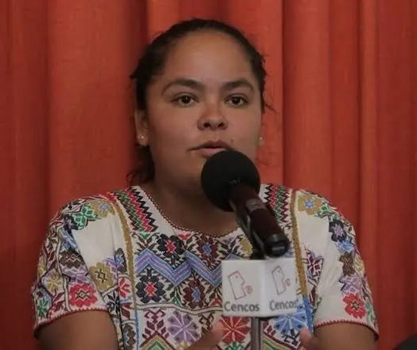
Kenia Hernandez Montalvan, an Indigenous Amuzga human rights defender and lawyer from Guerrero State, has been unjustly imprisoned since October 2020 for her peaceful activism. She is the coordinator of the Colectivo Libertario Zapata Vive and a member of the Movimiento Nacional por la Libertad de las y los Presos Politicos, advocating for Indigenous women’s rights, land justice, and the release of political prisoners in Mexico.
Kenia was arrested without a warrant by the National Guard while travelling between Guerrero and Mexico City. Following a series of politically motivated prosecutions in different states, she has been convicted in several cases based on weak and inconsistent evidence. In December 2022 she was sentenced to 10 years and 6 months in prison for “robbery with violence” a charge widely condemned by human-rights organisations as fabricated to silence her activism. While detained, Kenia has faced harsh conditions and discriminatory treatment. She has been placed in prolonged solitary confinement, denied adequate medical care and access to clean water, and restricted from contract with her family and legal team. According to reports by the World Organisation Against Torture and Front-Line Defenders, she has been subjected to physical and psychological ill-treatment and targeted verbal abuse, with guards referring to her Indigenous identity in degrading terms. These conditions constitute inhuman treatment and violate Mexico’s obligations under the Convention against Torture.

Background
Kenia’s imprisonment reflects a wider pattern of criminalisation of women human rights defenders and Indigenous activists in Mexico. Since 2015, federal and state authorities have used the criminal justice system to prosecute those protesting against privatisation, resource extraction, and inequality. Women defenders, particularly Indigenous women, face double discrimination – both for their gender and their activism. In Guerrero and Morelos movements for land and indigenous rights have been systematically repressed through harassment, arbitrary detention, and fabricated criminal charges. The UN Special Rapporteur on Human Rights Defenders and the Inter-American Commission on Human Rights have expressed grave concern about Kenia’s case, noting that her imprisonment is reflects Mexico’s failure to protect human rights defenders.

Please send a message (it can be religious and you can mention ACAT) to:
Kenia Hernandez Montalvan
Centro Federal de Readaptación Social Femenil No.16
95 Amacuzac-Grutas de Cacahuamilpa
Colonia Michapa, Coatlán del Rio, C.P. 62614
State of Morelos, Mexico

REMEMBER IN YOUR PRAYERS
Cécile Kohler and Jacques Paris, teachers and French nationals, who have been detained in Iran.
Sonia Dahmani, imprisoned in harsh conditions for campaigning against abuses of migrants in Tunisia.
Linn Htut, senior politician, tortured, in poor health and sentenced to 20 years following a military coup in Myanmar.
Ohla Baranevska, retired nursery school teacher, abducted, tortured and sentenced to six years in prison for refusing to return to work in Russian-occupied Ukraine.

Lord of heaven and earth, as Jesus taught his disciples to be persistent in prayer, give us patience and courage never to lose hope, but always to bring our prayers before you; through Jesus Christ our Lord. Amen.

Sonnet in honour of St Stephen, whose feast day is 26 December

Witness for Jesus, man of fruitful blood,  Your martyrdom begins and stands for all.  They saw the stones, you saw the face of God,  And sowed a seed that blossomed in St Paul.  When Saul departed breathing threats and slaughter  He had to pass through that Damascus gate  Where he had held the coats and heard the laughter  As Christ, alive in you, forgave his hate,  And showed him the same light you saw from heaven  And taught him, through his blindness, how to see.  Christ did not ask “Why were you stoning Stephen?”  But “Saul, why are you persecuting me?”  Each martyr after you adds to Christ’s story,  As clouds of witness shine through clouds of glory. | 
Picture: Saint Stephen by Carlo Crivelli (c.1430–c.1495), The National Gallery, London

A Prayer for Peace on Earth
Glory to God in the highest heaven, and on earth peace to those on whom his favour rests [Luke 2:14]

Lord, in the midst of times of unrest, war and suffering, please bring your peace on earth.
You are our peace, and through you we can have unity and harmony in our families, communities, and in our world.
May your peace rule in our hearts this Christmas season. Amen.

HOW YOU CAN HELP
Read our newsletters, case appeals, ideas for action, background information and prayer materials.
Join in our Christmas and Easter Campaigns and write to prisoners, victims and human rights workers.
Urge authorities to expose torture, release prisoners, improve prison conditions and bring torturers to justice.

What finer sound
Is there than a human being
Singing
Against
Cruelty, against Hate?
(Nidar Dinshaw)

