CHRISTMAS GREETINGS CAMPAIGN 2022
For this campaign, please write a simple card or greeting to the individual saying, for instance, that you are thinking of him/her and/or perhaps urging them not to lose hope (or words to that effect). A picture postcard ― in an envelope if you choose ― is always welcome and cheapest to send. You can include your name and address if you wish but do not mention ACAT or include a religious greeting or motif (even a Christmas tree!) if so advised, since communication from a foreign organisation can endanger the prisoner. Several individuals featured in previous campaigns have been released. Sadly, others are still in prison, and it is important not to forget them. Changes in their circumstances are described, where known. As usual we include a couple of human rights groups. For individual prisoners or their families, it is heartening to receive fairly regular cards of encouragement. Do not feel obliged to respond to every appeal case or to write to every address given for a case (we present several in some cases). Postage overseas is expensive: a letter or card (e.g. postcard) weighing up to and including 20g costs £1.85 to the countries featured in our appeals. This is according to currently available information online, see: Our prices (valid from 4 April 2022) (royalmail.com)

GROUPS
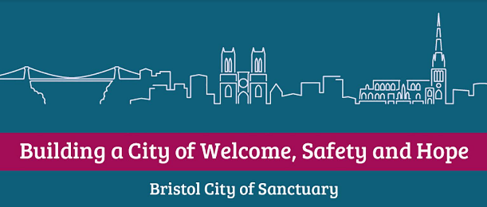
The charity Bristol City of Sanctuary encompasses organisations that offer support, solidarity and advice to people seeking sanctuary in the city. It advocates a fair and humane asylum system that protects rather than punishes and works to embed individuals in Bristol’s businesses and institutions. It also runs the Schools of Sanctuary award.

Bristol City of Sanctuary
The Assisi Centre,
Lawfords Gate,
Bristol, BS5 0RE
Email: bristol@cityofsanctuary.org

Gryffe Women’s Aid is a feminist organisation founded in 1981 as Scotland’s first Asian, Black and Minority Ethnic Women’s Aid Group. Initially 15 women volunteered to run the refuge in Inverclyde to accommodate the growing number of Asian women fleeing domestic abuse. The project was initially named Gryffe Womens Aid as the first refuge was situated near the river Gryffe in Kilmacolm for sixteen years.
In 1995 the drop-in centre opened at 24 Willowbank Street, Glasgow. It was then that the word ‘Hemat’ (meaning courage) was added to the business name. It is now widely known as Hemat Gryffe Women’s Aid, Glasgow. The group provides bilingual specialised service, safe refuge accommodation, outreach, and follow-on services primarily to women, children, and young people. It also assists women, children and young people to settle into their own home when leaving refuge. The support encompasses young people up to the age of 18 impacted by domestic abuse, forced marriage or honour-based abuse.

Hemat Gryffe Women’s AiD
Flat 0/1,
24 Willowbank Street,
Glasgow, G3 6LZ
Tel: 0141 353 0859

INDIVIDUALS
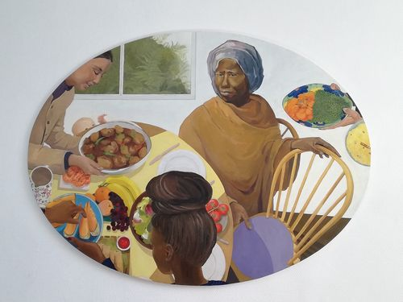
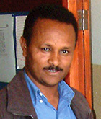
In May 2004, Reverend Haile Nayzgi was arrested and taken to a police station in Asmara. He was the leader of Eritrea’s Full Gospel Church, which comprises 120 to 150 house meeting groups. The church groups were closed by government decree at a meeting with a government official on 15 May 2002. At that time the church groups were given an application form for government registration. The Full Gospel Church filled out the form and returned it to the appropriate offices, but no reply was ever received.
Haile is married and has three children. He was previously an accountant with World Evangelical Alliance. During his incarceration, Haile has been refused any personal contact with his family. When family and friends went to take food and clothing to the prison for Haile on 24 August 2004, they were told that he was no longer there. Mr Nayzgi has been moved to various locations since his arrest, but the actual charges against him have not been released. He is believed to be at the location below.

Please send a message (do not mention ACAT) to:

Haile Nayzgi
Karsheli Prison
2nd Police Station
Zone 7 Northern East
Asmara, Zoba Maakel
Eritrea

Pastor Li Juncai of the Yuanyang County Central House Church in Xinxiang, Henan Province in China is currently serving a prison sentence of five and a half years after protesting against the government’s attempts to remove the cross atop his church building in 2019. Mass removals of crosses from church buildings began in Henan Province in 2018, with police removing at least 4,000 crosses over the course of a year. Even the crosses of government-run churches were removed, and smaller churches were completely shut down. When authorities brought a crane to remove the cross from Pastor Li Juncai’s church in February 2019 a group of Christian senior citizens, mostly women, met the plainclothes policemen and their crane. The Christians sang hymns and prayed while attempting to keep the authorities from taking the cross. Police beat and arrested the protestors before forcing the church gate open and removing the cross. Pastor Li Juncai told the workers they should proceed according to the law and that he opposed the removal of the crosses. He was arrested and accusing of disrupting public service. He was charged with embezzlement and obstructing government administration, sentenced to five and a half years in prison and given a fine of more than $7,000 USD. The Yuanyang County Central House Church was a government-run Three-Self church until 2013, when it merged with a local house church. Each week they served approximately 700-800 people. Many churches are now required to display the national flag along with an image of President Hu Jingpin in the sanctuary and to install security cameras facing the congregation.

Please send a non-religious message (do not mention ACAT) to:
Pastor Li Juncai
The No. 3 Prison Section
Jiao’nan Prison
Yinghu Road,
Jiefang District, Jiaozuo city,
Henan province
454003
The People's Republic of China

In July 2021 Fariba Dalir (51), was arrested in Iran along with five other Christian converts, including her fiancé Soroush. While awaiting trial all six believers were released on bail. Fariba was released on 18 November and the others in October. While out on bail, Fariba and Soroush were married. On 4 December 2021 the courts sentenced Fariba to five years in prison for ‘acting against national security by establishing and leading an Evangelical Christian church’. Soroush and three others were sentenced to ten months in prison for their membership with the church. Fariba’s sentence was later reduced to two years, and the others were released with a fine due to the prison time they had by then already served. On 16 April 2022 Fariba returned to Tehran’s notorious Evin Prison to begin her two-year sentence. She is due to be released in April 2024.

Please send a (non-religious) message (do not mention ACAT) to:
Fariba Dalir
Evin Prison
Saadat Abad
Tehran
Islamic Republic of Iran

In 2019 Reverend Ramon Rigal and his wife Pastor Adya Exposito Leyva were imprisoned in Cuba for home-schooling their children. They didn’t want their children Ruth and Noel to go to a state-run school where they would be bullied for their beliefs, so they enrolled their children with an online school. Parents are legally required to send their children to state-run schools in Cuba, and protecting Ruth and Joel in this manner is illegal. As a result, in April 2019, both Raman and Adya were imprisoned for their decision to home-school their children, and Ruth and Joel were separated, having to live in different homes for many months.
Adya was released from detention in March 2020, after serving over 11 months of an 18-month sentence for the alleged crime of ‘other acts against the normal development of a minor’. Ramon was released in June 2020 after serving 14 months of a two-year sentence. For most of his imprisonment, Ramon was in a maximum security unit where he was denied conditional freedom and was allowed only one visit a month.
Please send a message (it can be religious and you can mention ACAT) to:

La Familia Rigal
1075 Luz Caballero entre Donato
Marmol y Varona
Ciudad de Guantanamo
Guantanamo
Cuba
Note: This case does not involve torture, but readers may feel that the punishments for their actions are disproportionate.

In February 2012 Pastor Reutilio Columbie of the Shalom Christian Centre in Cuba was beaten so violently that he suffered brain damage. It is believed that the attack was a direct result of his challenge to the authorities over their arbitrary confiscation of his church truck. Pastor Columbie had bought a truck from a local person five years earlier and modified it to transport members of the Pentecostal church in Moa, Cuba. In December 2011 it was confiscated by the authorities without warning or explanation and apparently returned to the original owner, who has family ties to an individual in the Central Committee of the Cuban Communist Party. When the pastor protested about the confiscation and began lodging a complaint to prove ownership, the family received anonymous threatening phone The pastor suffered severe inflammation of the brain as a result of the attack. He still struggles with his speech and with memory loss and suffers nauseous attacks and vertigo. His attackers have never been brought to justice. Pastor Columbie was last featured in our Easter Greetings Campaign of 2018.

Please send a message (it can be religious and you can mention ACAT) to:

Pastor Reutilio Columbie
Iglesia Evangelica Centro, Cristiano Shalom
Calle Cabana, Reparto Monterrey
Moa, Holguín
Cuba

Freelance journalist Zhang Zhan, a well-known activist for human rights in China, was detained in May 2020 as a reprisal for her coverage of the Covid-19 pandemic from February 2020. She reported on the detention of other independent journalists in Wuhan and the harassment of families of victims seeking accountability. Her licence to practise as a lawyer has been revoked. During July and August 2021 she was hospitalised due to her deteriorating health as a result of an ongoing hunger strike begun in June 2020. Tied to a bed and force-fed, Zhang Zhan is in extremely poor health, suffering weight loss, severe malnutrition, a gastric ulcer, and swollen legs and feet. She was later transferred back to the Shanghai Women’s Prison, where she is currently believed to be held. There is very grave concern about her well-being as China is known for the human rights defenders who have either died in prison or shortly after their release.

Please send a non-religious greeting (do not mention ACAT) to:
Ms Zhang Zhan
Songjiang Women's Prison
No.1601, Zhang Jing Road
Sijing Town
Songjiang District
Shanghai, China


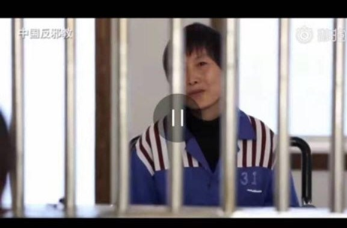
In 2017 sisters Ju Dianghong (pictured) and Liang Qin were sentenced to jail terms of 13 and 10 years respectively for their Christian activities. Christians in China’s southern Yunnan province face long prison sentences as Chinese authorities try to eradicate their religion under the guise of cracking down on 'evil cults'.
In 2016 Yunnan officials investigated the Three Grades of Servants religious sect as dangerous cult and launched systematic attacks against them. Over 200 Christians across the province were arrested, with 40 still detained in 2018. Their lawyers came under review just for defending them. Denials that they ever belonged to the cult were ignored and six— Ju Dianghong, Liang Qin, Zhang Hongyan, Zi Huimei, Yang Shunxiang, and Zhang Shaocai — were sentenced to between four and 13 years in prison. Ju Dianghong and Liang Qin claimed they were never involved with the sect and had never heard of it, but were accused of leading and recruiting members, doing missionary work and spreading news of the apocalypse on behalf of the cult.
The cult is deemed dangerous by mainstream Christians and probably died out after a crackdown in 2005-6, but it is used by the authorities as a catch-all to persecute other Christians. Christian prisoners often suffer torture, beatings, and even death at the hands of prison officials. Others leave their cells in extremely poor physical and mental health from subjection to inhumane practices and medical neglect. The location of their prisons — in remote areas over 1,000 miles from homes and families —is rarely disclosed and requires exhaustive research to uncover. The sisters have featured in our last Christmas and Easter campaigns. [Picture: ChinaAid]
Please send a non-religious card/greeting to the women at the following address, reminding them that they are not forgotten. Do not mention ACAT.
Liang Qin
No. 1 Prison for Women of Yunnan Province,
Kunyang Town, Jinning District,
Kunming City, Yunnan Province,
China 650600
Ju Dianghong
No. 1 Prison for Women of Yunnan Province,
Kunyang Town, Jinning District,
Kunming City, Yunnan Province,
China 650600

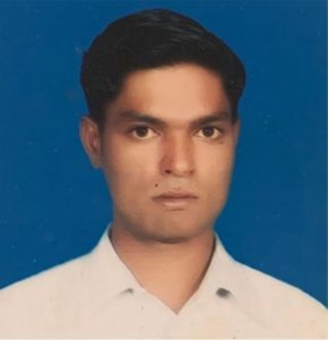
Ashfaq Masih (34) has been in prison in Pakistan since 2017, when he was accused of blasphemy. He is still awaiting trial as his court hearings have been cancelled repeatedly because the judge or witnesses failed to appear. A bicycle mechanic from the Christian Mariam Colony in Lahore, Ashfaq Masih was accused of blasphemy after he was involved in a dispute with a Muslim customer over payment for repairing a bicycle. It is not unusual in Pakistan for Christians to be targeted in this way over minor business disputes that escalate into religious disputes. The customer claimed to be a poor sadhu (holy man) demanding a rebate on the cost of the bicycle repair. A crowd gathered and Ashfaq was accused of blasphemy for reportedly insulting the Prophet Muhammad by telling the bicycle owner that Christians believe Jesus was the final prophet. Police were called and arrested Ashfaq, who is imprisoned in the District Jail (aka Camp Jail), Lahore. Ashfaq’s family is very poor but his older brother is hoping to start a small business. On 4 July 2022 Judge Khalid Wazir sentenced Ashfaq to death for blasphemy. He plans to appeal to the High Court.
Another Christian, Anglican Patras Masih, was arrested in 2018 and also faced imprisonment/the death sentence under Section 295-C of the Pakistan Penal Code. Tortured under interrogation by the Federal Investigation Agency (FIA), he spent four years in detention before being granted bail in August 2022. Pastor Raja Waris was arrested and charged in December/January 2021 and also granted bail in August 2022. Despite the bail, both men still face conviction.

Please send a non-religious greeting (do not mention ACAT) to:

Ashfaq Masih
District Jail Lahore
Ferozepur Road
Shadman 1 Shadman
Lahore
Punjab 54000
Pakistan

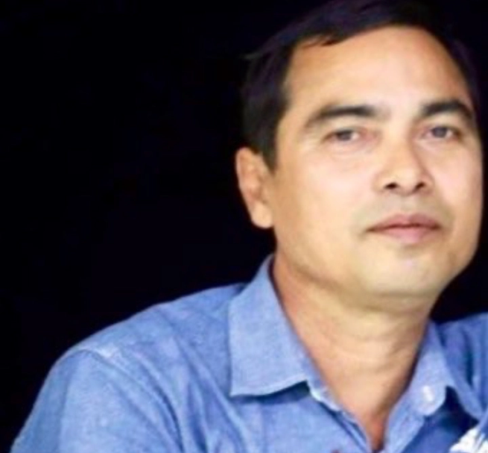
On 3 March 2021 journalist Min Nyo was arrested and severely beaten by police while he was covering a pro-democracy protest against the military coup in Pyay, Bago Region ibn Myanmar. On 12 May 2021 a military court in Pyay Prison found him guilty of attempting to 'hinder, disturb, damage the motivation, discipline, health and conduct' of soldiers and civil servants and 'cause their hatred, disobedience or disloyalty toward the military and the government' (Penal Code, Article 505-a) and sentenced him to three years in prison. He is currently detained at Pyay Prison, where he is at risk of being tortured, and is appealing against the verdict. Mr Min Nyo is also featured in our section for appeals to authorities. [Picture: DVB, cpj.org]
Please send a message (it can be religious and you can mention ACAT) to:

Min Nyo
Pyay Prison
R6HC+P8Q, Pyay
Bago Region
Myanmar


Since the Arab Spring of 2011, when thousands demonstrated for democracy in several Arab countries, death sentences in Bahrain have greatly increased following convictions in sham trials based on flawed evidence and confessions obtained through torture and coercion. Bahrain was the only Gulf state to see mass protests during the Arab Spring. The Sunni Muslim monarchy used force to suppress protests, led mostly by the Shi'ite Muslim community, and cracked down on sporadic unrest and dissent later.
The following men are believed to be held in a prison notorious for its insanitary conditions, poor health, abusive treatment and the obstruction of family visits: Maher Abbas al-Khabbaz, Sayed Ahmed al-Abar, Zuhair Ebrahim Jasim Abdullah, Husain Ebrahim Ali Husain Marzooq, Husain Moosa, Mohamed Ramadhan, Husain Ali Mehdi, and Salman Isa Ali Salman.
In June 2022, 26 men were on death row, and all have exhausted their appeals. Under Bahraini law King Hamad bin Isa Al Khalifa has the power to ratify these sentences, commute them, or grant pardons.

Please send a non-religious greeting (do not mention ACAT) to one or more of the above:
Name of prisoner
Jaw (Jau) Central Prison
Jaw
The Kingdom of Bahrain

REMEMBER IN YOUR PRAYERS
Reverend Hatile Nayzgi, a Christian prisoner in Eritrea who was arrested in 2004 and remains in detain in poor conditions and denied contact with his family.
Li Juncai, a Christian prisoner in China after erecting a Christian cross on his church. Protesters against the cross’s removal were beaten and arrested.
Fariba Dalir, a Christian convert held in Iran’s notorious Evin prison.
Reverend Ramon Rigal and his wife Pastor Adya Exposito Leyva, imprisoned in Cuba for home-educating their children but released early. Ramon was held in a maximum security prison with limited visiting.
Zhang Zhan, a journalist and human rights activist in China, imprisoned in China and in very poor health.
Sisters Ju Dianghong and Liang Qin, sentenced to long prison terms in China for Christian activities.
Ashfaq Masih, a young Christian man imprisoned since 2017 and sentenced to death in July 2022 in Pakistan for alleged blasphemy during a minor business dispute. Remember also the many other Christians and members of minority religions persecuted in Pakistan.
Min Nyo, a journalist severely beaten while covering a pro-democracy protest in Myanmar and currently at risk on torture in prison.

Remember also the many individuals imprisoned and persecuted for their fight against repression and injustice or for their religious faith.
Remember also the many prisoners facing the death penalty in Bahrain

