EASTER GREETINGS CAMPAIGN
For this campaign we suggest that you write a simple card or greeting to the individual saying, for instance, that you are thinking of him/her and/or perhaps urging them not to lose hope (or words to that effect). A picture postcard is always welcome and cheapest to send. You can include your name and address if you wish but do not mention ACAT or include a religious greeting or motif if so advised, since communication from a foreign organisation can endanger the prisoner. Several individuals featured in previous campaigns have been released. Sadly others are still in prison and it is important not to forget them. Changes in their circumstances are described, where known. As usual we include a couple of human rights groups. For individual prisoners or their families it is heartening to receive fairly regular cards of encouragement. Do not feel obliged to respond to every appeal case or to write to every single address given for a case. A letter or card (e.g. postcard) weighing up to and including 20g currently costs £1.70 to Europe and the rest of the world.
https://www.royalmail.com/sites/royalmail.com/files/2021-03/royal-mail-our-prices-april-2021.pdf

GROUPS
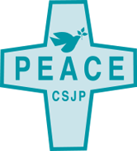
The SISTERS OF ST JOSEPH OF PEACE, who have been faithful supporters of ACAT-UK and its campaigns, have opened their first UK House of Hospitality for asylum seekers and refugees in Nottingham. The House will be a home for three sisters and for long- and short-term guests/refugees. The sisters, who also have a House in New Jersey, USA, describe themselves as 'an international Catholic community of women religious and women and men associates serving in the United States, United Kingdom, and Haiti. Our charism of peace calls us to practice radical hospitality, non-violence, and care of creation'.

Please send a greeting to:
The sisters of St Joseph of Peace
United Kingdom Regional Office
Foxhall Lodge
Foxhall Road
Nottingham
NG7 6LH
England
Telephone: 01158 456418
Website: https://csjp.org/

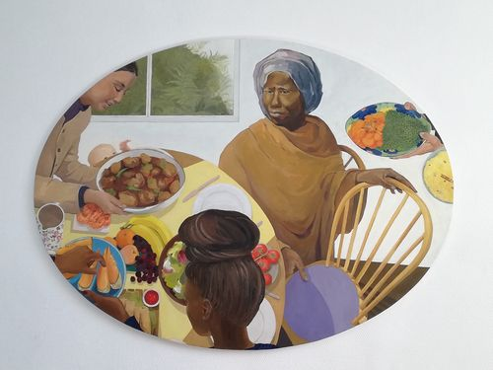
In the north-western state of Kaduna, Nigeria, where religious tensions have spilled over into violence, banditry, killing, and kidnapping by armed groups, the WOMEN'S INTERFAITH COUNCIL (WIC) was founded in 2010 to foster peace and understanding between Christians and Muslims. Women of 23 Christian and faith associations work together to build peace and stability and address the problems of conflict, poverty, insecurity and vulnerability. The violence between the cattle herders in the majority Muslim Hausa-Fulani tribes of the north and the Christian farmers of the south has decimated agriculture and created waves of refugees, a situation in which women struggle to find a voice as protagonists of peace. The WIC was founded in 2010 by Sister Kathleen McGarvey, who worked for seven years as a missionary in Argentina before becoming closely involved in interfaith development and pastoral work in Nigeria. In a recent interview she drew attention to the thorny issues of interfaith marriage, the very early marriage age (14) in some Muslim cultures of girls whose immature bodies cannot cope with childbirth, the lack of education for women, and abandoned wives reduced to street begging.

Please send a greeting to:

Women's Interfaith Council (WIC)
Shop ff9 Matz Plaza, Adjacent Stadium Roundabout
Kachia Road
Kaduna
Nigeria
Email: interfaithcouncilwomen@gmail.com
info@womeninterfaithcouncil.org
Website: http://www.womeninterfaithcouncil.org/
This Easter we include some prisoners who are still incarcerated in Guantánamo Bay, which has now been in operation for 20 years. More details about one of them, Khalid Qasim, are given in our newsletter, which is available to ACAT members. Here is a message from Sami al Haj, a former Sudanese cameraman who was held at Guantánamo without charge for years and finally returned home to Sudan in 2008:

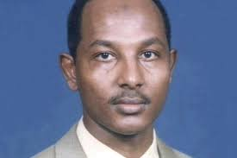
I received more than 20,000 letters from members and supporters of Amnesty International during my last two years at Guantánamo Bay. These letters really encouraged me during my very difficult time. They made me feel as though I was not alone and not to give up. Also, I felt and could notice that from all these letters, the Administration of Guantánamo Bay changed and improved towards me, as they knew I was not alone and I had people who cared about me. The guards said to me that they could see I was someone who mattered and must be important because of all the letters – this made them respect me more. [Reproduced from the American Friends Services Committee, www.afsc.org. Picture: www.pressgazette.co.uk]
President Joe Biden has picked up where George W. Bush and Barak Obama left off in sending prisoners to countries that promise to ensure the men remain under security measures (President Trump recommended only one for release). In July 2021 Abdul Latif Nasser, 56, was sent to Morocco. He was never charged with a crime. This has reduced the prison population to 39. More releases are scheduled. To send a greeting to a prisoner, include his name and Internment Security Number (ISN) in the first line of the address.

Detainee name and ISN number
Camp Delta
US Naval Station Guantánamo Bay, Cuba
Washington DC 20355
USA

The prisoners are:
Khalid Qasim, a Yemeni national who is currently challenging his detention in US courts. ISN 241
Mohammed Al Qahtani, a Saudi Arabian with profound mental health problems. ISN 063
Ridah Al Yazidi, a Tunisian cleared for release in 2010 but still detained. ISN 038
Tawfiq Al Bihani, a Saudi Arabian. ISN 893
Abu Zubaydah, a Palestinian/Saudi Arabian. ISN 10016

For details on the many more prisoners still held and on those released see https://www.closeguantanamo.org

INDIVIDUALS

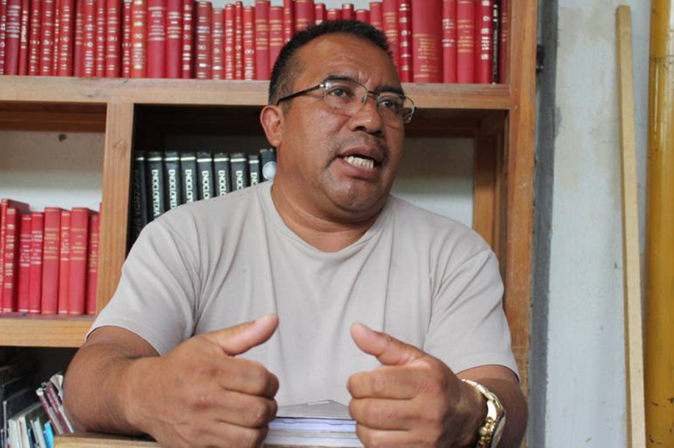
Pablo López Alavez has fought a long-standing campaign to protect local forests (from logging) and rivers (a fresh water source) in the district of Ixtlán (State of Oaxaca), Mexico. On 15 August 2010 he and his family were attacked by gunmen who beat him up and then kidnapped him. In a deeply flawed trial he was later accused of two murders and sentenced to 30 years in prison. His trial and conviction are believed to be in retaliation for his campaign against logging. His wife has had to go into exile in another part of Mexico. Full details are available in the appeals section of our newsletter, which is distributed to ACAT members. [Picture: OMCT]

Please send a greeting to:
Mr Pablo López Alavez
Reclusorio Regional de Villa de Etla
Camino Real a San Juan de Dios S/N
Centro, 68200
Villa de Etla
Oaxaca
Mexico

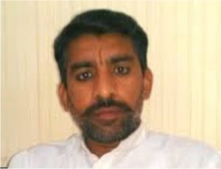
Pastor Zafar Bhatti has been in Rawalpindi's Adiala Central Jail (Pakistan) since July 2012. Arrested for sending blasphemous text messages on a mobile phone (which was not registered to him), he was sentenced to life imprisonment in 2017 for blasphemy — a charge he denies. Before his arrest he founded a small NGO called Jesus World Mission to help the poor but in 2012 was accused by a local Islamic leader of sending text messages insulting the mother of Mohammed. Held in detention for almost five years before appearing before a court, he was tortured to extract a confession. Although an appeal court found that there was no evidence against him and he should be released, the prosecution and police have called for more time to produce evidence. Court hearings have been postponed over seven times but in January 2022 he was sentenced to death. He has experienced several attempts to kill him in prison, suffers from heart problems and diabetes and is not allowed to leave his cell. The Adiala Central Jail is a favourite destination for political prisoners and dissenters and is notorious for its dreadful conditions. According to Release International Zafar's wife, Nawab, struggles to make ends meet and has sent her children to relatives. [Pastor Bhatti was last featured in our March-May 2020 newsletter).

Send a card (non-religious) but do not mention ACAT.
Zafar Bhatti
Central Jail
Adyala Rd
Rawalpindi
Punjab, Pakistan
Claude Lwaboshi Buhazi, Faustin Ombeni Tulinabo and Serge Mikindo Waso are members of the citizens' movement Jicho la Raiya (The Eye of the Citizens) who were arrested on 18 February 2021 in Kirotshe, in the Democratic Republic of Congo's North Kivu province, as they were preparing to take part in a peaceful protest against 'illegal road taxation' and alleged mismanagement at the Kirotshe health district. They were accused of defamation and jailed at the police station in Kirotshe before being transferred to Goma Central Prison on 2 March. On 26 November, their request for release on bail was rejected by a military magistrate in Goma. Conditions at the prison are known to be inhuman. There is severe overcrowding and insufficient food.
Since May 2021 the provinces of North Kivu and Ituri have been under emergency police and military rule after decades of armed conflicts among armed groups. Journalists, members of parliament and human rights activists criticising the so-called 'State of Siege' have been targeted and detained as the solution to continued insecurity.
The African Commission on Human and Peoples' Rights has called on all states parties to the African Charter on Human and Peoples' Rights during the Covid-19 pandemic to release different groups of detainees in severely overcrowded prisons (Resolution 466 on prisons and conditions of detention in Africa).

Please send a greeting to:
Prisoner's name(s)
Prison Central de Goma,
Goma
North Kivu Province
Democratic Republic of the Congo

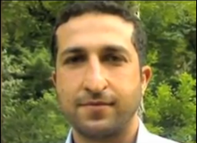
Yousef Nadarkhani (pictured) and three of his church members, Saheb (Zaman) Fadaee, Mohammad Ali (Yasser) Mosayebzadeh and Mohammad Reza Omidi, were sentenced in 2018 to ten-year prison sentences on charges of 'acting against national security' and 'promoting Zionist Christianity.' The men, who were first featured in our Easter greetings campaign in 2019, are all members of the Church of Iran. Omidi was released into two years internal exile in August 2020. Yasser's sentence was reduced to three years in January 2021 and he was released from prison in February 2021 on condition of having no interaction with other Christians or engaging in Christian activities.
A Christian since the age of 19, Yousef had already spent nearly three years in prison after being sentenced to death for apostasy in 2010, but was acquitted in September 2012. A second arrest followed in 2016 and he was sentenced in 2017/18. Yousef is known to have been beaten in detention. In June 2020 his sentence was reduced to six years. His wife is also a convert and the couple have been fighting for over ten years for their two boys to be recognized as Christians. For the past several years the boys have been denied certificates showing they completed their studies because they refused to take Islamic classes. [Picture: Wikipedia].
In February 2019 nine more members of the Church of Iran were also arrested in Rasht. Helping to lead the church in Pastor Nadarkhani's absence, they were all given five-year prison sentences. Neither they nor their lawyers were allowed to attend an appeal hearing in February 2020. Their names are:

Babk Hosseinzadeh,
Mehdi Khatibi,
Kamal Naamanian,
Mohammad Vafadar,
Behnam Akhlaghi,
Khalil Deghanpour,
Hossein (Elisha) Kadivar,
Shahrooz Eslamdoust,
Abdolreza (Matthias) Haghnejad.

Abdolreza (Matthias) Haghnejad has reportedly been moved to a prison in Bandar Anzali, for which no address is currently available. The others are in Evin Prison, Tehran.
Please send a non-religious card/greeting to one or more of the above prisoners, giving them encouragement and reminding them that they are not forgotten. Do not mention ACAT.
Prisoner's name
Evin Prison
Saadat Abad
Tehran
Islamic Republic of Iran

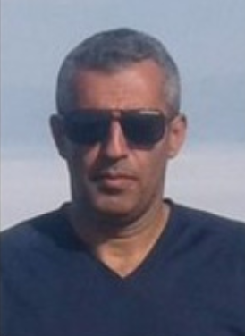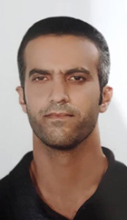

From left: Babk Hosseinzadeh, Kamal Naamanian, Shahrooz Eslamdoust [Pictures: https://articleeighteen.com, https://prisonersoffaith.vom.org.nz/]


Freelance journalist Zhang Zhan, a well-known activist for human rights in China, was detained in May 2020 as a reprisal for her coverage of the Covid-19 pandemic from February 2020. She reported on the detention of other independent journalists in Wuhan and the harassment of families of victims seeking accountability. Her licence to practise as a lawyer has been revoked. During July and August 2021 she was hospitalised due to her deteriorating health as a result of an ongoing hunger strike begun in June 2020. Tied to a bed and force-fed, Zhang Zhan is in extremely poor health, suffering weight loss, severe malnutrition, a gastric ulcer, and swollen legs and feet. She was later transferred back to the Shanghai Women's Prison, where she is currently believed to be held. Zhang, 38, is close to death after a partial hunger strike she has been conducting to protest her innocence. In November, the last time her family was allowed to visit her, Zhang, whose height is 177 centimetres, weighed less than 40 kilograms and could not walk properly or even raise her head without help.
Zhang Zhan's family have no direct physical contact with her, although they have twice communicated by phone. After seven months of pre-trial detention, on 28 December 2020, the Shanghai Pudong People's Court found Zhang Zhan guilty of 'picking quarrels and provoking trouble' (Article 293 of China's Criminal Law) and sentenced her to four years in prison. The court rejected an application filed by her lawyers for bail, and refused to allow live-streaming of the trial or a time extension for the proceedings. It also rejected requests for defence witnesses to appear in order to present exculpatory evidence. Zhang Zhan attended her trial in a wheelchair and was force-fed via a nasal tube during her detention. [Picture: South China Morning Post/YouTube]

Please send a non-religious greeting (do not mention ACAT) to:
Ms Zhang Zhan
Songjiang Women's Prison
No.1601, Zhang Jing Road
Sijing Town
Songjiang District
Shanghai, China


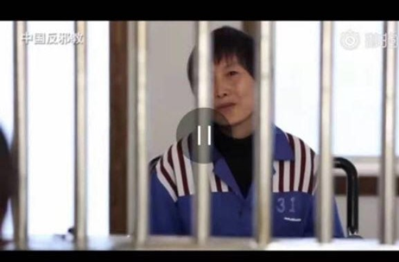
In 2017 sisters Ju Dianghong (pictured) and Liang Qin were sentenced to jail terms of 13 and 10 years respectively for their Christian activities. Christians in China's Yunnan province face long prison sentences as Chinese authorities try to eradicate their religion under the guise of cracking down on 'evil cults'. In 2016 Yunnan officials formed an investigative team dedicated to wiping out the Three Grades of Servants religious sect, which China regards as a dangerous cult, and launched systematic attacks against them. The authorities conducted mass arrests of more than 200 Christians across the province. In 2018 around 40 were still in custody, facing long sentences. Their lawyers are under official review just for defending them. Ignoring their denials that they ever belonged to the cult, Chinese officials sentenced six of these imprisoned Christians — Ju Dianghong, 46, Liang Qin, 30, Zhang Hongyan, 34, Zi Huimei, 30, Yang Shunxiang, 29, and Zhang Shaocai, 42 — to between four and 13 years in prison. Ju Dianghong and Liang Qin claimed they were never involved with the sect and had never heard of it, but were accused of leading and recruiting members, doing missionary work and spreading news of the apocalypse on behalf of the cult. In its verdict the court stated that Christianity could fall under the definition of an 'evil cult', supported by the possession of Christian books such as 'Pilgrim's Progress' and 'Streams in the Desert'. In fact the cult is deemed dangerous by mainstream Christians and probably died out after a crackdown in 2005-6, but it is used by the authorities as a catch-all to persecute other Christians. Christians face many perils in prison. The Chinese government infamously persecutes those it deems “enemies of the state,” many of whom are Christians. Christian prisoners often suffer torture, beatings, and even death at the hands of prison officials. Others leave their cells in extremely poor physical and mental health from subjection to inhumane practices and medical neglect. The location of their prisons — in remote areas over 1,000 miles from homes and families — is rarely disclosed and requires exhaustive research by Christian charities to uncover. This is also true of Ju Dianghong and Liang Qin. [Picture: ChinaAid]

Please send a non-religious card/greeting to the women at the following address, reminding them that they are not forgotten. Do not mention ACAT.
Prisoner's name
No. 1 Prison for Women of Yunnan Province,
Kunyang Town, Jinning District,
Kunming City, Yunnan Province,
China 650600


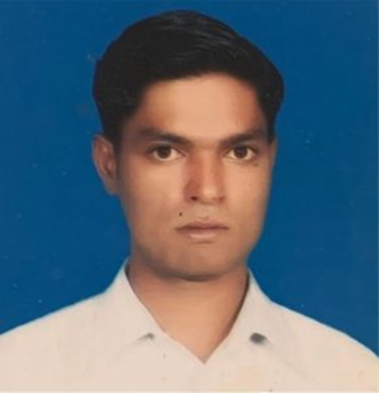
Ashfaq Masih (34) has been in prison in Pakistan since 2017, when he was accused of blasphemy. He is still awaiting trial as his court hearings have been cancelled repeatedly because the judge or witnesses failed to appear. A bicycle mechanic from the Christian Mariam Colony in Lahore, Ashfaq Masih was accused of blasphemy after he was involved in a dispute with a Muslim customer over payment for repairing a bicycle. It is not unusual in Pakistan for Christians to be targeted in this way over minor business disputes that escalate into religious conflicts. The customer claimed to be a poor sadhu (holy man) demanding a rebate on the cost of the bicycle repair. A crowd gathered and Ashfaq was accused of blasphemy for reportedly insulting the Prophet Muhammad by telling the bicycle owner that Christians believe Jesus was the final prophet. Police were called and arrested Ashfaq, who is imprisoned in the District Jail (aka Camp Jail), Lahore. Like many victims of the blasphemy laws, Ashfaq and his family are very poor.

Please send a non-religious greeting (do not mention ACAT) to:

Ashfaq Masih
District Jail Lahore
Ferozepur Road
Shadman 1 Shadman
Lahore
Punjab 54000
Pakistan


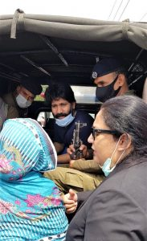
Salamat Mansha Masih and his friend Haroon Ayub Masih (both aged 26) were accused of blasphemy after a group of Muslims heard them reading the Bible in Lahore's Model Town Park on 13 February 2021. Haroon fled the park but Salamat was arrested and spent over two months in detention before being presented before a judge on 16 April (24 hours is the required period). According to his lawyer, during this period he was kept in at least three different police stations and illegal torture cells. Police threatened to kill him, and his family were not allowed to see him before he appeared in court. The family were not allowed to talk to him until a week later.
The police investigators reportedly forced him to admit to blasphemy and tortured him into naming other members of his Bible study circle. Police registered a case for derogatory remarks against the Prophet Muhammad (Section 295-C of the Pakistan Penal Code, punishable by death); defiling the Quran (Section 295-B, punishable by life imprisonment and a fine); and deliberate and malicious acts intended to outrage religious feelings (Section 295-A, punishable by up to ten years in prison and a fine). [Picture: Daily Morning Star: Salamat Mansha Masih (centre), with mother (left) and lawyer (right) arriving at Lahore Prison on 23 April 2021]

Please send a non-religious greeting (do not mention ACAT) to:

Salamat Mansha Masih
District Jail Lahore
Ferozepur Road
Shadman 1 Shadman
Lahore
Punjab 54000
Pakistan



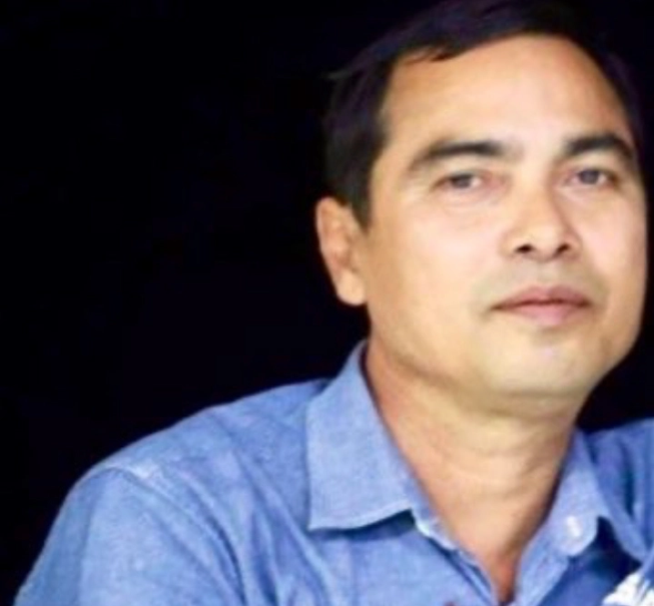
On 3 March 2021 journalist Min Nyo was arrested and severely beaten by police while he was covering a pro-democracy protest against the military coup in Pyay, Bago Region, Myanmar. On 12 May 2021 a military court in Pyay Prison found him guilty of attempting to 'hinder, disturb, damage the motivation, discipline, health and conduct' of soldiers and civil servants and 'cause their hatred, disobedience or disloyalty toward the military and the government' (Penal Code, Article 505-a) and sentenced him to three years in prison. He is currently detained at Pyay Prison, where he is at risk of being tortured, and is appealing against the verdict. [Picture: DVB, cpj.org]
Please send a non-religious greeting (do not mention ACAT) to:
Min Nyo
Pyay Prison
R6HC+P8Q, Pyay
Bago Region
Myanmar
REMEMBER IN YOUR PRAYERS

Salah Soltan, who has been held in secret detention in Egypt since June 2020 in reprisal for his son's human rights work and is at risk of torture.
Pablo López Alavez, a long-standing campaigner against logging, who has been sentenced to 30 years in prison following bogus charges and a deeply flawed trial in Mexico.
Pastor Zafar Bhatti, who has been in jail in Pakistan since 2012 on blasphemy charges and was sentenced to death in January 2022.
Yousef Nadarkhani, a Christian pastor in Iran, who has been in prison since 2018 on charges of 'acting against national security'. Remember also other members of his church who have been provisionally released pending a review of their cases but still face an uncertain future.
Zhang Zhan who was sentenced to four years in prison in 2021 for reporting on COVID-19 in China and who is dangerously ill.
Sisters Ju Dianghong and Liang Qin who were sentenced in 2017 to 13 and 10 years in prison in China for membership of a Christian sect.
Ashfaq Masih, a Pakistani Christian who remains in prison since 2017 facing accusations of blasphemy.
Salamat Mansha Masih, a Christian and member of a Bible study circle who was tortured into confessing to blasphemy in 2021 and remains in prison in Lahore.
Min Nyo, who was arrested and detained in Myanmar while reporting on a pro-democracy protest in 2021, was severely beaten by police, and remains at serious risk of torture in prison.
Claude Lwaboshi Buhazi, Faustin Ombeni Tulinabo and Serge Mikindo

