APPEALS

Please send a message on behalf of Jafar Azimzadeh, Iran
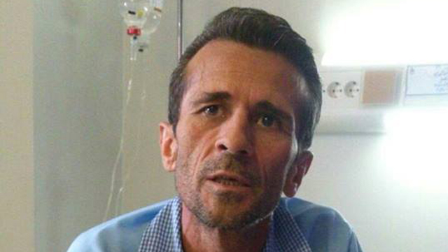
Trade union leader Jafar Azimzadeh is a political prisoner of conscience jailed in 2015, re-arrested and jailed in 2019/2020. He began a second hunger strike in August 2020 and his already fragile health condition is known to have worsened. His transfer, after contracting COVID, from Evin to Rajai Shahr Prison, notorious for torture, rape and ill-treatment, is likely to have further endangered his life. He was featured in our previous newsletter but ACAT members are invited to repeat their appeals and ask for further information about his condition. For further details see under the Easter Greetings section below.

Please write to the following (do not mention ACAT):
Hassan Rouhani
President of Iran
Email: media@rouhani.ir
Twitter: @HassanRouhani
Salutation: Dear President
Ali Khamenei
Supreme Leader of Iran
Email: info_leader@leader.ir
Twitter: @khamenei_ir
Salutation: Dear Supreme Leader

H.E. Mr Esmaeil Baghaei Hamaneh
Ambassador and Permanent Representative
Permanent Mission of the Islamic Republic of Iran to the United Nations
Chemin du Petit-Saconnex 28
1209 Geneva
Switzerland
Fax: +41 22 733 02 03
Email: iranunog@mfa.gov.ir / Email: iran@un.int
Salutation: Your Excellency / Dear Ambassador

H.E. Mr Hamid Baeidinejad
Embassy of the Islamic Republic of Iran
16 Prince's Gate
London SW7 1PT
Tel: 020 7225 4208 / 020 7225 4222
Fax: 020 7589 4440
Email: iranemb.lon@mfa.gov.ir
Website: www.london.mfa.ir
Salutation: Your Excellency/Dear Ambassador

Suggested message:
Salutation
We are writing to you on behalf of Mr Jafar Azimzadeh, a trade union and labour leader who was sentenced to prison in 2015 and subsequently also in 2019/20 for campaigning for better wages for workers and improved prison conditions. He has reportedly been assaulted in prison, contracted Covid-19 and removed from Evin Detention Centre to Rajai Shahr Prison, although his current whereabouts may have changed again. He has also been on hunger strike and is in seriously poor health. We understand that his wife and family have been threatened not to publicise his case.
Since he has not been charged with recognisable offences under international law and is imprisoned solely for his peaceful activities to improve conditions of workers and prisoners, we urge you to ensure his immediate release. In the meantime, we ask you also to ensure that he is provided with medical treatment for his health condition and that his family are not subject to intimidation. Further information on his condition would be greatly appreciated.
Yours respectfully

Please send a message on behalf of Abdulhadi Al-Khawaja, Naji Fateel and Dr Abduljalil Al-Singace, Bahrain. They are all human rights workers who have been arrested, detained and tortured. Full details on them are available below in the Easter Greetings Campaign section, where you are also asked to send them a personal message of hope and encouragement.
Please write to the following (do not mention ACAT):

H.E. Shaikh Fawaz bin Mohammed Al Khalifa
Ambassador to the United Kingdom
The Embassy of the Kingdom of Bahrain
30 Belgrave Square
London SW1X 8QB
Email: Political@bahrainembassy.co.uk
Salutation: Your Excellency / Dear Ambassador

H.E. Ali bin Mohammed Al Romaihi
Minister of Information
Ministry of Information Affairs
Directorate of Media Administration
P.O. Box 253
Manama
Kingdom of Bahrain
Email: yousif@info.gov.bh / dma@info.gov.bh
Website: https://www.mia.gov.bh/contact-us/?lang=en
Salutation: Your Excellency / Dear Minister
Mr Nawaf Al-Maawada
Head of the Prisoner and Detainees Rights Commission (PDRC)
10th Floor, Bronze Towers, Building No: 204
Road 2803, Block: 428
Seef District,
P.O. Box 23452,
Kingdom Of Bahrain
Salutation: Dear Mr Nawaf Al-Maawada
[No email available]

Suggested message:
Salutation
I/we write to you on behalf of Abdulhadi Al-Khawaja, Naji Fateel and Dr Abduljalil Al-Singace, who were arrested, detained and tortured following pro-democracy protests in 2011. They and eight other activists were sentenced to life imprisonment in an unfair trial, on a charge of attempting to overthrow the government. They now languish in Jaw Prison, where Abdulhadi Al-Khawaja and Dr Abduljalil Al-Singace have also been denied medical treatment for ongoing health conditions. I/we call upon the Bahraini authorities to immediately and unconditionally free prisoners of conscience and human rights defenders.
Equally I/we urge the authorities to end torture and ill-treatment in prisons, police stations and secret locations and bring perpetrators to justice immediately.
I/we would greatly appreciate any information or update on the condition of Abdulhadi Al-Khawaja, Naji Fateel and Dr Abduljalil Al-Singace. I/we would also urge you to ensure that Mr Abdulhadi Al-Khawaja and Dr Abduljalil Al-Singace receive the urgent medical treatment which they need.
Thank you for your attention to this urgent matter.
Yours faithfully

EASTER GREETINGS CAMPAIGN
For this campaign we suggest that you write a simple card or greeting to the individual saying, for instance, that you are thinking of him/her and/or urging them not to lose hope (or words to that effect). A picture postcard is always welcome and cheapest to send. You can include your name and address if you wish but do not mention ACAT or include a religious greeting or motif if so advised, since communication from a foreign organisation can endanger the prisoner. Several individuals featured in previous campaigns have been released. Sadly others are still in prison and it is important not to forget them. Changes in their circumstances are described, where known. As usual we include human rights groups. For individual prisoners or their families it is heartening to receive fairly regular cards of encouragement. Members should not feel obliged to respond to every appeal case or to write to every address given for a case.
Overseas postage rates (to Europe and the rest of the world):
£1.70 for up to 20g.

GROUPS
THE CLEWER INITIATIVE enables Church of England dioceses and wider Church networks to develop strategies to detect modern slavery in their communities and to promote victim support and care. They work on community-based projects and share learning and knowledge in order to reach a common goal: a world without slavery. The initiative is funded by the Clewer Sisters, an Anglican order of Augustinian nuns founded in 1852 to help marginalised, mainly young women who have found themselves homeless and drawn into the sex trade, by providing them with shelter and teaching them a trade.

THE CLEWER INITIATIVE
The Archbishops' Council
The Church of England
Church House
Great Smith Street
London SW1P 3AZ
Email: https://www.theclewerinitiative.org/contact

Winchmore Hill United Reformed Church in Enfield, London, led a successful campaign in 2020 to prevent the UK from deporting one of its parishioners, Madhi, a gay Iranian who was being held at Colnbrook Detention Centre and due for deportation. In 2016 he fled Iran where he had been detained and tortured. Homeless and abused in Germany, he eventually arrived in the UK in February 2019. At the time of writing the church, led by Revd Melanie Smith, was still working to prevent further detention and deportation attempts and achieve refugee status for him in this country. In her words: 'We fear that his life is at risk if he is forcibly deported. [...] Madhi is a vulnerable adult suffering PTSD and prone to self-harm following his experiences which led to his fleeing Iran. After mistreatment whilst in detention with G4S, he had a serious self-harm episode in custody.’
Please send a greeting to:
Revd Melanie Smith
Winchmore Hill URC Church
77 Compton Road
Winchmore Hill
London N21 3NU
Email: Minister@winchmorehillurc.co.uk

INDIVIDUALS
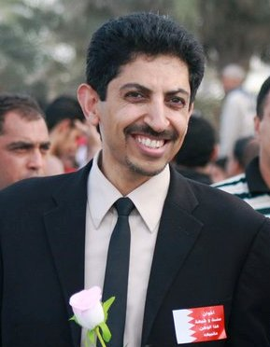
Abdulhadi Al-Khawaja, Dr Abduljalil Al-Singace and Naji Fateel are all human rights defenders who were arrested and detained in the Kingdom of Bahrain following pro-democracy protests during the country's 2011 uprising. In an unfair trial they and eight other activists were sentenced to life imprisonment on a charge of attempting to overthrow the government and now languish in Jaw Prison. There are credible allegations of torture during their detention at Al Qurain Military Prison, as also of beatings and insults suffered en route from the police station. At the prison, officers tortured Dr Al-Singace and threatened to kill him and members of his family. He was held in solitary confinement for two months. Both Dr Al-Singace and Abdulhadi Al-Khawaja have ongoing health issues. Mr Al-Khawaja is in danger of losing his sight after cancelled appointments and faces reprisals after protesting against poor prison conditions. During the early days of his detention he went on hunger strike, leading to fears for his life. His daughter, Zainab, has also protested by hunger strike and other means on his behalf and was forced to leave Bahrain for Denmark to escape the risk to her own life. Mr Al-Khawaja is the founder and former president of the Gulf Centre for Human Rights (GCHR) and the Bahrain Center for Human Rights (BCHR). He is also the former MENA Protection Coordinator for Front Line Defenders. [Picture: Wikipedia]
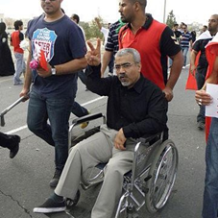
Dr Al-Singace was a Bahraini academic, human rights activist, and blogger until 2011, when he was detained for his participation in protests. He is one of the 'Bahrain Thirteen’, a group of 13 political leaders who were arrested for their role in the 2011 pro-democracy movement in Bahrain. He remains in Jaw Prison, where the authorities have repeatedly prevented him from receiving necessary medical care. He suffers from the effects of childhood polio and has sickle-cell anaemia, with symptoms including chronic pain, numbness of the extremities, and shortness of breath. His health has deteriorated following torture during his initial detention and the denial of adequate medical care. Prison officials have in the past withheld his medication and prescription medical devices, particularly the rubber padding for his crutches. [Picture: www.scholarsatrisk.org]
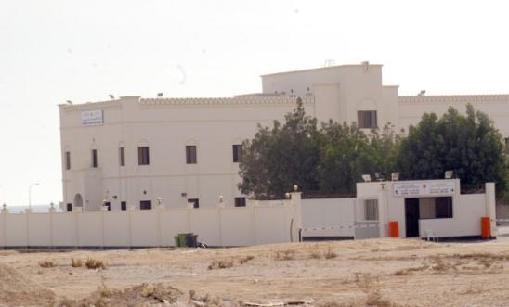
Naji Fateel is a human rights defender and board member of the Bahrain Youth Society for Human Rights (BYSHR). In 2013 he was arbitrarily arrested in his own home, and later suffered torture and ill-treatment, including electric shocks, threats, beatings and deprivation of food and sleep. He was sentenced in an unfair trial and still suffers from some of the severe injuries that he sustained from his torture. On 25 January 2016 he was among 57 prisoners sentenced to additional 15-year terms for alleged involvement in disturbances in Jaw prison in March 2015. The public prosecutor accused the men of having 'unleashed acts of chaos, riots and rebellion inside [prison] buildings’, and charges included 'damaging public property, attacking police, arson and resisting authorities'. Fateel was already serving a 15-year prison sentence for 'establishing a group for the purpose of disabling the constitution’, and has been in prison since May 2013. He was badly tortured there and it is believed that his imprisonment stems from his human rights work, including his interactions with the UN. [Picture: Jaw Central Prison]

Please send a non-religious message (do not mention ACAT) to:
[Name of prisoner]
Jaw Central Prison
The Kingdom of Bahrain

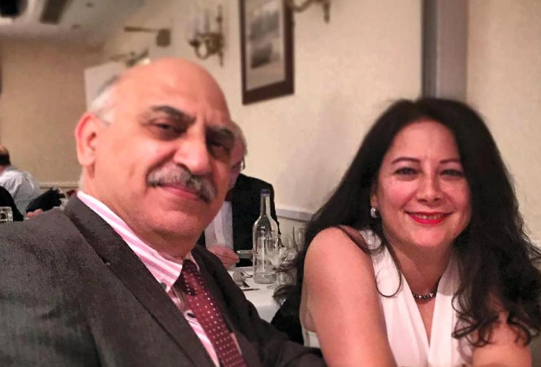
Anoosheh Ashoori (pictured with his wife) is a retired engineer and dual UK-Iranian citizen who was sentenced in 2017 to ten years in prison for 'cooperating with a hostile state against the Islamic Republic', with two additional years for allegedly obtaining 33,000 euros in 'illicit funds' which he must pay to the state on release. After his arrest he was held in solitary detention for six weeks, interrogated without access to a lawyer and threatened with intimidation of his family. At his trial the judge refused to acknowledge his retraction of a confession obtained under torture and rejected all six lawyers he had selected, appointing a state-approved one instead. During the summer he was denied dental and gum care, which could mean losing half his teeth. Although his fate and that of several others in Iran's prisons has not attracted the same publicity as that of others, it belongs to the pattern of arbitrary detention of foreign nationals for political purposes. In permitted phone calls to his family Anoosheh has reported that prisoners are tortured, have died under interrogation and have been moved to mental institutions for unknown injections and electric shock treatment. The prison authorities' response to Covid-19 has been chaotic. [Picture provided by family for www.thenational.ae]

Please send a (non-religious) message to the following. Do not mention ACAT.
Anoosheh Ashoori
Evin Detention Centre
Tehran Province
Tehran
District 2
Islamic Republic of Iran

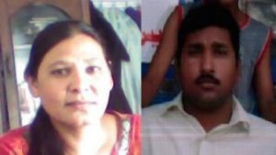
Shagufta Kausar and Shafqat Emmanuel, Pakistan, were arrested and convicted of blasphemy after allegedly sending text messages in June 2013 from a number registered in Shagufta's name. The messages were written in English, but Shagufta and Shafqat are illiterate and unable to write proper Urdu, let alone English. They claimed they lost the phone in question before the texts were sent, and that the SIM card in it was not theirs. In July 2013 local police registered a blasphemy case against the couple on the complaint of cleric Muhammad Hussain. In April 2014 they were sentenced to death. Their lawyer claimed that, to appease mobs led by Islamist clerics, the police tortured Shafqat into confessing before a magistrate that he had sent the messages. Shafqat told lawyers that the police tortured him in front of his wife and children, and threatened to torture his wife if he did not confess. Throughout the trial the complainant’s lawyers intimidated the judge by repeatedly proclaiming Quranic references calling for death to blasphemers.
Shafqat is paralysed from the waist down, having fractured his spine in an accident in 2004. He and Shagufta lived with their children in a church compound in Gojra, Punjab Province, and she supported the family by working as a cleaner. They are being held in different prisons about 250 km apart. Shafqat has spent months in hospital because of extremely painful bedsores all over his body. The couple's four children (aged 10-15) have had to be moved to another area following huge protests over the incident. Appeal hearings have been repeatedly postponed, most recently to 22 October. [Last featured in Easter Campaign 2019]

Please send a non-religious (picture) card with a simple greeting in English. Do not mention ACAT.

Shafqat Emmanuel  Central Jail  Faisalabad  Pakistan | Shagufta Kausar  District Jail  Multan  Pakistan

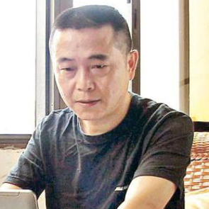
Co-founder of the Tianwang Center for Missing Persons (later renamed the Tianwang Human Rights Center), Huang Qi has documented human rights violations in China, reporting them on a Hong-Kong-based website. They include deaths in police custody and the kidnapping and sexual trafficking of girls. He also published accounts by participants of the protests in Tiananmen Square (1989) and assisted parents complaining about infrastructure failures that contributed to the collapse of schools in Sichuan Province during an earthquake (2008). Repeatedly detained and imprisoned in labour camps 2000-2005 and 2009-2011, he was most recently arrested in November 2016 and has not been seen since. In prison he has reportedly been tortured and ill-treated by police officers and beaten by other detainees. Denied access to a lawyer and refused medical treatment in order to force a confession, he has always refused to plead guilty. Qi's relatives fear that he will not survive his conditions of detention. He underwent a secret trial in Mianyang in January 2019 for 'providing state secrets overseas'. Other human rights workers targeted by the authorities include Liu Fieyue (sentenced to five years in prison in January 2019) and Zhen Janghau (two years in December 2018).

You can write a (non-religious) message (do not mention ACAT) to the family of Huang Qi at the following address. Messages will be scanned and passed on to his family:
Huang Qi
C/o ACAT-Switzerland - 'Huang Qi Action' -
Speichergasse 29 - PO Box -
3001 Bern
Switzerland

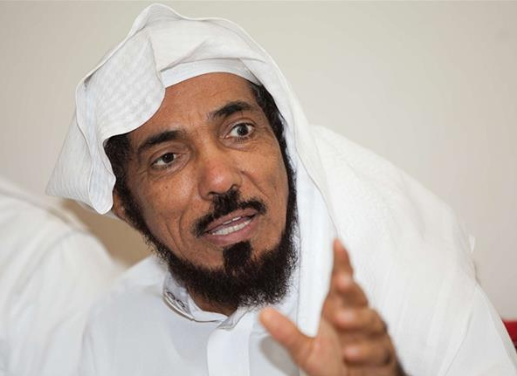
Salman Al-Awdah (or al-Ouda), is a political reformist who was imprisoned in 2017, shortly after Crown Prince Mohammed bin Salman launched a crackdown on dissent. He was detained in solitary confinement for five months, shackled and handcuffed in a cell, deprived of sleep, without medical support and questioned day and night. On leaving he had to be hospitalized. A popular religious preacher in Saudi Arabia (more than 13 million subscribed to his Twitter account) he is a prominent member of the Sahwa ('Awakening') Islamist movement, which opposed the presence of US troops in Saudi Arabia following Iraq's invasion of Kuwait. Although the movement campaigns peacefully, the ruling Al Saud family regards most Islamist groups as the biggest threat to its rule. In 2011 Al-Awdah called for elections and separation of powers, demands considered dangerous provocations in the kingdom. He is also reported to have been charged with establishing an organisation in Kuwait to defend the Prophet Mohammed (PBUH), and being a member of the European Council for Fatwa and Research and the International Union of Muslim Scholars. At one stage he faced 37 charges (probably including 'spreading discord and incitement against the ruler'), with the prosecutor demanding the death penalty (September 2018). Hearings have been repeatedly postponed.

Please write a (non-religious) message to Salman's son, Abdullah Al-Awdah, in English expressing your concern and support at the following address (you may mention ACAT).
Abdullah Alaoudh Center for Muslim-Christian Understanding
Bunn Intercultural Center (Suite ICC)
260 37th and O Street, N.W.,
Washington DC 20057
USA

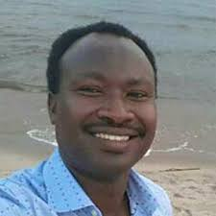
Germain Rukuki has been in prison in Burundi since July 2017. Following a trial marred by numerous irregularities, he was sentenced to 32 years in prison. Without any material proof being presented and on the basis of false accusations, he was condemned for membership of an 'insurrectional movement', 'undermining the internal security of the State', 'rebellion', 'assassination of servicemen, police and civilians', 'degradation of public and private buildings', and 'the will to change the democratically elected regime'. The proceedings were held in camera. When sentence was pronounced neither Germain nor his lawyers were present. His 'crime' was membership of ACAT-Burundi, which, like almost all Burundian human rights NGOs, has been banned since 2015. Their members are silenced by prison, exile or death. In November 2018 the African Commission on Human and Peoples' Rights urged the Burundi authorities to 'release all arbitrarily detained persons, including human rights defenders'. He has featured in regular ACAT appeals since the newsletter for June–August 2018.

Please send a greeting (religious or non-religious but do not mention ACAT) to the following:
Germain Rukuki
Ngozi Prison
Ngozi Province
Burundi BY19
[The postal route is very uncertain but we would appreciate members trying.]

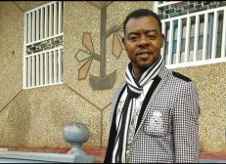
Arrested without warrant by soldiers and after over 14 postponements of hearings, radio journalist Mancho Bibixy was sentenced in May 2018 by a military court in Cameroon to 15 years in prison and a huge fine for 'acts of terrorism, secession, propagation of false information, revolution, insurrection, contempt of public bodies and officials and hostility against the fatherland'. He was considered a leader of a peaceful demonstration against the marginalization of the English-speaking minority. The authorities' response in the conflict has been very violent, including the use of live ammunition against protesters, mass arrests, torture, humiliation and intimidation. In 2019, after organizing, with four other human rights detainees, a protest against their ill-treatment, he was moved temporarily to a military camp where he was again tortured. His sentence was extended for another three years. In poor health owing to bad and overcrowded prison conditions, he can communicate with his family only with the authorization of the prosecutor and by paying fees. According to recent reports (May 2020) his health has seriously deteriorated and at least one fellow prisoner has tested positive for coronavirus. First featured in our Christmas Greetings Campaign 2019, Mr Bibixy recently (January 2021) sent us this very welcome message:
This is Mancho Bibixy, Yaounde Central Prison. I received many greeting cards and words of encouragement from many concerned individuals in the UK. I was so blessed and encouraged. Most of them heard about me from ACAT UK. I am so grateful to ACAT UK.
Please send a greeting (religious or non-religious, and you can mention ACAT) to:
Mr Mancho Bibixy
Yaoundé Central Prison
1000 Yaoundé
Cameroon

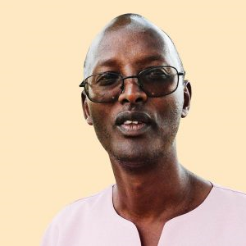
A non-violent campaigner for peace and democracy in Rwanda, Déogratias Mushayikdi has been imprisoned for many years and his situation nearly forgotten. A Tutsi, he lost his family during the 1994 genocide. During and after the armed rebellion in which Paul Kagame – current president of the Republic – was one of the leaders, he occupied a senior position in the Rwandan Patriotic Front (RPF) but left after discovering that it was committing extra-judicial killings with impunity. He began a career as a journalist, criticising the abuses of the Front. In 2000, following threats, he fled to Belgium, where he mobilized both Hutus and Tutsis with a view to bringing about peaceful political change in a united Rwanda. He also met representatives from the African continent.
In March 2010 he was arrested in Tanzania with an expired visa on a fake Burundian passport (which he used to avoid detection), and taken to Rwanda, where he was given a life sentence after an unfair trial. The Supreme Court upheld the sentence. With no family in Rwanda he receives few visits and has been largely forgotten by the international community.
In 2017 the US State Department documented various human rights problems in Rwanda, including government harassment, arrest, and abuse of political opponents, human rights advocates, and individuals perceived to pose a threat to government control. Other issues include arbitrary or unlawful killings, torture and harsh conditions in prisons and detention centres and prolonged pre-trial detention. [First featured in ACAT newsletter Sept-Nov 2020]
Please send a greeting (either religious or non-religious) to him via the following address. You can mention ACAT.

ACAT-France – Rwanda
Action Déogratias Mushayikdi
7, rue Georges Lardennois
75019 Paris
France
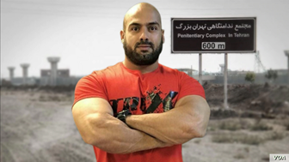
Khalid Pirzadeh is an Iranian political prisoner who has been beaten by security agents to the point of needing to use a wheelchair. Also following such beatings he suffered loss of bladder control. According to his lawyer he was beaten again most recently in September for complaining about a plan to transfer him to another part of the prison. A guard reportedly struck his knee, which had not yet fully recovered from recent surgery (which he was forced to pay for himself) to repair damage from a previous beating. Pirzadeh was arrested in early 2019, accused of writing anti-government slogans. After a trial in which he had no access to a lawyer, he was sentenced in May 2019 to five years in prison on charges of ‘assembly and collusion against national security’ and insulting Iranian Supreme Leader Ayatollah Ali Khamenei. Political prisoners are often beaten and their lawyers intimidated by the authorities. [Source: Michael Lipin, Ramin Haghjoo, https://iranhumanrights.org/]

Please send a non-religious greeting (do not mention ACAT) to:
Khalid Pirzadeh
Greater Tehran Penitentiary
Tehran Province
Islamic Republic of Iran
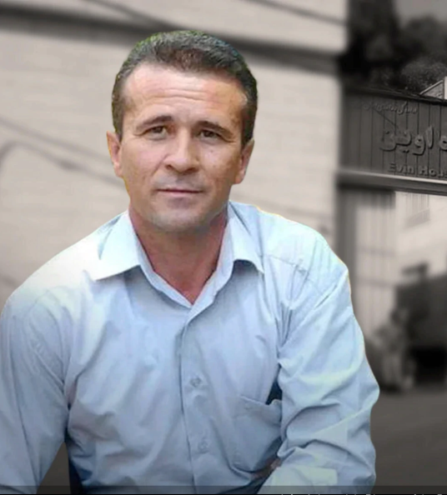
Iranian labour union leader Jafar Azimzadeh was jailed for five years in November 2015 for 'assembly and collusion against national security' and 'organizing and operating an illegal group'. He was released in 2016 after a two-month hunger strike, which attracted international attention and left him with heart, lung, eye, and intestinal problems. Re-arrested in 2019, his original sentence was extended for one year in August 2020, this time for spreading anti-government propaganda from inside the prison. He was also sentenced to 30 lashes for being absent from prison, despite having been given temporary leave by the prison officials (it is unclear whether this has been carried out).
Azimzadeh is a leading member of the Free Union of Iranian Workers, a group formed in 2006 without government approval which advocates higher wages for workers. He has highlighted the lack of medical treatment for sick prisoners in Iran and criticised the sentencing of workers demanding unpaid wages at Iran's Haft-Tapeh Sugar Cane Company. Assaults on him by other prisoners have not been investigated. Such assaults are often encouraged by the authorities to avoid responsibility for deaths in prison.
After recently contracting Covid-19 this year he was suddenly transferred from Evin to Rajai Shahr Prison — notorious for torture, rape and ill-treatment — under the pretext of moving him to a hospital. Again on hunger strike (at the time of writing) his life is in grave danger. His wife has also been threatened if she continues to speak with the media about her husband's situation.
[Source: Michael Lipin, Ramin Haghjoo, www.voanews.com/middle-east/voa-news-iran, and Observatory]
Please send a (non-religious) greeting to the following (do not mention ACAT):
Jafar Azimzadeh
Rajai Shahr Prison
Alborz Province
Karaj
Gohardasht
Moazzen Blvd
Islamic Republic of Iran

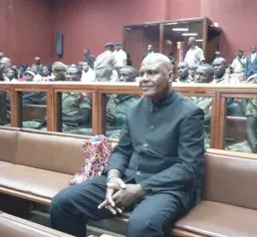
Bertrand Zibi Abeghe caused an uproar in Gabon in July 2016 when he resigned as an MP of the ruling Gabonese Democratic Party (PDG) during a public rally attended by President Ali Bongo Ondimba, who was re-elected a month later in a questionable electoral process. Bertrand was later arrested and held incommunicado for four months, before being transferred to the central prison in Libreville. In September 2017, after eight months of pre-trial detention, he was charged with 'illegal possession of a firearm', 'non-assistance to a person in danger' and ‘crimes against public peace'. He was repeatedly beaten, shackled, hooded, and placed in solitary confinement. His lawyers found him haggard, walking with difficulty, and his body covered with bruises. He told them that he had not eaten or drunk for three days. A complaint of torture was summarily dismissed. On various occasions he was denied food and water for several days in a row, and endured solitary confinement in a cell without light and only a few ventilation holes during extremely high temperatures. In July 2019 he was tried and sentenced to six years in prison. An appeal hearing has been postponed indefinitely.

Please send a (religious or non-religious) greeting (you can mention ACAT) to the following:
Bertrand Zibi Abeghe
C/o Libreville Central Prison
BP 2110, Libreville
Gabon
]
In Pakistan, Asif Pervaiz, aged 37, was arrested in 2013 and accused of sending offensive texts about Islam, the Quran and Islam's Prophet Muhammad on a mobile phone. According to the defence, the charge was an act of revenge by Muhammad Saeed Khokhar, Asif's supervisor at a hosiery manufacturing business. In his defence Asif said the accusations were made after he decided to quit his job because he had rejected Khokhar's efforts to convert him to Islam. The Lahore court ruled that even though there was no evidence of personal implication, he had not offered sufficient evidence of innocence. He was eventually sentenced to death in 2020. In October he was moved from Lahore to Faisalabad, which is 120 km from his family.

Please send a (non-religious) greeting to the following. Do not mention ACAT:
Asif Pervaiz
Central Jail
Faisalabad
Pakistan

Samar Badawi (pictured below) was targeted in 2018 in a wave of arrests directed at women's rights activists in Saudi Arabia. Between 2011 and 2017 Saudi courts had convicted at least 25 prominent activists and dissidents, sentencing them to long prison sentences under catch-all 'crimes' such as 'breaking allegiance with the ruler', 'sowing discord', 'inciting public opinion', 'setting up an unlicensed organization', and vague provisions from the 2007 cybercrime law. In 2017 a new regime under Crown Prince Mohammed Ben Salman (aka MBS) detained dozens of dissidents, including clerics, intellectuals and activists.
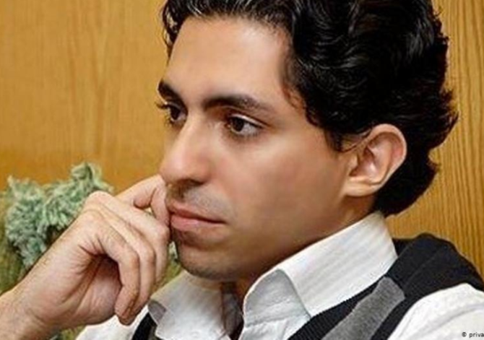
Held in Dhahban prison near Jeddah, Samar was tried and charged under the cybercrime law and faces up to 20 years in prison. She receives visits from relatives but is denied contact with a lawyer to organize her defence. She has reportedly suffered physical and sexual violence during interrogation. Repeatedly interrogated by the Saudi authorities, she was subjected to a travel ban in 2014, arrested in 2016, and imprisoned for seven months in 2010 after accusing her father of abusing his guardianship when she decided to leave home; she was released under international pressure. She then lobbied for the right of women to drive and the right to vote. She has also campaigned for the release of her brother Raïf Badawi (pictured above), also a human rights activist, and of her husband and lawyer Waleed Abulkhair (pictured below).
Raif Badawi was sentenced to ten years in prison, a huge fine and 1,000 lashes for criticising the regime and setting up a website for social and political debate (2010). Following an international uproar after suffering 50 lashes in public, he was never flogged again but remains in Dhahban Prison, near Jeddah. His wife and three children live in Canada.
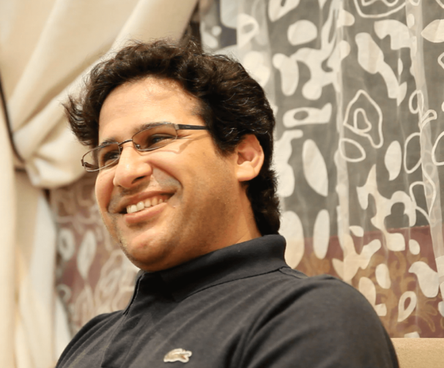
Waleed Abulkhair was sentenced in 2014 to 15 years in prison, with five years suspended, and awarded a large fine and a 15-year travel ban on release for 'insulting the kingdom' and criticising harsh and unjust sentences for dissidents. During his imprisonment he has been subjected to sleep deprivation and solitary confinement while being denied access to his lawyer and family. He has also staged a short hunger strike. [Pictures: www.dw.com, US Department of State, English Pen]

Please send a (non-religious) greeting to each of the above (do not mention ACAT):
(Name)
C/o ALQST For Human Rights Ltd
Unit 24.7, Coda Studios,
Samar Badawi Operation
189 Munster Road, Fulham
London SW6 6AW

Or to:
(Name)
Dhahban Central Prison,
Al Riyadh
Dhahban 23851
Kingdom of Saudi Arabia

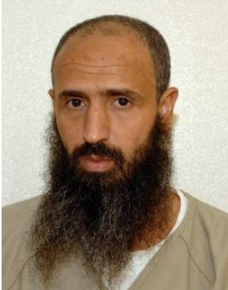
Abdul Latif Nasser (also: Nasir) has been incarcerated in Guantánamo Bay for almost 19 years. Although cleared for release by six US government agencies, he remains imprisoned without trial. Moroccan by birth, he compiled a 2000 word Arabic to English, English to Arabic dictionary while in the prison camp. Initially he was considered 'an enemy combatant' but was most recently on the point of being released until President Donald Trump vowed to keep the camp open and declared that no prisoner would leave it. The American Friends Service Committee (AFSC) is a long-standing Quaker organisation which provides a list of other detainees in Guantánamo Bay to whom messages and greetings may be sent (see https://www.afsc.org/action/letter-writing-guantanamo-prisoners].

Please send a (non-religious) greeting to the following (do not mention ACAT). The ISN is the prisoner's identification number.

Abdul Latif Nasser
ISN 244
Camp Delta
US Naval Guantánamo Bay, Cuba
Washington DC 20355
USA

REMEMBER IN YOUR PRAYERS
Jafar Azimzadeh, jailed for campaigning for the rights of workers and prisoners in Iran, and in poor health after two hunger strikes.
Abdulhadi Al-Khawaja, Naji Fateel and Dr Abduljalil Al-Singace, jailed and tortured for supporting a pro-democracy movement in Bahrain.
Let us remember also Waleed Abulkhair, Abdul Latif Nasser, Anoosheh Ashoori (Iran), Shagufta Kausar and Shafqat Emmanuel (Pakistan), Huan Qi (China), Salman Al-Awdah (Saudi Arabia), Germain Rukuki (Burundi), Mancho Bibixy (Cameroon), Déogratias Mushayikdi (Rwanda), Khalid Pirzadeh (Iran), Bertrand Zibi Abeghe (Gabon), Asif Pervaiz (Pakistan), and Samar Badawi and her brother and husband (Saudi Arabia) — all in prison, facing the death penalty or seeking justice for victims of persecution.
A Prayer for the Children of Persecuted Christians
Lord, we bring before you all persecuted Christians in so many parts of the world, and we particularly lift up their children, knowing that they can be abused, ill-treated and used as pawns to cause their parents to falter in their faith. Guard and protect all these little ones. Keep each one from long-term psychological harm, emotional pain or feelings of bitter revenge that can result from the atrocities they have had to endure and witness.
Lord, you were the one that said, 'Let the little children come to me and forbid them not.' I pray that each and every child that experiences some form of persecution against their faith, will be kept and protected by you, and brought at last into your everlasting kingdom, where every tear and all pain will be wiped away, forever. Amen.
[Adapted from https://prayer.knowing-jesus.com/Prayers-for-the-Persecuted]

A PRAYER FOR USE IN A PANDEMIC
May we who are merely inconvenienced remember those whose lives are at stake.
May we who have no risk factors remember those most vulnerable.
May we who have the luxury of working from home remember those who must choose between their health and paying the rent.
May those who have the flexibility to care for their children when schools close remember those who have no such options.
May we who have to cancel our travels remember those who have no place to go.
May we who are losing our margin money in the temple of the economy remember those who have no margin at all.
May we who settle in for quarantine at home remember those who have no home.
May we who self-isolate remember those who are in prison with no means of avoiding exposure to infection.
May we who have good and caring partners remember those for whom isolation exposes them to domestic abuse and violence at home.
May we who can hope for life after the pandemic remember those condemned to execution.
As fear grips our country let us choose love. During this time when we cannot physically wrap our arms around each other, let us find ways to be the loving embrace of God to our neighbour.
Amen
[With thanks to ACAT member Father Brady from whose contribution this prayer was adapted.]
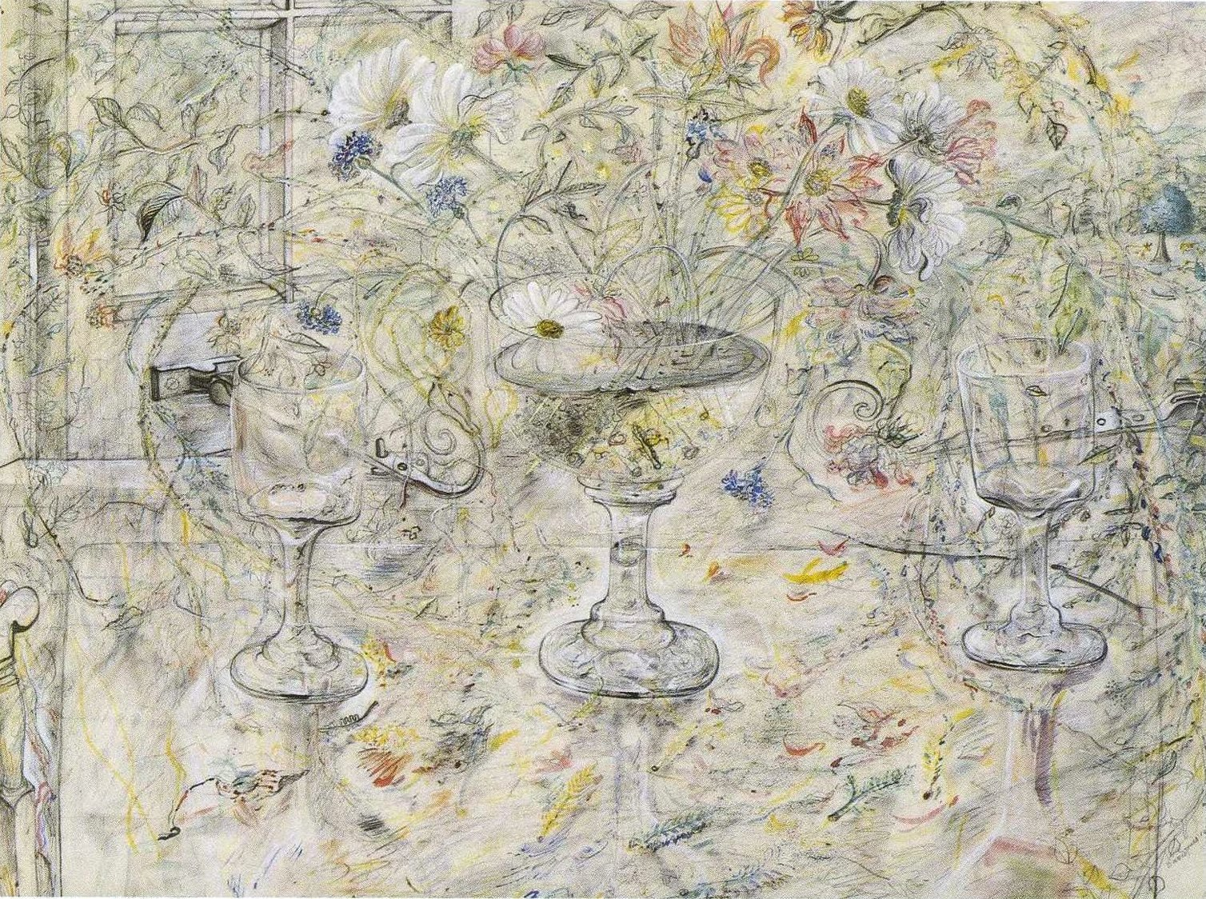

David Jones (1895-1974) was severely traumatised by his experiences in the trenches of World War I, notably at the battle of Mametz Wood (1916), where 4,000 men were killed or wounded in a mass attack. He later suffered a nervous breakdown and depression. Religion became a major theme in his later paintings and played a crucial, healing role in the recovery of his mental health. At the centre of Flora in Calix Light (1950) is a Eucharistic Chalice containing a profusion of flowers in irradiating and transformative light. [Picture: https://www.artway.eu]

