EASTER GREETINGS CAMPAIGN
For this campaign we suggest that you write a simple card or greeting to the individual saying, for instance, that you are thinking of him/her and/or urging them not to lose hope ― or words to that effect. A picture postcard is always welcome and cheapest to send. You can include your name and address if you wish but do not mention ACAT or include a religious greeting or motif if so advised, since communication from a foreign organisation can endanger the prisoner. Several individuals featured in previous campaigns have been released. Sadly others are still in prison and it is important not to forget them. Changes in their circumstances are described, where known. As usual we include human rights groups. For individual prisoners or their families it is heartening to receive fairly regular cards of encouragement. Members should not feel obliged to respond to every appeal case or to write to all the addresses listed for a particular case. Postage overseas is expensive: a letter or card (e.g. postcard) weighing up to and including 100g costs £2.20 (an economy £2.00 rate is only available for surface mail and is being discontinued).

GROUPS
Safe in Faith, a project of Caritas Westminster, provides survivors of domestic abuse, sexual violence and exploitation who are part of a faith community with safe, faith-based support and counselling that is tailored to their needs as believers and in ways that understand how their faith impacts their experiences. Among other initiatives, it aims to recruit people with lived experience of domestic abuse to create a peer support programme for victims. It has also recently set up a team of professional counsellors, therapists and trauma-informed clergy.
Please send a message to:
Email: admin@safeinfaith.org.uk
Website: https://safeinfaith.org.uk/safe-in-faith-news/

Open Doors originated in 1955, when a young Dutchman, later known as Brother Andrew, started smuggling Bibles to the persecuted church in Communist Europe. Open Doors currently works with churches and local partners to provide Bibles, Christian materials, training, livelihood skills and advocacy to numerous countries. It also publishes an annual World Watch List of persecuted Christians around the globe. You can send a message of support to any of the following contacts:
Open Doors  PO Box 6,  Witney  Oxon  OX29 6WG  Tel: 01993 460015  Fax: 01993 777301  Email: contact@opendoorsuk.org | Open Doors  PO Box 873  Belfast  BT15 1WZ  Tel: 02890 751080  Email: odireland@opendoorsuk.org
Open Doors Scotland
Tel: 01993 460015
Email: contact@opendoorsuk.org

Please send a message to:
Email: admin@safeinfaith.org.uk
Website: https://safeinfaith.org.uk/safe-in-faith-news/

INDIVIDUALS
Please send a message to Hisham Kassem, Egypt.
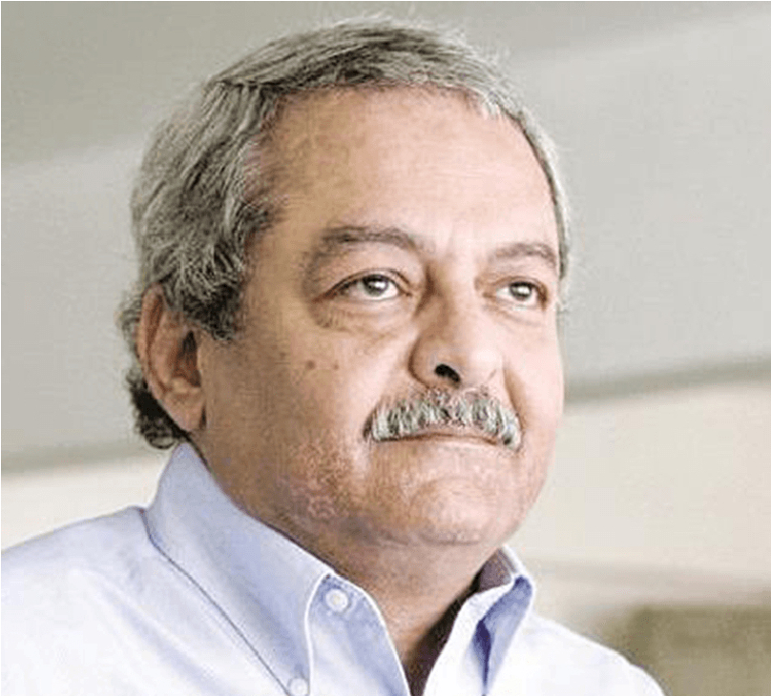
Hisham Kassem, a prominent 64-year-old opposition politician and publisher, has been arbitrarily detained since 20 August 2023 for peacefully exercising his right to freedom of expression. On 16 September 2023 he was sentenced to six months in prison on charges that stemmed from an online disagreement with the former labour minister, Kamal Abu Eita.
Hisham’s lawyers were denied access to his case file before the trial, and authorities banned diplomats and media from attending trial hearings. There has been no update on Hisham’s current health situation since his hunger strike from 23 August to 12 September, protesting his unjust imprisonment. He is at grave risk of torture and ill-treatment, given Egypt’s concerning track record of prison conditions.
Despite the reactivation of the Presidential Pardons Committee in May 2022, leading to the release of hundreds of political prisoners, arbitrary arrests continue at an alarming rate. This includes the arrest of Egypt-based relatives of dissidents living abroad. The situation remains grim as new detentions outnumber the releases, resulting in thousands of political prisoners still incarcerated. AI believes that Hisham’s prosecution for simply posting critical messages online is part of the Egyptian authorities’ relentless campaign to silence peaceful critics and punish dissent, including through the use of criminal defamation and other draconian laws.

Please send a non-religious message (do not mention ACAT) to:
Hisham Kassem
10th of Ramadan Prison Complex
Al-Sharqia Governorate 7062901
Arab Republic of Egypt

Please send a message to Narges Mohammadi, Iran.
Narges Mohammadi has been unjustly imprisoned since 2021, solely for her courageous human rights activism and continued fight against ‘the oppression of women’ in Iran. She condemned the authorities’ crackdown on nationwide protests, called for the abolition of the death penalty and the prohibition of solitary confinement, and exposed sexual violence against women protesters in detention.
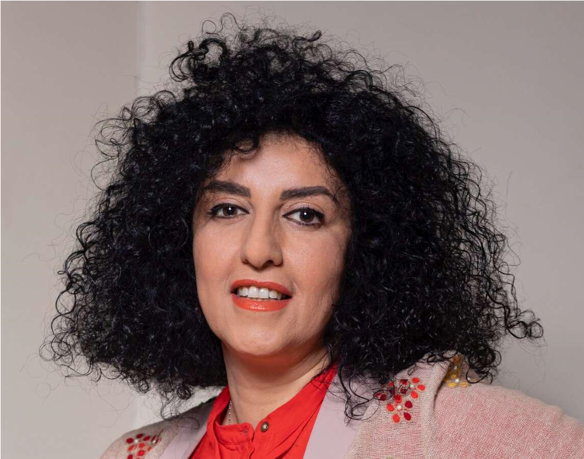
In October 2023, when her selection as the Nobel Peace Prize laureate was announced, Narges was confined in Tehran’s notorious Evin prison. Her husband, Taghi Rahmani, who has been described as ‘Iran’s most frequently jailed journalist’, writes on religious activism and reason.
Narges is currently serving multiple sentences totalling 12 years and 11 months, along with other cruel, inhuman, and degrading punishments, including 154 lashes. Iranian authorities deliberately denied or severely delayed her access to adequate healthcare to coerce her into adhering to Iran’s abusive and degrading compulsory veiling laws. On 12 November 2023 Narges was summoned to the prosecutor’s office in relation to a new case; however, prison officials refused to transfer her unless she complied with discriminatory compulsory veiling laws, which she refused.
Narges’s health is at great risk. She suffers from serious heart and lung conditions and has previously gone on hunger strike in protest at the prosecution authorities' refusal to transfer her for urgent medical tests at a hospital outside the prison for over two months. This placed Narges life at grave risk while authorities continue to deny her the adequate healthcare she requires.

Please send a non-religious message (do not mention ACAT) to:
Narges Mohammadi
Evin Prison
Saadat Abad
Tehran Province
Islamic Republic of Iran

Please send a message to Mohamed Benhlima, Algeria.
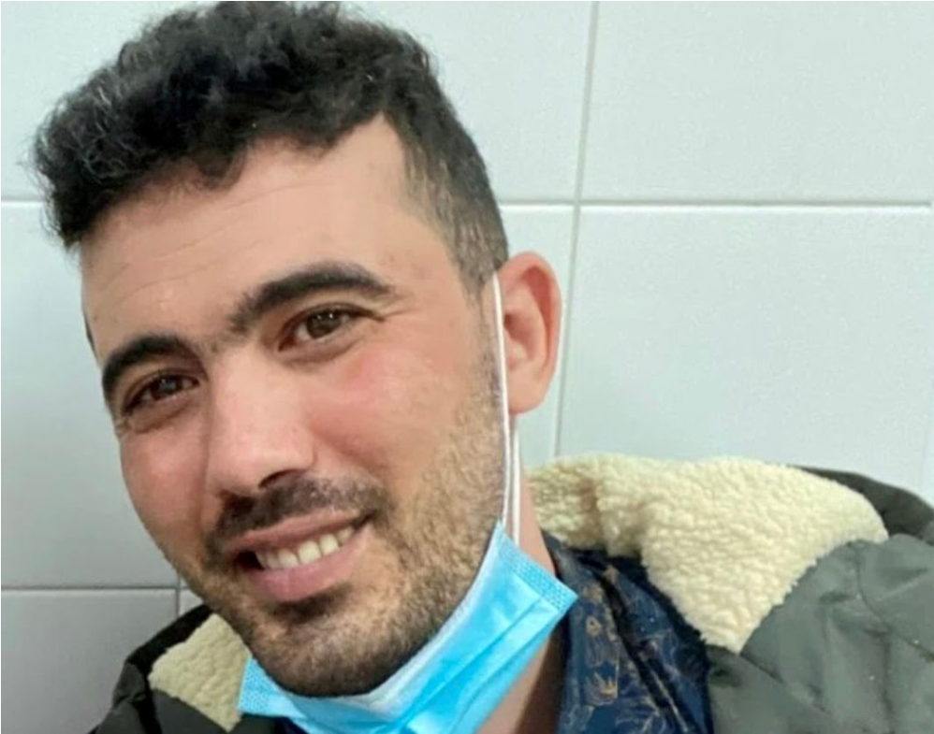
Mohamed Benhlima is a former military official and whistle-blower who exposed the corruption of high-ranking Algerian military officials online. He also participated in peaceful protests against the Algerian authorities that began in Algeria in 2019. Seeking asylum in Spain on 18 February 2020, Mohamed faced refoulement to Algeria by Spanish authorities, who cited him as ‘a danger to national security’ and potential harm to ‘Spain’s relations with other countries’. However, the alleged ‘well-founded’ reasons behind this decision have never been explained nor investigated. Spanish authorities failed to provide any evidence of violence, advocacy of hatred, or any other actions by the activist that could be considered as ‘terrorism’, according to the UN Special Rapporteur on the protection of human rights while countering terrorism.
On 24 March 2022 Mohamed arrived in Algeria, where guards handcuffed him and later placed him in a straitjacket. Before being deported to Algeria, Mohamed in a video statement, claimed that any confession he might make would be due to being ‘subjected to torture’. Alarmingly, during a court session, Abdelkadir Chohra, one of his lawyers, indicated that Mohamed had been transferred to a prison in Saoula, where he stated ‘things have happened to me in the Saoula police station. I am not going to say what now. That will happen in due course.’ Mohamed is currently detained in the military prison of Blida and has stated that he endured torture and other ill-treatment, including physical abuse and prolonged solitary confinement in a cell with no light.

Please send a non-religious message (do not mention ACAT) to:
Mohamed Benhlima,
Prison De Blida
N1, Blida 09000
The People’s Democratic Republic of Algeria

Please send a message to Fatma al-Arwali, Yemen.
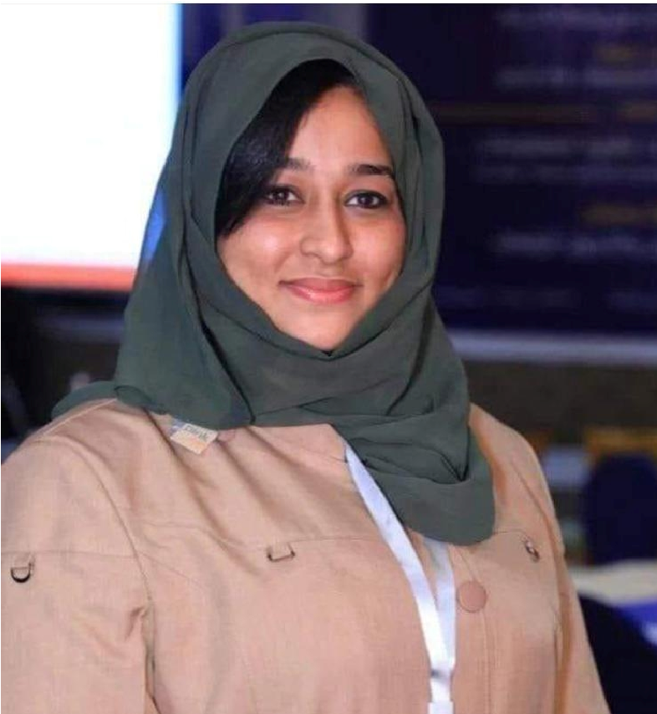
Fatma al-Arwali, a 34-year-old woman human rights defender, is at risk of execution after the Huthi-controlled Specialised Criminal Court in Sana’a, Yemen, convicted her of ‘aiding an enemy country’ on 5 December 2023. This conviction followed a grossly unfair trial where she had no legal representation. Since her arrest in August 2022, her family has only been able to contact her twice.
Huthi security forces detained Fatma on 13 August, 2022, at a checkpoint in al Manshour in Ta’iz governorate and endured enforced disappearance for over eight months. Her family later discovered that she had been held at the security and intelligence detention centre in Chamlan in Sana’a, where she remains detained. Due to the lack of communication it is difficult to know the conditions Fatma faces in detention. However, her lawyer revealed that during a September hearing, Fatma said that she was being kept in a small, mouldy room without a window. When one of Fatma’s brothers, Mohammed, briefly spoke with her during the September hearing, she disclosed that she had been injected with unknown substances and showed bruises, saying that she had been hit over the head. Mohammed described his sister as looking ‘sick, exhausted, and weak’. Fatma also has diabetes, and the judge at her trial denied her plea for her family to bring her medicine.
While there is no further information about Fatma’s condition in prison, the UN Security Council’s Panel of Experts on Yemen in 2023 noted that ‘Houthi-held prisoners are subjected to systematic psychological and physical torture, including the denial of medical intervention to cure the injuries caused by the torture inflicted, which for some prisoners resulted in permanent disabilities and death.’ Women are ‘subjected to torture and other forms of ill-treatment … [and are] also sexually assaulted … and are often prevented from gaining access to essential goods, including feminine hygiene products.’
Please send a non-relgious message (do not mention ACAT) to:
Fatma al-Arwali
Security and Intelligence Detention Centre
Chamlan, Sana’a
Republic of Yemen

Please send a message to Abbas Deris, Iran.
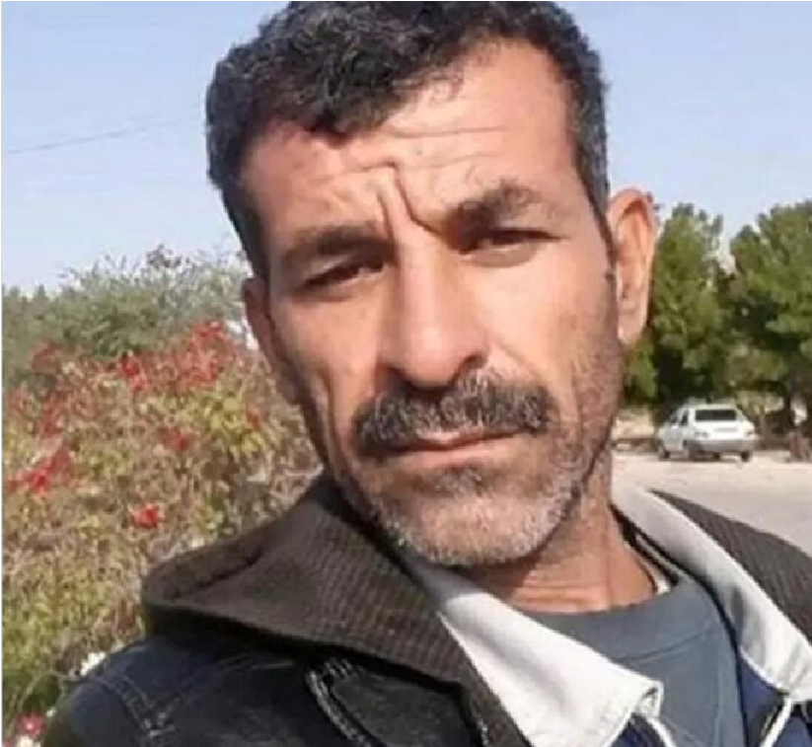
Abbas Deris is currently held in Mahshahr prison, facing an imminent risk of execution following the rejection of his request for a judicial review by Iran’s Supreme Court in January 2024. This rejection occurred despite blatant violations of his right to a fair trial. In desperation his lawyers have submitted a special appeal, coinciding with a concerning surge in executions across Iran. Abbas, arrested in December 2019 alongside his brother, Mohsen Deris, after a crackdown on nationwide protests, faced charges of ‘enmity against God’, disrupting public order, and involvement in the death of a commander (Iran’s Counter Terrorism Special Forces). In October 2022 Abbas was sentenced to death, while his brother was acquitted. Abbas’s wife suffered a fatal stroke after the sentence, leaving their three young children without a parent. Additionally he was charged with murder and possessions of a weapon in Khuzestan Province and on 19 November 2023 was sentenced to 14 years’ imprisonment with the risk of execution ― later upheld by the Supreme Court.
Since Abbas’s arrest in 2019 Revolutionary Guards agents denied him access to a lawyer for months during the investigation stage. During interrogations he was coerced into making self-incriminating statements under torture and other forms of ill-treatment. Information obtained by Amnesty International indicates that he endured beatings, two months of prolonged solitary confinement, and threats to execute his brother and nephew, as well as to subject his wife to sexual violence. Forced ‘confessions’, extracted while he was held in solitary confinement, were broadcast on state television weeks after his arrest and prior to his trial, a clear violation of his right to the presumption of innocence, and the right to not self-incriminate.

Please send a (non-religious) message (do not mention ACAT) to:
Abbas Deris
Mahshahr Prison
Bandar-e Mahshahr, Khuzestan Province
Islamic Republic of Iran

Please send a greeting to Alaa Abdel Fattah, Egypt.

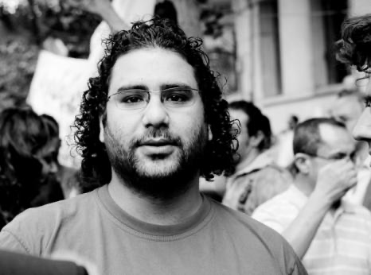
Alaa Abdel Fattah, a British national and human rights activist in Egypt, has faced repeated arrests over the past decade, including for his involvement in the 2011 uprising. Human rights lawyer Mohamed Baker was arrested on 29 September 2019 when he went to represent Alaa Abdel Fattah, who had been arrested earlier that day on bogus terrorism-related charges by the Supreme State Prosecution following an unfair trial. On 20 July Baker was finally released after enduring 45 months of arbitrary detention. Alaa remains arbitrarily detained in Wadi al-Natrun prison, held in inhumane conditions at the Tora Maximum Security 2 Prison in Cairo from September 2019.
Prison authorities have confined Alaa to cramped, poorly ventilated cells, denying him access to beds and mattresses. He has been deprived of reading materials, exercise, adequate clothing, access to hot water and any personal belongings, including family photos. Further, Alaa informed his mother that he was beaten while handcuffed by the deputy prison warden. He has been on hunger strike and was first featured in an appeal to the authorities at Christmas 2023/24.

Please send a message to:
Alaa Abdel Fattah
Tora Mahkoum Prison 2
Cairo Governorate
Egypt

Please send a message to Reverend Haile Nayzgi, Eritrea.
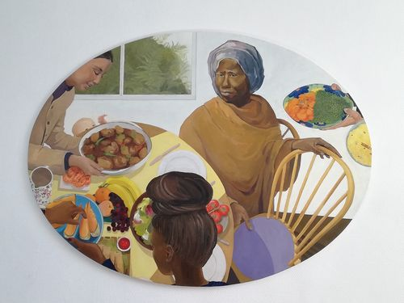
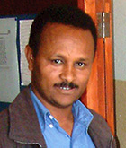
In May 2004 Reverend Haile Nayzgi was arrested and taken to a police station in Asmara. He was the leader of Eritrea’s Full Gospel Church, which comprises 120 to 150 house meeting groups. The church groups were closed by government decree at a meeting with a government official on 15 May 2002. At that time the church groups were given an application form for government registration. The Full Gospel Church filled out the form and returned it to the appropriate offices, but no reply was ever received. Despite the release of 13 Christians in the summer of 2023, Mr Nayzgi, first featured in our Christmas appeal of 2022 was still being held in October 2023. Dr Kiflu Gebremeskel has also not been released. He was first featured in 2016.

Please send a message (do not mention ACAT) to:
Haile Nayzgi
Karsheli Prison
2nd Police Station
Zone 7 Northern East
Asmara, Zoba Maakel
Eritrea

And to:

Dr. Kiflu Gebremeskel
Karsheli Prison
2nd Police Station Zone 7 Northern East
Zoba Maakel
Asmara, Eritrea

Please send a message to Pastor Li Juncai, China
Pastor Li Juncai of the Yuanyang County Central House Church in Xinxiang, Henan Province in China is currently serving a prison sentence of five and a half years after protesting against the government’s attempts to remove the cross atop his church building in 2019. Mass removals of crosses from church buildings began in Henan Province in 2018, with police removing at least 4,000 crosses over the course of a year. Even the crosses of government-run churches were removed, and smaller churches were completely shut down.
When authorities brought a crane to remove the cross from Pastor Li Juncai’s church in February 2019 a group of Christian senior citizens, mostly women, met the plainclothes policemen and their crane. The Christians sang hymns and prayed while attempting to keep the authorities from taking the cross. Police beat and arrested the protestors before forcing the church gate open and removing the cross. Pastor Li Juncai told the workers they should proceed according to the law and that he opposed the removal of the crosses. He was arrested and accused of disrupting public service. Charged with embezzlement and obstructing government administration, he was sentenced to five and a half years in prison and given a fine of more than $7,000 USD.
The Yuanyang County Central House Church was a government-run Three-Self church until 2013, when it merged with a local house church. Each week they ministered to approximately 700-800 people. Many churches are now required to display the national flag along with an image of President Xi Jinping in the sanctuary and to install security cameras facing the congregation. Li Juncai was featured in our Christmas 2022 campaign.

Please send a non-religious message (do not mention ACAT) to:
Pastor Li Juncai
The No. 3 Prison Section
Jiao’nan Prison
Yinghu Road,
Jiefang District, Jiaozuo city,
Henan province
454003
The People's Republic of China

Please send a message to Fariba Dalir, Iran
In July 2021 Fariba Dalir (51), was arrested in Iran along with five other Christian converts, including her fiancé Soroush. While awaiting trial, all six believers were released on bail. Fariba was released on 18 November and the others in October. While out on bail, Fariba and Soroush were married. On 4 December 2021 the courts sentenced Fariba to five years in prison for ‘acting against national security by establishing and leading an Evangelical Christian church’. Soroush and three others were sentenced to ten months in prison for their membership of the church. Fariba’s sentence was later reduced to two years, and the others were released with a fine due to the prison time they had by then already served. On 16 April 2022 Fariba returned to Tehran’s notorious Evin Prison to begin her two-year sentence. She is due to be released in April 2024. She was last featured in our Christmas 2022 campaign.

Please send a (non-religious) message (do not mention ACAT) to:
Fariba Dalir
Evin Prison
Saadat Abad
Tehran
Islamic Republic of Iran

Please send a message to Zhang Zhan, China.

Freelance journalist Zhang Zhan, a well-known activist for human rights in China, was detained in May 2020 as a reprisal for her coverage of the Covid-19 pandemic from February 2020. She reported on the detention of other independent journalists in Wuhan and the harassment of families of victims seeking accountability. Her licence to practise as a lawyer has been revoked. During July and August 2021 she was hospitalised due to her deteriorating health as a result of an ongoing hunger strike begun in June 2020. Tied to a bed and force-fed, Zhang Zhan is in extremely poor health, suffering weight loss, severe malnutrition, a gastric ulcer, and swollen legs and feet. She has also undergone surgery for cancer. She was later transferred back to the Shanghai Women’s Prison, where she is currently believed to be held. There is very grave concern about her well-being as China is known for the human rights defenders who have either died in prison or shortly after their release. Her case was featured at Christmas in 2021.

Please send a non-religious greeting (do not mention ACAT) to:
Ms Zhang Zhan
Songjiang Women's Prison
No.1601, Zhang Jing Road
Sijing Town
Songjiang District
Shanghai
People’s Republic of China

Please send a message to Ashfaq Masih, Pakistan.

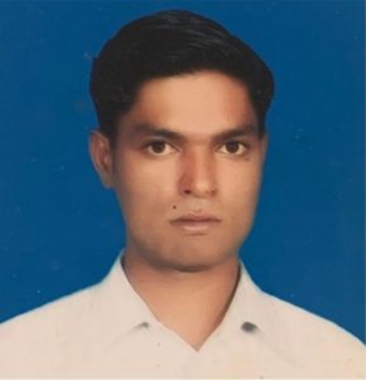
Ashfaq Masih (34) has been in prison in Pakistan since 2017, when he was accused of blasphemy. He is still awaiting trial as his court hearings have been cancelled repeatedly because the judge or witnesses failed to appear. A bicycle mechanic from the Christian Mariam Colony in Lahore, Ashfaq Masih was accused of blasphemy after he was involved in a dispute with a Muslim customer over payment for repairing a bicycle. It is not unusual in Pakistan for Christians to be targeted in this way over minor business disputes that escalate into religious disputes. The customer claimed to be a poor sadhu (holy man) demanding a rebate on the cost of the bicycle repair. A crowd gathered and Ashfaq was accused of blasphemy for reportedly insulting the Prophet Muhammad by telling the bicycle owner that Christians believe Jesus was the final prophet. Police were called and arrested Ashfaq, who is imprisoned in the District Jail (aka Camp Jail), Lahore. Ashfaq’s family is very poor but his older brother is hoping to start a small business. On 4 July 2022 Judge Khalid Wazir sentenced Ashfaq to death for blasphemy. The appeal against his death sentence is still pending in the Lahore High Court. His case was first featured in our newsletter of September-November 2022.

Please send a non-religious greeting (do not mention ACAT) to:

Ashfaq Masih
District Jail Lahore
Ferozepur Road
Shadman 1 Shadman
Lahore
Punjab 54000
Pakistan

Please send a greeting to Emil Ostrovko, Belarus.
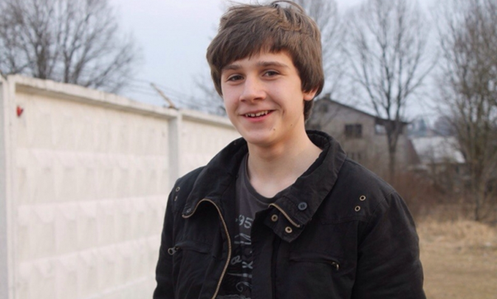
In April 2018, waiting at a bus stop, 17-year old Emil Ostrovko (Emil Astrauko in Belarusian) was beaten by police officers, arrested and convicted for distributing illicit drugs. While working after school as a courier for an online company, his employer had told him the parcels he was delivering contained legal smoking mixtures. After months of detention he received a ten-year prison sentence for drug trafficking, later reduced to eight. Investigators never looked for the owner of the company, nor for anyone else. Some 15,000 children and young persons are serving lengthy prison sentences in Belarus for petty drugs offences. They are treated far worse than other offenders and forced to do long hours of hard labour. Emil was not allowed to carry his asthma medicine and got frostbite from clearing snow with his bare hands. Things improved a little when he went to an adult prison. He was first featured in our Christmas 2019 greetings campaign.
Please send a (religious or non-religious) greeting and message of encouragement. You can mention ACAT and include your home address.
Emil is keen on studying and reading, and is particularly interested in economics, business and innovation. You can send any of the latest news in these fields, alongside other interesting stories which you feel may appeal to him. Emil is also a Catholic, so you can send him appropriate Christmas greetings.
Emil Vadimovich Ostrovko
Correctional Colony Number 2
Ul. Sikorskogo 1, otryad 1
Bobruisk
Mogilevskaya oblast
213800
Belarus

Please send a greeting to Mancho Bibixy, Cameroon.
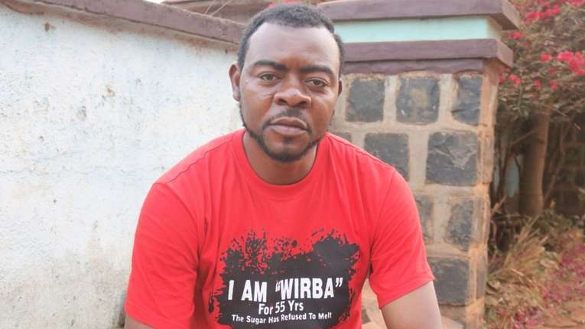
Mancho Bibixy is a Cameroonian journalist and activist who was sentenced to 15 years in prison by a military court in Yaoundé on charges of ‘acts of terrorism, hostility against the homeland, secession, revolution and insurrection’. He was arrested in January 2017 after anti-government protests and was convicted in May 2018. In 2019, he was sentenced to an additional two years in prison for his alleged role in a prison protest. He was first featured in our newsletter of December 2019-February 2020. Our latest information (from early 2022) is that he remains in detention .

Please send a greeting (religious or non-religious, and you can mention ACAT) to:

Mr Mancho Bibixy
Yaoundé Central Prison
Rue de Kondengui
1000 Yaoundé
Cameroon

You can also send greetings to two other imprisoned MRC supporters. They are Intifalia Oben and Dorgelesse Nguessan (who is female). Both are believed to be held in the Prison de New-Belle (Central Prison), Av. de L'Indépendance, Douala, Cameroon.

Please send a message to Le Dinh Luong, Vietnam.

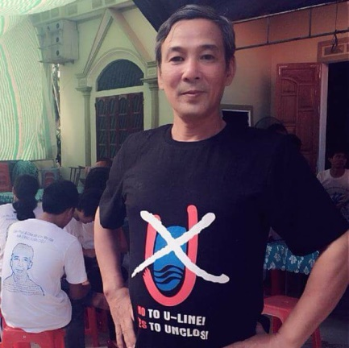
Le Dinh Luong, Vietnam, was detained by police in July 2017 for alleged subversion. Having written on an environmental disaster and campaigned for a clean environment and greater democracy, he was targeted by authorities for calling for an election boycott and for connections to Viet Tan, an overseas pro-democracy group. After a year of incommunicado detention he was finally allowed to meet with his lawyers but following an unfair trial was sentenced in August 2018 to 20 years for subversion, despite the emergence of news that a journalist, Nguyen Van Hoa, was beaten and forced into giving testimony used against him. Hoa later recanted on the witness stand, saying the statements were made under duress of the assault (Hoa is the subject of a separate appeal — see below).
It is also reported that the imprisoned founder of the Vietnam Republic Party, Nguyen Viet Dung, was also coerced into giving false testimony. Luong's lawyers were not allowed to meet with either witness and, after Dung recanted, his family was denied a visit to him in prison. Luong is a Roman Catholic, although this is not the main reason for his detention. On 18 October 2018 his appeal was rejected and in January 2019 he was transferred to Ba Sao prison in Nam Ha province, without prior notice to his family, who are in Ho Chi Minh City, thousands of kilometres away. In September 2019 prison authorities prevented his family from visiting him.

Please send a non-religious message to him in the prison at the address below but do not mention ACAT.
Mr Le Dinh Luong
Ba Sao Prison
Kim Bảng District
Hà Nam Province
Socialist Republic of Vietnam

Please send a message to Qaisar and Amoon Ayub.
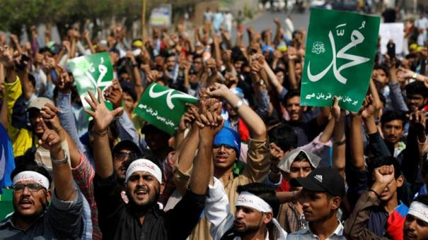
On 13 December 2018 a court in Pakistan sentenced Christian brothers Qaisar and Amoon Ayub to death for blasphemy after they were convicted of insulting the Prophet Mohammed in articles and portraits posted on their website. Since their arrest in 2014 Qaisar (44) and Amoon (38) have been held in Jhelum District Jail, Punjab Province. The judge heard their case in the jail for security reasons. Although the evidence against them was dubious, he found them guilty of the 'use of derogatory remarks in respect of the Holy Prophet' and sentenced them to death by hanging. [Picture: Katehon]

Please send a non-religious message to them at the address below but do not mention ACAT.

Qaisar and Amoon Ayub
Sahiwal District Jail
Main Farid Town Road
Sahiwal
Punjab
Pakistan

Please send a message to Anas el-Beltagy, Egypt.

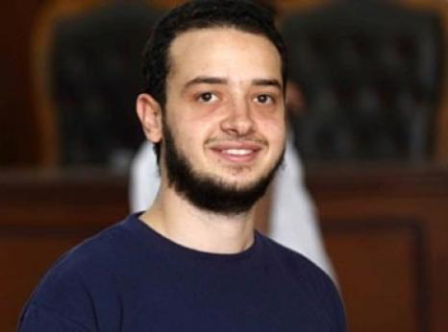
Anas el-Beltagy, son of detained Mohamed el-Beltagy, has endured over 9 years of arbitrary detention in Egypt, solely due to his family association. Anas was first arrested on 24 December 2013, during a visit to the Tora Prison Complex to see his detained father. Security forces surrounded and beat Anas before transferring him to the Maadi prosecution centre, where he was interrogated over the alleged assault of prison guards. After enduring 20 hours of detention, the prosecution ordered his release on bail.
On 31 December 2013, Anas was arrested again in Nasr City and taken to Nasr City 1 Police Station, where he was forcibly disappeared for nearly a month. During this time, he was subject to torture and other ill-treatment. Security forces held Anas in a small iron cage, described as ‘unfit for humans’. Following his transfer to Abu Zaabal prison in Alexandria in early 2014, the prison administration held him in prolonged solitary confinement and forced him to sleep on the concrete floor. He was subsequently transferred to the Tora Prison Complex south of Cairo, where he continued to be subjected to torture and other ill-treatment, including prolonged solitary confinement. Anas was transferred to the Badr Prison Complex in November 2022.
Since February 2023, grave concerns about inhumane detention conditions at Badr 3 Prison have increased amid leaked letters from prisoners indicating a proliferation in suicide attempts by prisoners. Detainees have suffered torture and other ill-treatment deliberate denial of healthcare, exposure to extreme cold, constant surveillance, bombardment with bright lights 24 hours a day, and cruelly deprived of outdoor exercise and contact with other prisoners.
During his detention renewal hearings, often appearing with his hands and legs cuffed, Anas complained about the deterioration in his physical and mental health due to sustained torture and ill-treatment.

Please send a non-religious message (do not mention ACAT) to:
Anas el-Beltagy
Badr Security Complex, Badr 3 Prison
Badr, Cairo Governorate 4958130
Egypt

Please send a message to Anastasia Loika, Belarus.

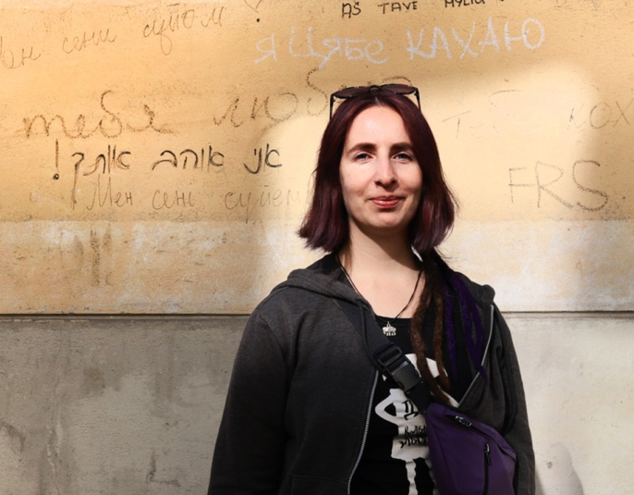
Nasta (Anastasia) Loika is a Belarusian human rights defender working in the field of human rights education. She also analyses repressive ‘anti-extremist’ laws, and advocated for the protection of the rights of migrants in Belarus.
Nasta was sentenced to seven years in a penal colony for ‘inciting radical, national, religious or other social enmity or discord’ on 20 June 2023. On 6 September 2022 Nasta was arbitrarily detained as she was leaving Minsk City Court after attending a hearing in the trial against fellow human rights defenders Marfa Rabkova, Andrei Chapyuk, and their eight co-defendants. She was temporarily released on 5 October 2022, only to be detained again. Nasta was arrested on 28 October 2022 and has been arbitrarily detained ever since.
During her detention, she was denied access to her lawyer, essential medical treatment and other basic necessities, including warm clothes and drinking water. Nasta reported she had been tortured through electric shock questioning and that whilst in detention she was left out in the courtyard for eight hours without outerwear in cold weather. Nasta has been consistently denied adequate medical care, which amounts to inhumane and degrading treatment.

Please send a message (do not mention ACAT) to:
Anastasia Loika
Penal Colony No.4
3 Antoshikina Street
Gomel, 246035
The Republic of Belarus

Please send a message to Zeynab Jalalian, Iran.

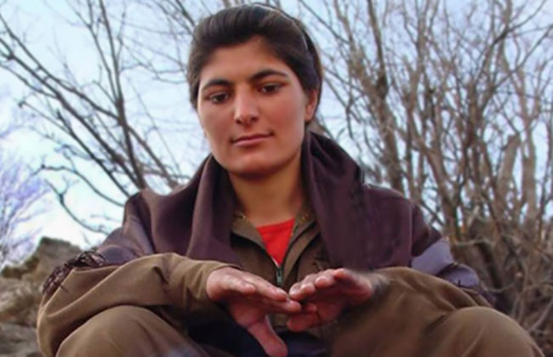
Zeynab Jalalian, a Kurdish advocate for women’s rights and an active member of the political faction of Party for Free Life of Kurdistan (PJAK), was arrested and sentenced to death by an Iranian court in 2008 following an unjust and brief trial. Her commitment to the empowerment of Kurdish women and the cause of Kurdish self-determination led to this grave injustice. In 2011 her death sentence was commuted to life imprisonment. According to the report received by the Hengaw Organization for Human Rights, Zeynab has been deported to Yazd prison without any legal justification, and isolated from her family throughout this time.
Since Zeynab’s arrest, she has endured mental and physical torture, allegedly to extract false confessions. She recounted enduring long interrogations, beatings while being blindfolded, flogging under her feet, threats of rape, and solitary confinement. Moreover, Zeynab has been intentionally deprived of essential healthcare and forced to live in inhumane living conditions to coerce a false confession through a forced videotaped statement. This deliberate denial of medical care has caused severe pain and suffering for Zeynab, with reports of intestinal and kidney infections, internal bleeding, and difficulties when walking. [Picture: Redress]

Please send a non-religious message (do not mention ACAT) to:
Zeynab Jalalian
Yazd Central Prison
Yazd Province
Imam Street
W99P+XG4
Iran


REMEMBER IN YOUR PRAYERS
Ana da Silva Miguel in Angola, in poor health sentenced to six months in prison and then two years for ‘outrage against the state’ after criticising the president.
Anwar Khezri in Iran, tortured and after an unfair trial sentenced to ten years in prison with a serious risk of execution for ‘corruption on earth’.
Ibrahim Metwaly, detained in Egypt for campaigning against enforced disappearances, and held in a prison notorious for torture and ill-treatment.
Oqba Hashad, a student human rights activist in Egypt, held in pre-trial detention for over two years, severely tortured and denied a replacement for a broken prosthetic leg.
Reza Rasaei, and Iranian Kurd, severely tortured and facing the threat of execution for supported the ‘Woman Life Freedom’ protests in 2022.

Remember also the many individuals imprisoned, tortured, on death row or displaced throughout the world for whom a short message of hope and encouragement may give them God’s strength to endure and survive injustice.

