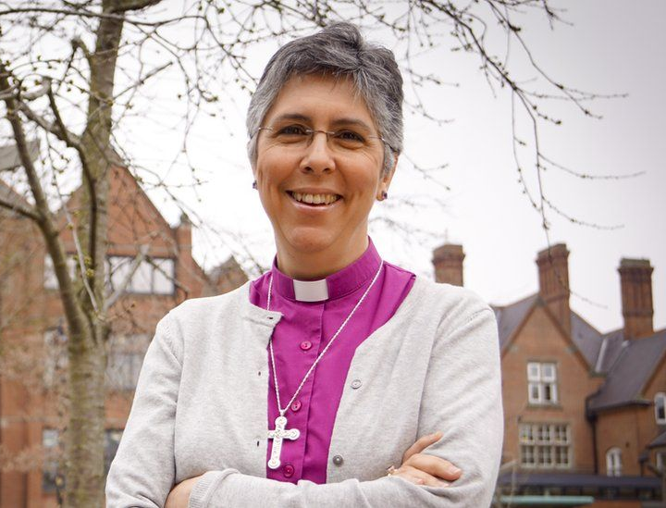
It is our great pleasure to welcome the Bishop of Chelmsford, Guli Francis-Dehqani (pictured), as a patron. A former refugee who was forced at the age of 14 to flee with her family from Iran during the Islamic revolution of 1980, she made history in 2017 when she became the first woman from an ethnic minority to be ordained as an Anglican bishop; in 2021 she took up her seat in the House of Lords. As England’s first Bishop of Housing, she understands very well the importance of a stable, secure home and is dedicated to providing affordable housing for the homeless.

