ACTION BY CHRISTIANS
AGAINST TORTURE
ANNUAL REPORT 2022
Registered Charity No.1072628
President: Revd Dr Paul Oestreicher,
Patrons: Professor Lord David Alton, Revd Dr David Cornick, Baroness Caroline Cox, Revd Dr David Deeks,
Rt Revd Declan Lang, Cardinal Vincent Nichols, Rt Revd Peter Wheatley

ACTION BY CHRISTIANS AGAINST TORTURE: MISSION STATEMENT
ACAT-UK for reasons of Christian faith:

- works to educate and inform the general public, but particularly the churches, regarding the existence, extent and evil of torture, as set out in Article 5 of the UN Universal Declaration of Human Rights;

- campaigns for the worldwide abolition of torture and extrajudicial executions (government sponsored assassinations of opponents or "undesirables");

- provides help, comfort and support to victims of torture and the families of those who have been tortured, executed or face the threat of death;

- remembers in constant prayer the victims, their families and their communities;

- prays also for those who order, inflict or tolerate the torture of their fellow human beings;

- exercises vigilance to ensure that these same human rights are secured, without exception, for all people within the United Kingdom.

ACAT-UK uses all established methods to realise these aims and such new methods as may from time to time be appropriate to its goals. We are also part of an international Federation of Action by Christians for the Abolition of Torture (FIACAT) and a Body in Association with Churches Together in Britain and Ireland.

Secretary: 25 Higher Woolbrook Park, Sidmouth, Devon, EX10 9ED
Email: uk.acat@gmail.com
Registered Charity No. 1072628

REVIEW OF ACTIVITIES

Appeals or messages of support for around 30 individuals and several groups have been featured in our newsletter case appeals and campaigns since September 2021. In addition, monthly appeals for urgent action have been circulated, alongside death penalty cases (see report below). We have also participated in the Common Appeal system of European ACATs, which aims to prepare and share cases.
Of some of the appeal cases featured over the past year: Nazanin Zaghari-Ratcliffe (Iran) was finally released to the UK in March 2022, although an undetermined number of other dual nationals remain in prison in Iran; Burmese journalist Min Nyo, sentenced to 20 years in prison in 2020, was released in October 2021.
The newsletter has reported on various aspects of torture and/or human rights, both in the UK and abroad. In the UK, the Nationality and Borders Act become law in April 2022, which introduces more restrictions on the asylum system. The government is also proposing a revision of the existing Human Rights Act (1988), with elements of derogation from the implementation of the European Convention on Human Rights.
As usual we included in our newsletter information and links on materials for the International Day of Prayer Vigil to mark the United Nations Day of Support for Victims of Torture (26 June 2021, ). Members and groups are reminded that, for those unable to access the internet, we are able to print off and distribute at least some of the material (which is extensive) on request.
FIACAT’s International Council met twice since our last AGM, during 24-29 June and 1-2 December 2021. The first meeting, held virtually, reviewed and adopted the activity and financial reports for 2020 and an action plan and provisional budget for 2021. Dr Audrey Wells was our nominated voting delegate for the meeting. The meeting also approved and welcomed ACAT Ghana as a new member. The second, extraordinary meeting took place in Abidjan, Cote d'Ivoire, and was largely concerned with issues of governance. ACAT-UK also participated in the second ‘ACAT internet café’, in which ACAT-UK delivered a short presentation on its activities to a number of representatives and members of ACATs from other countries.

SECRETARY'S REPORT (MEMBERSHIP)

Total individual membership at the end of August 2022 stood at 213, including 19 life members and eight patrons (including the president). We have 20 registered groups across the UK (with the exception of Northern Ireland) and around 30 individuals are registered for the SOS programme. Around half of members receive the newsletter by email. Printed versions are distributed to groups and to individuals who request them and by default to those without internet access. Around 100 individuals or organisations (non-members) have registered an interest in participating in the Christmas and Easter greetings campaigns and often contribute generously to our expenses. Considered in the longer term, our membership has remained fairly stable, although there is a gradual trend of decline in numbers, mainly due to age and a lack of influx of new members.

ACAT-UK DEATH PENALTY REPORT August 2021- August 2022
Co-ordinator Audrey Wells

The ACAT Death Penalty Appeals Group wrote appeals for the following people condemned to death:

AUGUST 2021
IRAN: Hossein Shahbazi and Arman Abdolali were sentenced to death although both were aged 17 at the time of the alleged crimes . (Execution for crimes committed by those under the age of 18 is forbidden in international law). In November 2021 Arman Abdolali was executed. Hossein Shahbazi remains condemned to death in prison.

SEPTEMBER 2021
MISSOURI ,USA: Ernest Johnson was sentenced to death for alleged murder despite a serious intellectual disability. International appeals included one from the Pope. Nevertheless, Ernest Johnson was executed in October in violation of international human rights law.

OCTOBER 2021
SAUDI ARABIA: Good news: Ali al-Nimr, the subject of many appeals, was released. He was arrested aged 17, sentenced to death for crimes linked to attending pro-democracy protests and imprisoned for ten years, mostly on death row.
EGYPT: Dr Osama Yassin, a distinguished paediatrician and former minister of President Morsi’s cabinet, was sentenced to death in a mass trial in 2013 that dealt with a protest sit-in at Raba’a against the army’s removal of President Morsi. An international campaign for him in October 2021 failed to remove him from death row.
GHANA: Ghana’s parliament was presented with a proposal to abolish the death penalty. ACAT-UK’S DP group wrote to Ghana’s ambassador in London in support of this.

NOVEMBER 2021
SINGAPORE: Nagaenthran Dharmalingam was sentenced to death for drug trafficking despite a very low IQ. His imminent execution was halted after international protest.
SAUDI ARABIA :Abdullah al-Howaiti, the subject of several appeals, was only 14 years old at the time of his arrest in 2017 for alleged armed robbery and murder. In 2019 he was sentenced to death. However, in November 2021 Saudi Arabia’s Supreme Court overturned his conviction and ordered a retrial.
IRAN: Arman Abdolali was executed (see entry for August 2021)

JANUARY 2022
PAPUA NEW GUINEA: The death penalty was abolished. Good news!

FEBRUARY 2022
PAKISTAN: Zafar Bhatti, a Christian charity worker, was sentenced to death for alleged blasphemy He has been imprisoned for over ten years and suffered two heart attacks while his case has been transferred from court to court. His sentence was changed to death by hanging.

MARCH 2022
SAUDI ARABIA: The retrial of Abdullah al-Howaiti resulted in his once again being sentenced to death by beheading although he was only aged 14 at the time of the alleged crime. He has an alibi and claims he was tortured into making a false confession

APRIL 2022
SINGAPORE: Nagaenthran Dharmalingam, whose execution was halted in November, was executed along with two other men with low IQ’s for drug trafficking despite another international protest.

MAY 2022
CENTRAL AFRICAN REPUBLIC abolished the death penalty and became the 24th abolitionist state in Africa. Good news!

JUNE 2022
PAKISTAN: Qaisar and Amoon Ayub were sentenced to death for allegedly posting blasphemous contents on the internet. It is probable that they were framed.

JULY 2022
MYANMAR resumed use of death penalty after a 30-year moratorium. Despite world-wide protests, prominent pro-democracy protesters were executed: Kyaw Min Yu (known as ‘Ko Jimmy’), former lawmaker Phyo Zeya Thaw, Hla Myo Aung and Aung Thura Zaw.

AUGUST 2022
INDONESIA: Lindsay Sandiford (a British grandmother) remains on death row in Indonesia for allegedly being a drug mule. ACAT-UK DP group wrote to their MP’s and FCDO to ask if she could be moved to a British jail. Their responses assured us that the UK is in contact with the Indonesian government about her case.
OKLAHOMA,USA, plans to execute a man a month. ACAT-UK DP group wrote to Oklahoma’s Governor Stitt in protest and to argue for the abolition of the death penalty.

We pray for the families of those who are facing execution, that they may be comforted by your love and compassion. We pray for civic leaders, that they may commit themselves to respecting every human life and ending the use of the death penalty in our land. Compassionate Father, give us wisdom and hearts filled with your love
[A Prayer to End the Use of the Death Penalty, The United States Conference of Catholic Bishops]

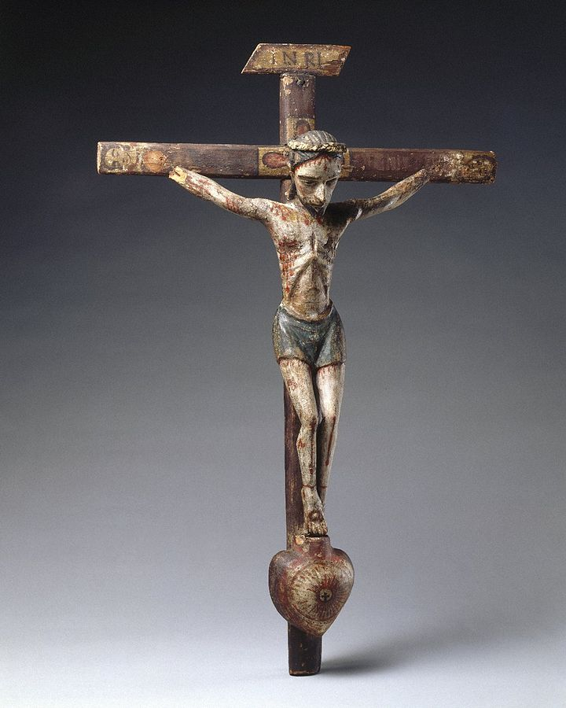

Crucifix by José Rafael Aragón (1796 - 1862), a woodcarver and painter in early New Mexico who used local woods and reflected traditional native art in his religious iconography.

ACTION BY CHRISTIANS AGAINST TORTURE
(Registered Charity No. 1072628)
Accounts for 12 months from 1st July 2021 to 30th June 2022
 |  | 2021-22 |  | 2020-21
 |  | £ |  | £
INCOME
Membership: Individuals | 2,119.10 |  | 2,470.00
Groups | 370.00 | 2,489.10 | 450.00 | 2,920.00
Donations |  | 2,528.94 |  | 2,766.36
Gift Aid tax refund |  | 547.00 |  | 612.99
Bank & Deposit account interest |  | 31.59 |  | 4.45
Total income |  | 5,596.63 |  | 6,303.80
EXPENDITURE
Administration
Committee travel | 190.59
Office expenses | 81.89 |  | 45.04
Postage | 510.23 |  | 648.27
Printing | 1,320.76
Printing of newsletter |  | 2,103.47 | 1,240.79 | 1,934.10
AGM expenses |  | 146.27 |  | 116.80
Bank charges |  | 133.50 |  | 103.15
FIACAT |  | 1,532.73 |  | 1,325.00
Insurance |  | 347.20 |  | 339.20
Subscriptions & donations |  | - |  | 247.98
Total expenditure |  | 4,263.17 |  | 4,066.23
Surplus (deficit) for period |  | 1,333.46 |  | 2,237.57
Balance at start of period |  | 50,571.11 |  | 48,333.54
Balance at end of period |  | 51,904.57 |  | 50,571.11
Represented by
CAF Cash |  | 1,765.28 |  | 5,463.25
CAF Gold |  | 50,139.29 |  | 45,107.86
Total funds available |  | 51,904.57 |  | 50,571.11

ACTION BY CHRISTIANS AGAINST TORTURE
Accounts for 12 months from 1st July 2021 to 30th June 2022

TREASURERS’ STATEMENT

I have prepared the financial statements on page 1 for the period from 1st July 2021 to 30th June 2022. These have been prepared on a receipts and payments basis.

Signed by the Treasurer: DRAFT date:
(Name: Maurice Dyson)

INDEPENDENT EXAMINER’S REPORT

I report on the financial statements of Action by Christians Against Torture [ACAT (UK)] for the period from 1st July 2021 to 30th June 2022 which is set out on page 1.

Respective responsibilities of the Trustees and Examiner

The trustees are responsible for the preparation of the accounts and consider that an audit is not required for this year under section 144(2) of the Charities Act 2011 (the 2011 Act) but that an independent examination is needed.

Having satisfied myself that the charity is not subject to audit under Part 16 of the Companies Act 2006 and is eligible for independent examination, it is my responsibility:
- to examine the accounts under section 145 of the 2011 Act;
- to follow the procedures specified in the General Directions given by the Charity Commissioners under section 145(5)(b) of the 2011 Act; and
- to state whether particular matters have come to my attention

Basis of Independent Examiner’s Report

My examination was carried out in accordance with the General Directions given by the Charity Commission. An examination includes a review of the accounting records kept by the Charity and a comparison of the accounts presented with those records. It also includes consideration of any unusual items or disclosures in the accounts and seeking explanations from you as trustees concerning such matters. The procedures undertaken do not provide all the evidence that would be required in an audit, and consequently no opinion is given as to whether the accounts present a ‘true and fair’ view and the report is limited to those matters set out in the statement below.

Independent Examiner’s Statement

In the course of my examination, no matter has come to my attention:

1. which gives me reasonable cause to believe that, in any material respect, the requirements:
- to keep accounting records in accordance with section 130 of the Act and
- to prepare accounts which accord with the accounting records and comply with the accounting requirements of the 2011 Act,

have not been met or

2. to which, in my opinion, attention should be drawn in order to enable a proper understanding of the accounts to be reached.

Signed by the Independent Examiner: DRAFT date:
Name and address of the Independent Examiner:

Mr S J Cutler FCA, 23 Grasmere Close Surrey GU1 2TG

